Holy Week Quiz for FRHC, Primary School Children (Key stage 2)

Children please complete the quiz and send your answers on an email to Deacon Axcel at pbalpha@rcdow.org.uk , make sure you include your name, age and an email address and contact number for your parents. All entries must be in by Tuesday 14th^{th} April. Then we will then put all the names of the children who completed the quiz into a prize draw and there will be a prize for the winner, for any queries please call the parish office on 01707 654359

- What is the period of time called before Easter and how long is it?

- During this time what are the three things we are meant to do?

- As Jesus entered Jerusalem (Palm Sunday), what did the
crowds shout and what does it mean?
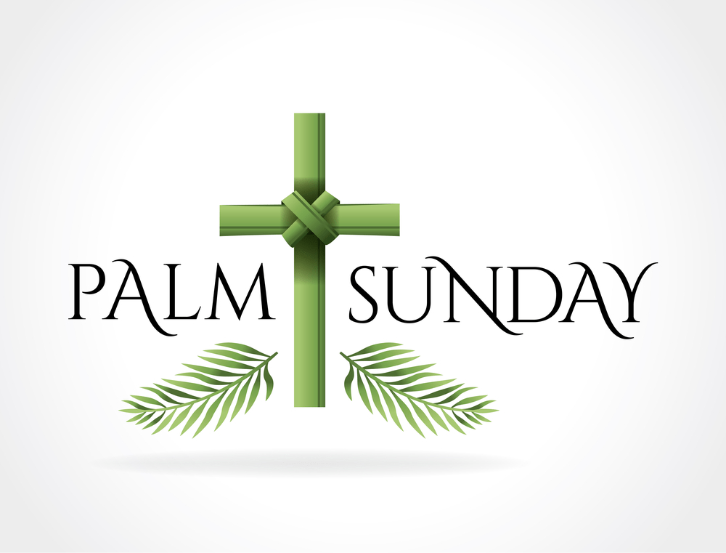

- What is the first day of Holy Week called?

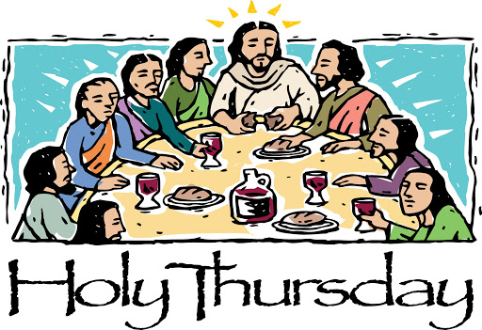
- What did Jesus do as he shared supper with the disciples on the night before he died (Holy Thursday)?

- Which disciple said that he didn’t want Jesus to wash
his feet at the Last Supper (Holy Thursday)?
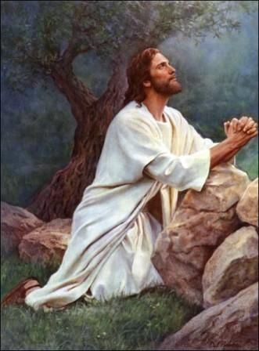

- What did Jesus ask the disciples to do after they had shared
supper the night before he died? And did they do it?

- What was the name of the disciple who was about to betray Jesus? How many pieces of silver was he paid?

- What did the disciple who betrayed Jesus do to show the soldiers who Jesus was?

- How many times did Simon Peter deny Jesus before the cock crew (Good Friday)?

- What was the name of the leader who sentenced Jesus to death?

- What was the name of the criminal who the crowds shouted to be released
instead of Jesus?

- How many Stations of the Cross are there?

- What was the name of the woman who wiped the face of Jesus at the Sixth Station of the Cross?

- How many times did Jesus fall whilst carrying the cross to Golgotha, where he was crucified?

- What was the name of the man who the soldiers got to help Jesus carry his cross?

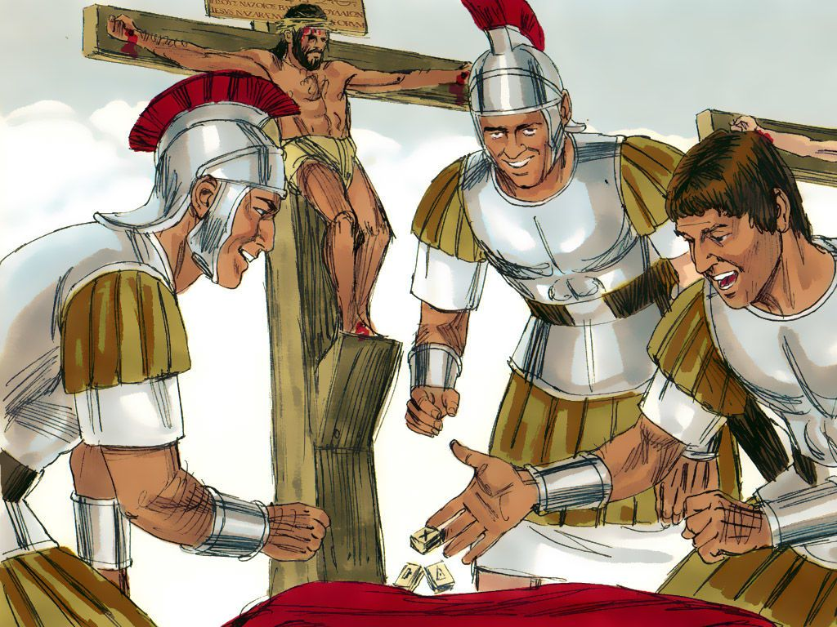

- What did the soldiers do to share Jesus’ clothes out between them?

- What did the sign INRI that was placed above Jesus’ head on the cross mean?
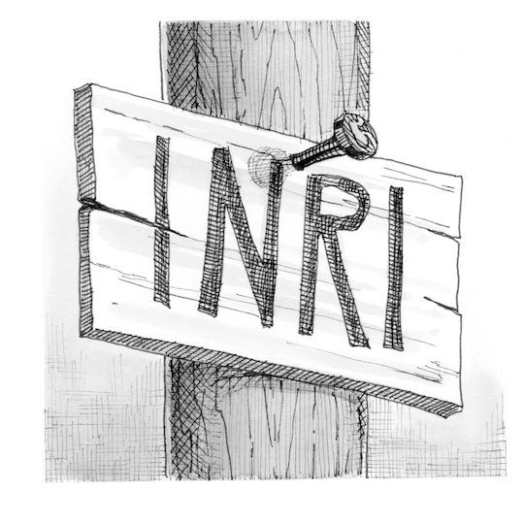

- How many other people were crucified with Jesus?

- Who asked Pilate for permission to take Jesus down from the cross and placed him in the tomb

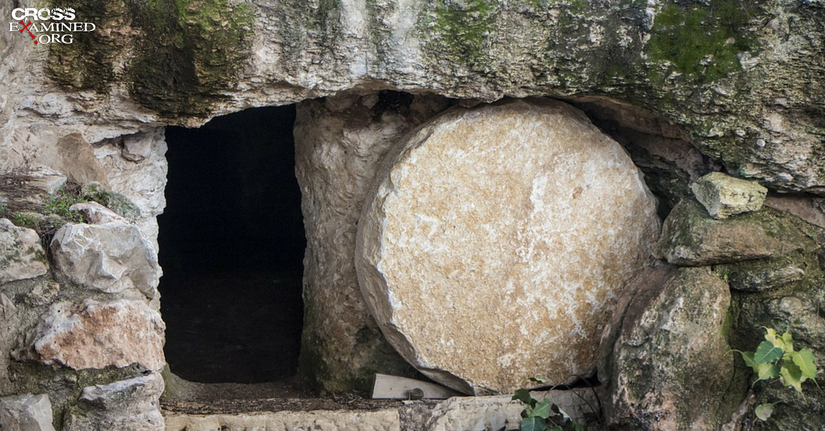
- What did the women find when they went to the tomb?

- Who appeared to the women when they were at the tomb
and told them that Jesus had risen?

- After Jesus’ resurrection who did he appear to in the garden?

- After Jesus rose from the dead, he walked with his followers to a village called Emmaus, they didn’t recognise him until they sat down for supper, how did they recognise that it was Jesus?

