Holy Week Quiz for Younger Children (Key stage 1)

Children please complete the quiz and send your answers on an email to Deacon Axcel at pbalpha@rcdow.org.uk , make sure you include your name, age and an email address and contact number for your parents. All entries must be in by Tuesday 14th^{th} April. Then we will then put all the names of the children who completed the quiz into a prize draw and there will be a prize for the winner, for any queries please call the parish office on 01707 654359
- What was Jesus riding when he entered Jerusalem
(Palm Sunday), complete the dot to dot for the answer?

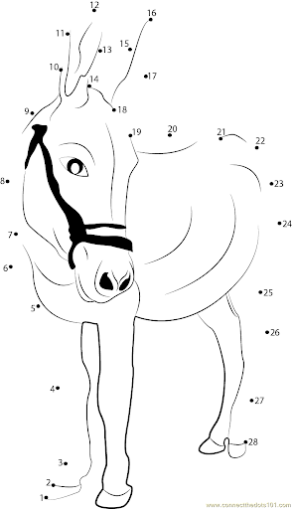
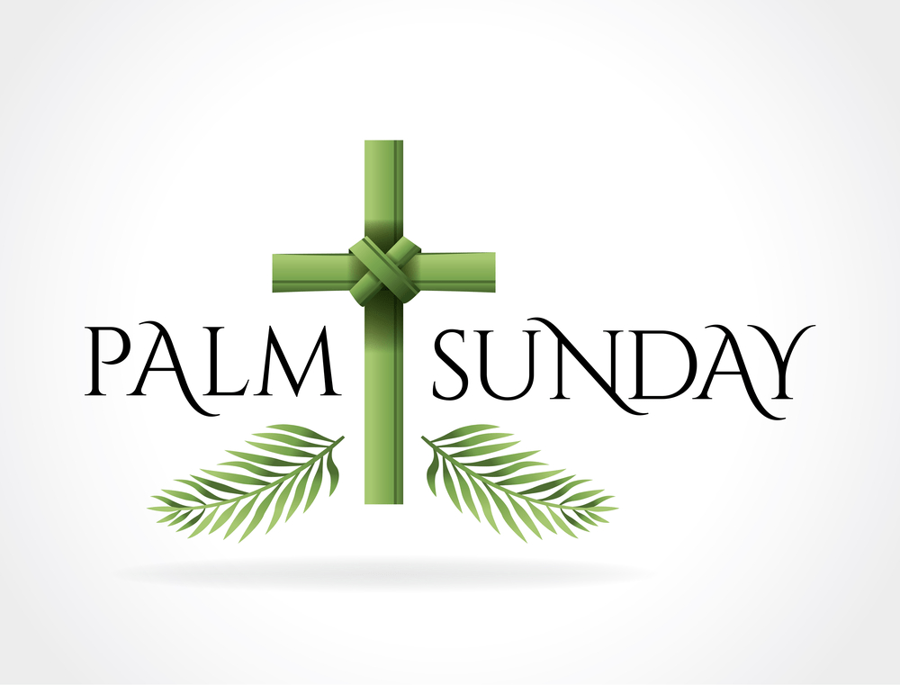

- What did the crowd wave as Jesus arrived in Jerusalem?

- What did they shout when Jesus arrived?

- What did Jesus wash during the last supper? (Holy Thursday)?
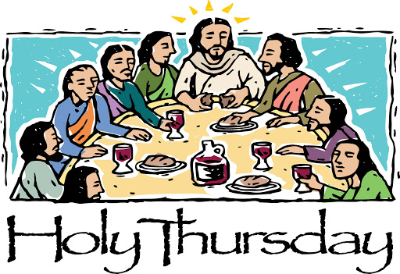

- What was the name of the disciple who was about to betray Jesus?

- What did the disciple who betrayed Jesus do to show the soldiers who Jesus was?

- What animal made a sound after Peter denied Jesus three times,
complete the dot to dot for the answer?
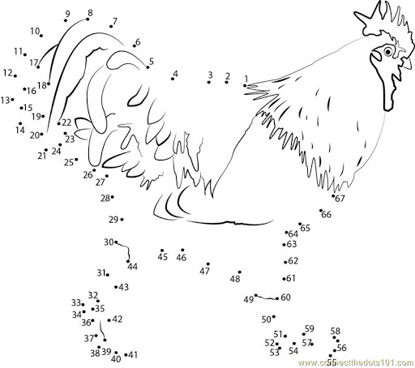

- What did the soldiers put on Jesus after Pilate had sentenced him to be crucified?

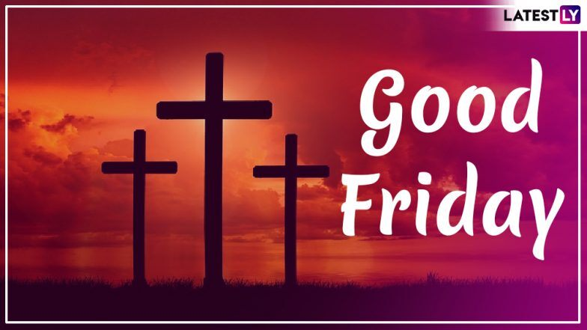

- What did Jesus have to carry all the way to Golgotha,
the place where he was crucified?
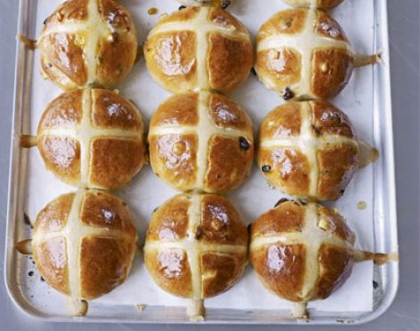

- What do we normally eat on Good Friday?

- Where did Joseph of Arimathea place Jesus after her took him down from the cross?
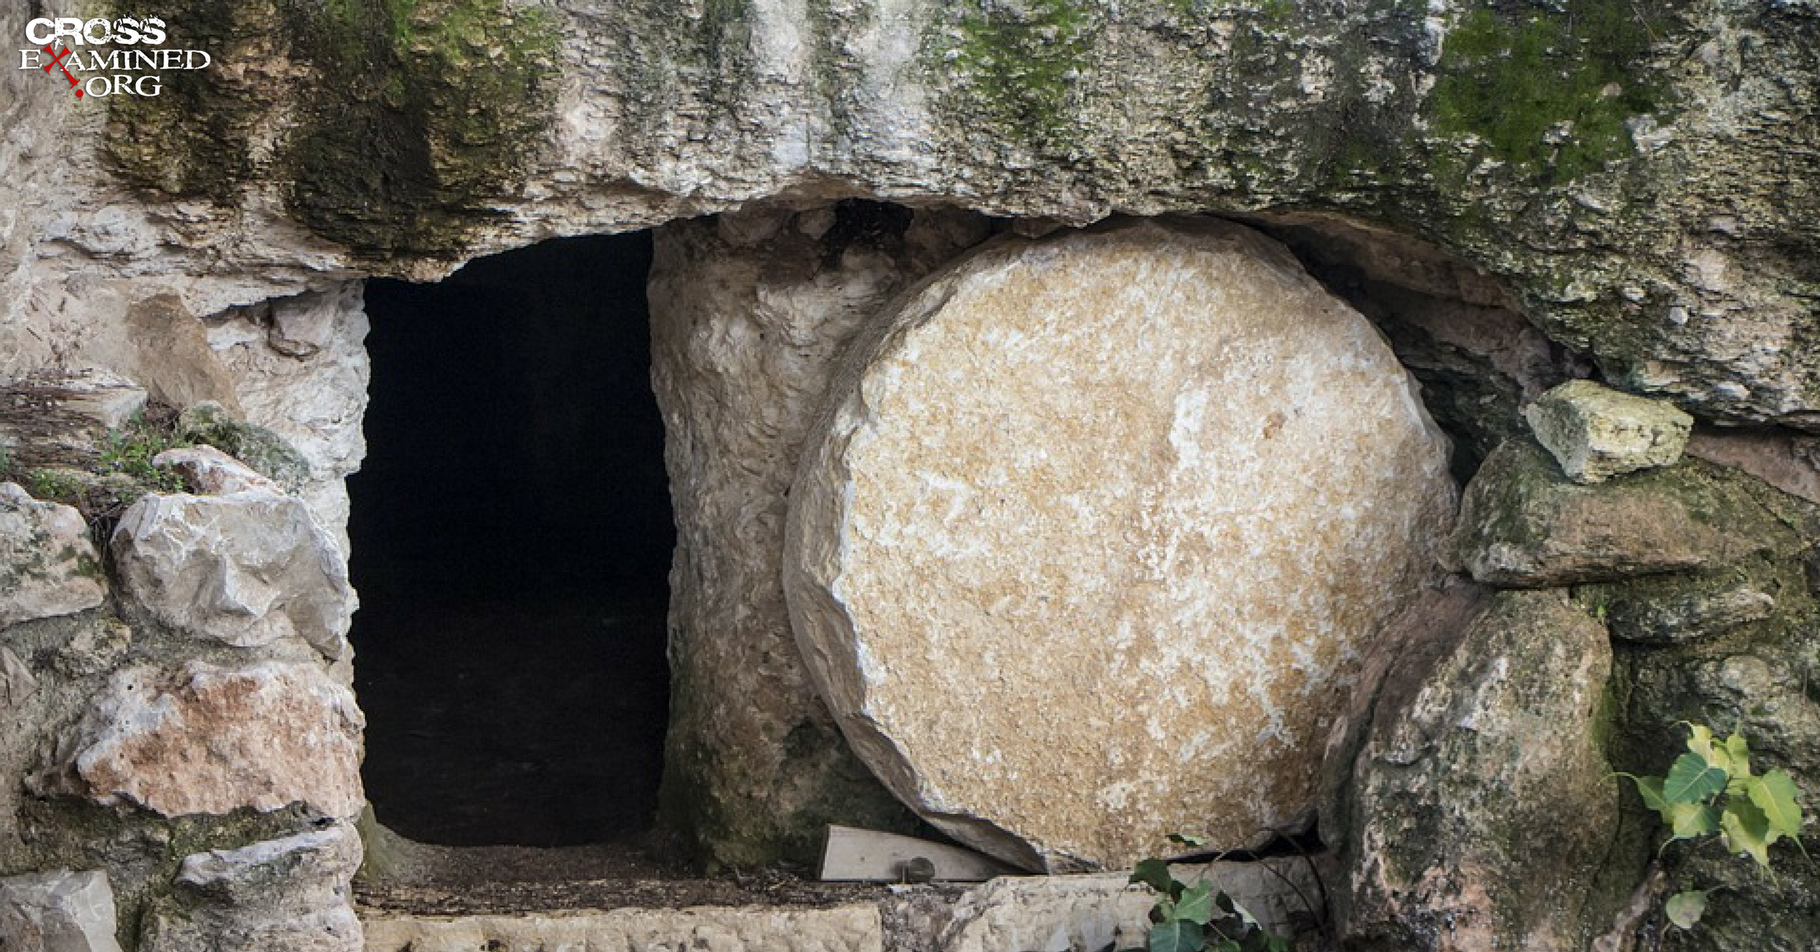

- What did the women find when they went to the tomb?

- Who appeared to the women when they were at the tomb
and told them that Jesus had risen?

- After Jesus’ resurrection who did he appear to in the garden?
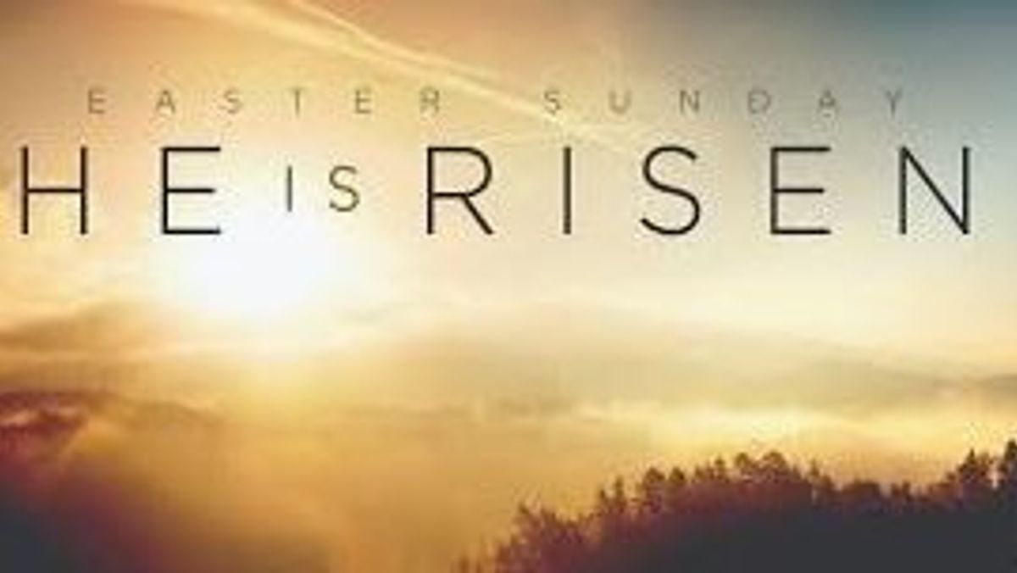

- What do we traditionally eat on Easter Sunday?

