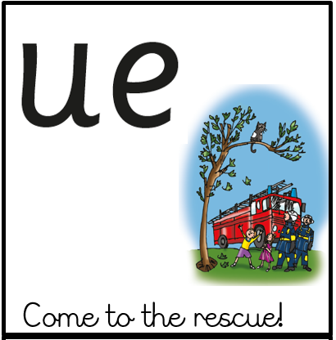  ue  fuel, glued, clue, argue, | 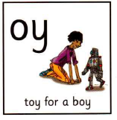  oy  toy, boy, enjoy, ploy, annoy, oyster
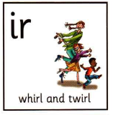  ir  girl, stir, bird, third, | 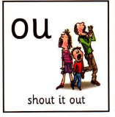  ou  shout, out, proud, cloud, mound

