Year 7 Maths Name:
Measuring and geometric reasoning
1. The shape below is a regular pentagon.
All five sides are exactly the same length.
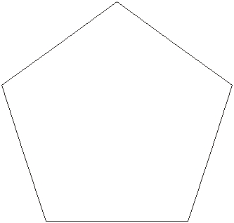
Measure accurately one of the sides, then work out the perimeter of the pentagon.
Perimeter = __________________cm
3 marks

2. (a) The diagram shows part of a ruler.
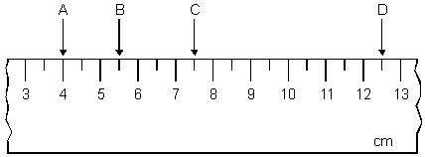
Complete these sentences.
The distance between A and B is _________ cm.
1 mark
The distance between C and D is _________cm.
1 mark
(b) Look at the ruler below.
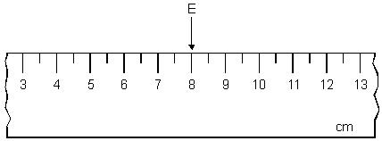
I want the distance between E and F to be 3½ cm.
There are two places F could be.
Show the two places by drawing arrows on the ruler.
2 marks

3. (a)
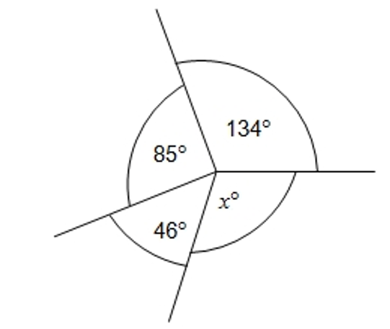
Not drawn accurately
(a) Work out the value of x.
_________________________________________________________________
_________________________________________________________________
_________________________________________________________________
_________________________________________________________________
Answer _____________________________
2 marks
(b) Which of the following describes angle x?
Circle your answer.
acute obtuse reflex equilateral
1 mark
4. The diagram shows three straight lines.
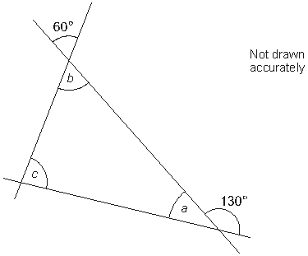
Work out the sizes of angles a, b and c
Give reasons for your answers.
a = ________ because ______________________________________________
__________________________________________________________________
__________________________________________________________________
1 mark
b = ________ because ______________________________________________
__________________________________________________________________
__________________________________________________________________
1 mark
c = ________ because ______________________________________________
__________________________________________________________________
__________________________________________________________________
1 mark

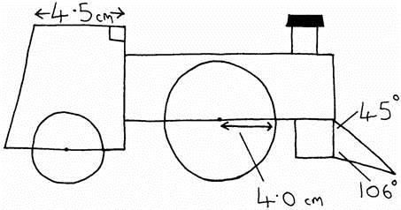
5. Jane wants to design a toy engine.
She makes a rough sketch to show some of the measurements.
Jane starts to draw the accurate side view.
Finish Jane’s side view below.
You will need a ruler, an angle measurer or protractor, and a pair of compasses.
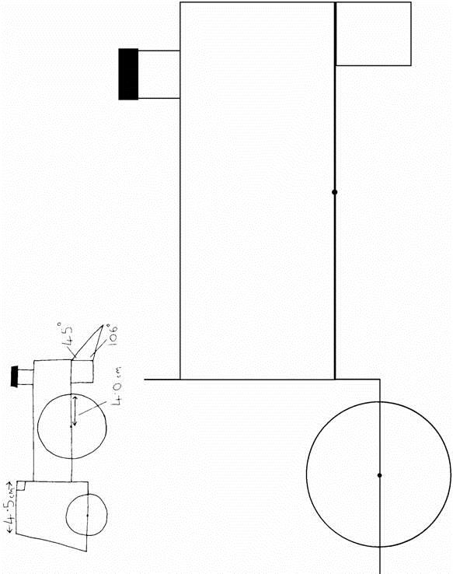
4 marks

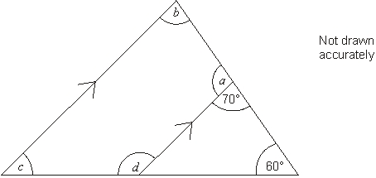
6. Look at the diagram, made from four straight lines.
The lines marked with arrows are parallel.
Work out the sizes of the angles
marked with letters.

_________________________________________________________________
_________________________________________________________________
_________________________________________________________________
_________________________________________________________________
a = ____________° b = ____________
c = ____________° d = ____________
3 marks
7. A company logo is made of two identical parallelograms.
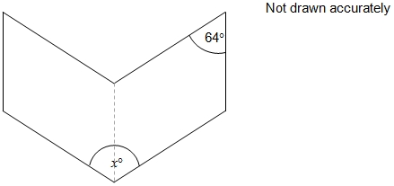
Work out the value of x.
_________________________________________________________________
_________________________________________________________________
Answer ______________________ degrees
2 marks
8. An isosceles triangle has an angle of 40°
What are the other two angles?
Give the two possible pairs of answers.
_________________________________________________________________
_________________________________________________________________
_________________________________________________________________
_________________________________________________________________
Answer ___________________ and ___________________
or Answer ___________________ and ___________________
2 marks
9. AB and CD are parallel lines.
EF is at right angles to GH.
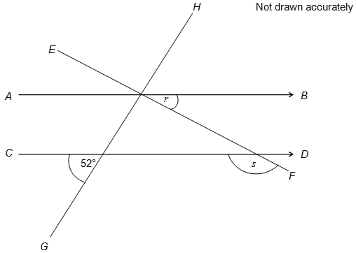
(a) Work out the size of the angle marked r.
_____________________________________________________________
_____________________________________________________________
Answer _______________________ degrees
2 marks
(b) Work out the size of the angle marked s.
_____________________________________________________________
_____________________________________________________________
_____________________________________________________________
Answer _______________________ degrees
1 mark
10. This pattern has rotation symmetry of order 6.
What is the size of angle w?
Show your working.
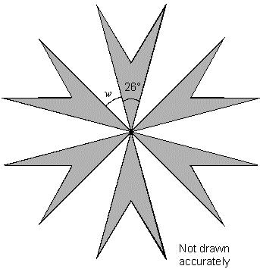

________________°
2 marks

11. This shape is made of four congruent kites meeting at a point.
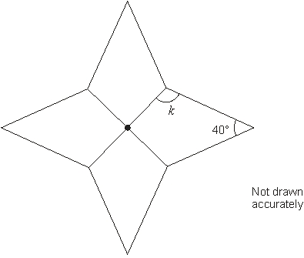
Calculate the size of angle k
_________________________________________________________________
_________________________________________________________________
_________________________________________________________________
_________________________________________________________________
_________________________________________________________________
k = ________________°
2 marks

Feedback Form Instructions
When you have answered as many questions as you can, complete the form on the last page to help you reflect on your work.

How to fill in the form
1 Put your confidence score in Column C. This is not about the number of marks you achieved but how sure you felt while you were answering the question.
Confidence | Definition
0 | I didn’t answer this one
1 | I guessed the answer
2 | I needed help with the answer
3 | I understood the question but wasn’t sure about my answer
4 | I was fairly confident I would get most of the marks
5 | I was sure my answer was correct and I would get full marks
2 Use the mark scheme to check your answers.
Put the mark you think you achieved in Column Mark.
3 Write an overall comment about how you felt each question went.
- If you got help, make a note in the comment box specifying the source: internet,
friend, book, parent or tutor.
4 Complete ‘I can…’ and ‘I need to…’ sentences.
- ‘I can…’ sentences might include the questions you found easiest to answer, got the most marks for or felt the most confident about.
- ‘I need to…’ sentences might include areas you need to revise, questions you want to ask your teacher or the next topic or skill you want to work on.
5 Return the form to your teacher.

Feedback form Name

Qu | Total marks | Self-assessment
 |  | C | Mark | Comment
1 | 3
2 | 4
3 | 3
4 | 3
5 | 4
6 | 3
7 | 2
8 | 2
9 | 3
10 | 2
11 | 2
Overall
I can ……

I need to …….

Qu | Total marks | Teacher review
 |  | Mark | Comment
1 | 3
2 | 4
3 | 3
4 | 3
5 | 4
6 | 3
7 | 2
8 | 2
9 | 3
10 | 2
11 | 2
Overall
You can ……

You need to …….

