Pope Paul Catholic Primary School
Baker Street

Potters Bar

Hertfordshire

EN6 2ES
Tel: 01707 659755
Email: admin@popepaul.herts.sch.uk
Website: www.popepaul.herts.sch.uk
Headteacher:
Mrs Liz Heymoz

2023 – 2024 Academic Year
Autumn Term

Dear Parents,

Autumn Term 2023 Relationship and Health Education (RHE)/PSHE and Wellbeing

In school we use a Relationship Education programme provided by TenTen, known as ‘Life to the Full Plus’ to teach Relationship and Health Education/PSHE and Wellbeing.
This programme is designed specifically for Catholic schools. It aims to teach this curriculum within the context of a Christian understanding rooted in the wisdom and teaching of the Catholic Church.

As parents, you are the first educators of your child and we want you to be aware of the teaching programme schedule, so you can anticipate and answer your children’s queries and questions in their supportive home environment.

On the other side of this letter, you will see what modules of learning your child(ren) will be covering in his/her respective year group during this autumn term.

If you wish to explore the lesson resources more fully, please see below the link to Ten Ten’s Parent Portal, including suggested home activities to support learning:
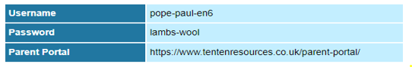

When you login, please click on Year 1 and 2 where you will get guidance on the content of the lessons in the programme.

If you have any questions regarding the content, please do not hesitate to contact me.

Many thanks for your continued support in your child’s education.

Mrs McNamara (RHE/PHSE subject lead)

Autumn Term 2023

Module 1: Created and Loved by God

Unit 1 Story Sessions
Examining a Bible Story

Unit 2 Me, My Body, My Health

