Home Learning
Please could you make this at home to support their learning in class. Please send into class on Monday 26th September
Modelling - Make a model of the muscles in the arm

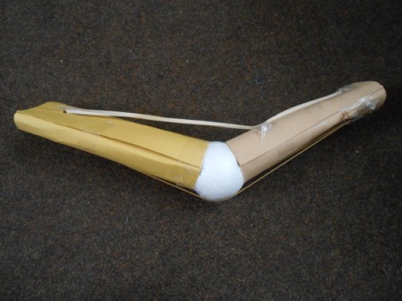

- Use sellotape to tape a ball to one end of a tube of card.
- In both cards make 2 holes 5cm from the end of the card and opposite each other. Unfold a paperclip, stick through the hole (do this for both tubes)
- Pass an elastic band over one of the ends of a paperclip, stretch down both tubes and attaché to another paperclip. Tape over both paperclips’ ends. Repeat with the other elastic band and other ends of the paperclips.
- Tape the top elastic band on to the ‘forearm’ tube, about 5 cm from the ball. Separate the other elastic band(on the bottom) and tape to the ball

Thank you for your support
Mrs Carey

