What to do today
Dear Year 5,
Today you have another chance to become illustrators. See if you can bring the poem to life with you images. Have fun!
Mrs Lines

1. Read an Edward Lear poem
- Use the Hamilton Reader to read The Pobble Who Has No Toes.
- Now follow the words as you listen to the poem being read: you may want to use the text version below. https://bit.ly/3hMc1Ge (there are no images – this is an audio-only version): Which is your favourite verse in this poem?
2. Write the story of The Pobble’s adventure
- Use the Adventure Notes and turn these into a recount of the Pobble’s adventure.
- You will need to add connectives: conjunctions and adverbials, to make your recount flow and make sense.

3. Handwrite one of the Edward Lear poems
- Choose one of the Edward Lear poems that we have studied:
- The Owl and the Pussycat (Days 1 and 2)
- The Quangle Wangle’s Hat (Day 3)
- The Pobble who has no toes (Day 4)
- Choose 2/3 verses from the poem and handwrite these as carefully as you can. Add illustrations in the style of Lear’s.

Well done. Show a grown-up your writing about The Pobble’s adventure. Read them the verse that you chose to handwrite from the Edward Lear poems.

Try the Fun-Time Extra
Try learning your handwritten verse off-by-heart. Can you learn other verses from the poem off-by-heart as well?
The Pobble who has no toes - TEXT

I
The Pobble who has no toes
Had once as many as we;
When they said, 'Some day you may lose them all.’
He replied, 'Fish fiddle de-dee!'
And his Aunt Jobiska made him drink,
Lavender water tinged with pink,
For she said, 'The World in general knows
There's nothing so good for a Pobble's toes!'

II
The Pobble who has no toes,  Swam across the Bristol Channel;  But before he set out he wrapped his nose,  In a piece of scarlet flannel.  For his Aunt Jobiska said, 'No harm  Can come to his toes if his nose is warm;  And it's perfectly known that a Pobble's toes  Are safe, -- provided he minds his nose.' |  | 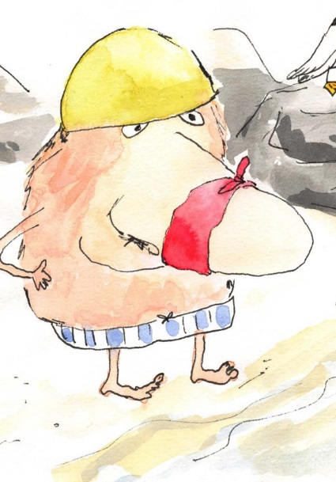
III
The Pobble swam fast and well  And when boats or ships came near him  He tinkledy-blinkledy-winkled a bell  So that all the world could hear him.  And all the Sailors and Admirals cried,  When they saw him nearing the further side,  'He has gone to fish, for his Aunt Jobiska's  Runcible Cat with crimson whiskers!' | 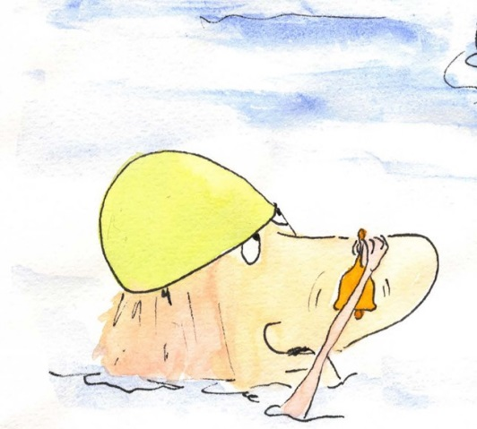

IV
But before he touched the shore,  The shore of the Bristol Channel,  A sea-green Porpoise carried away  His wrapper of scarlet flannel.  And when he came to observe his feet  Formerly garnished with toes so neat  His face at once became forlorn  On perceiving that all his toes were gone! | 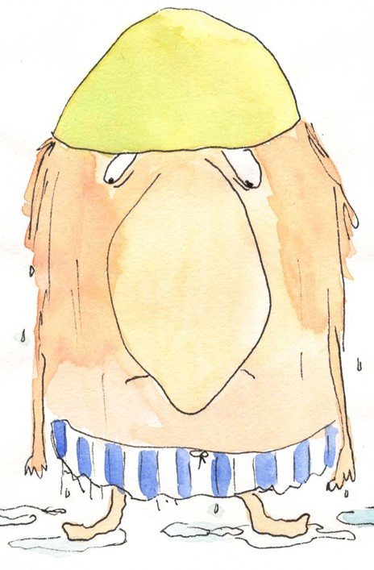
V
And nobody ever knew
From that dark day to the present,
Whoso had taken the Pobble's toes,
In a manner so far from pleasant.
Whether the shrimps or crawfish grey,
Or crafty Mermaids stole them away --
Nobody knew; and nobody knows
How the Pebble was robbed of his twice five toes!

VI
The Pobble who has no toes
Was placed in a friendly Bark,
And they rowed him back, and carried him up,
To his Aunt Jobiska's Park.
And she made him a feast at his earnest wish
Of eggs and buttercups fried with fish;--
And she said,-- 'It's a fact the whole world knows,
'That Pebbles are happier without their toes.'

Adventure Notes

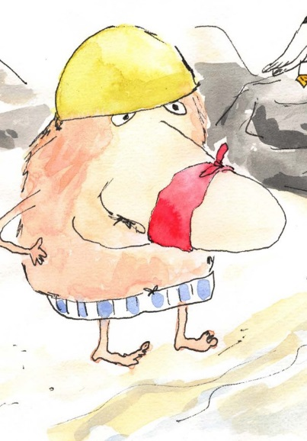

- decided to swim across the Bristol Channel

- wrapped his nose up with a scarlet flannel

- swam fast and well

- tinkled a bell at passing ships

- had his scarlet flannel stolen by a porpoise

- lost all his toes

- was carried back to shore

- was given a feast by his Aunt Jobiska

These conjunctions and adverbials might help your recount to flow:

First, To begin with, To start off,
When, Then Next, Following this, Whilst
After that, Later, Before, Finally, At last, Eventually In the end

The Pobble’s Adventure

Write your recount of The Pobble’s Adventure here.

Handwriting
Handwrite your chosen verse here.

