What to do today
Dear Year 5,
I hope you enjoy writing your character descriptions today. They are a very interesting looking bunch!
Mrs Lines

1. Read a poem
- Look at Main Character. What can you spot in this picture? What do you think might be happening?
- Listen to the reading of The Quangle Wangle’s Hat, (or read the poem to yourself) https://www.youtube.com/watch?v=KgrrTAFfDW0
- Write detailed answers to the Poetry Questions. Look back at the text to help you. Check with the Answers at the end of the document.

2. Revise expanded noun phrases
- Use the PowerPoint on Expanded Noun Phrases or, if this is not possible, remind yourself using the Revision Card.
- Complete Owl’s Head Noun Hunt & Owl’s Expanded Noun Phrases.

3. Now for some writing
- Choose one of the Quangle Wangle Creatures.
- Fill in Spotter’s Guide for this creature. Write a description of what they like, how they behave and where they live. Include expanded noun phrases in your description.

Well done. Show your writing to a grown-up. Look together at the picture of the creature and where it is mentioned in the poem. You can check your answers to Owl’s Head Noun Hunt and Expanded Noun Phrases at the end of this pack.

Try the Fun-Time Extra
Practise reading the poem out loud until you are really fluent with it.

Main Character

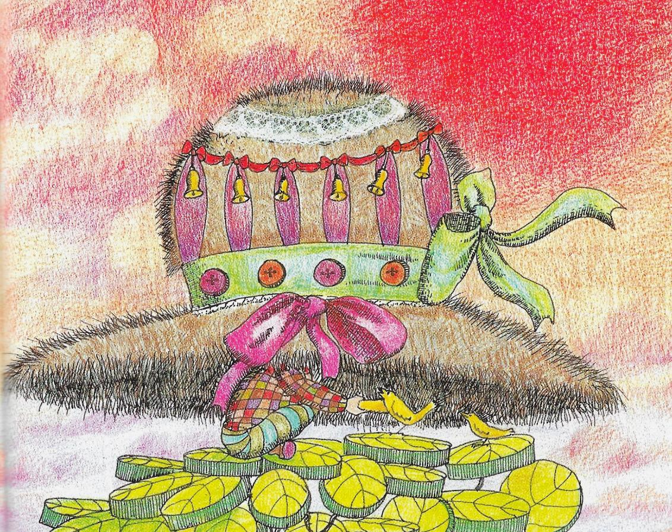

The Quangle Wangle's Hat by Edward Lear

I
On the top of the Crumpetty Tree
The Quangle Wangle sat,
But his face you could not see,
On account of his Beaver Hat.
For his Hat was a hundred and two feet wide,
With ribbons and bibbons on every side
And bells, and buttons, and loops, and lace,
So that nobody ever could see the face
Of the Quangle Wangle Quee.

II
The Quangle Wangle said
To himself on the Crumpetty Tree, —
"Jam; and jelly; and bread;
Are the best of food for me!
But the longer I live on this Crumpetty Tree
The plainer than ever it seems to me
That very few people come this way
And that life on the whole is far from gay!"
Said the Quangle Wangle Quee.

III
But there came to the Crumpetty Tree,
Mr. and Mrs. Canary;
And they said, — "Did ever you see
Any spot so charmingly airy?
May we build a nest on your lovely Hat?
Mr. Quangle Wangle, grant us that!
O please let us come and build a nest
Of whatever material suits you best,
Mr. Quangle Wangle Quee!"

IV
And besides, to the Crumpetty Tree
Came the Stork, the Duck, and the Owl;
The Snail, and the Bumble-Bee,
The Frog, and the Fimble Fowl;
(The Fimble Fowl, with a corkscrew leg;)
And all of them said, — "We humbly beg,
We may build our homes on your lovely Hat, —
Mr. Quangle Wangle, grant us that!
Mr. Quangle Wangle Quee!"

V
And the Golden Grouse came there,
And the Pobble who has no toes, —
And the small Olympian bear, —
And the Dong with a luminous nose.
And the Blue Baboon, who played the Flute, —
And the Orient Calf from the Land of Tute, —
And the Attery Squash, and the Bisky Bat, —
All came and built on the lovely Hat
Of the Quangle Wangle Quee.

VI
And the Quangle Wangle said
To himself on the Crumpetty Tree, —
"When all these creatures move
What a wonderful noise there'll be!"
And at night by the light of the Mulberry moon
They danced to the Flute of the Blue Baboon,
On the broad green leaves of the Crumpetty Tree,
And all were as happy as happy could be,
With the Quangle Wangle Quee.

By Edward Lear
Poetry Questions

What do you like about the poem? Is there anything you dislike? What does it remind you of? What mood would you say this poem has?
Comment on the features of this poem.
Is there a regular rhyme?
Describe the rhyming pattern by giving each line a letter. E.g. A & C rhyme.

Can you find any examples of alliteration*? Of assonance*?

What repetition is there? What purpose does it serve?

What is the rhythm? Is it regular?

What interesting vocabulary words or phrases can you find?
Find some unusual words/phrases. What do they mean?

Are there any vivid descriptions? Write examples.

What types of word does Edward Lear like to invent? Circle those you think.

verb adverb noun adjective preposition pronoun

*Alliteration: several words begin with the same sound. E.g. bells, buttons, loops, lace
*Assonance: several words have the same or similar vowel sounds. E.g. ribbons, bibbons

Revision Card – Expanded noun phrases

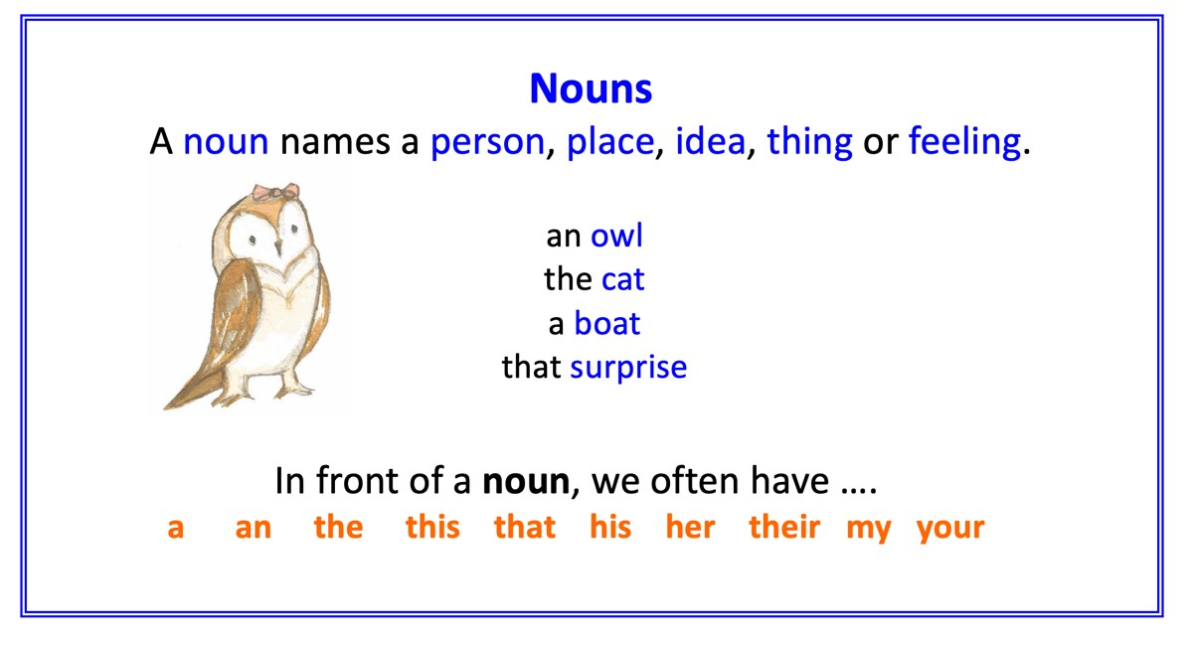 | 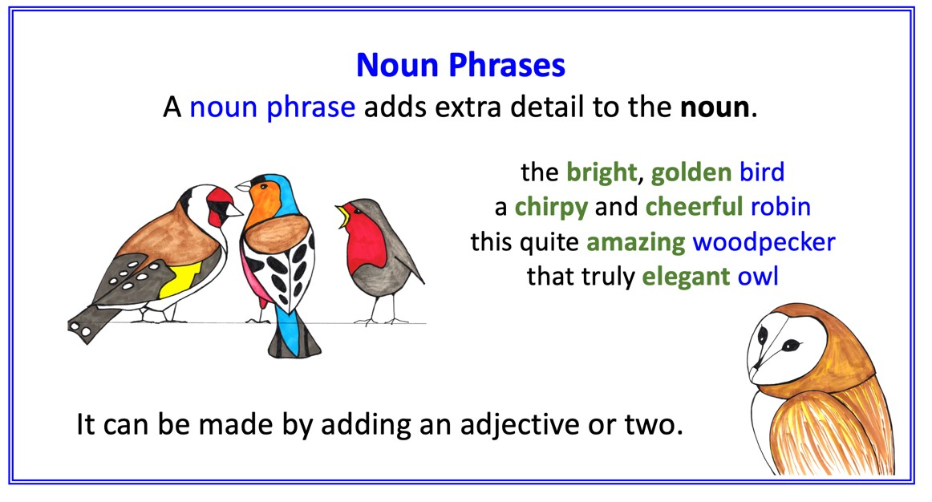
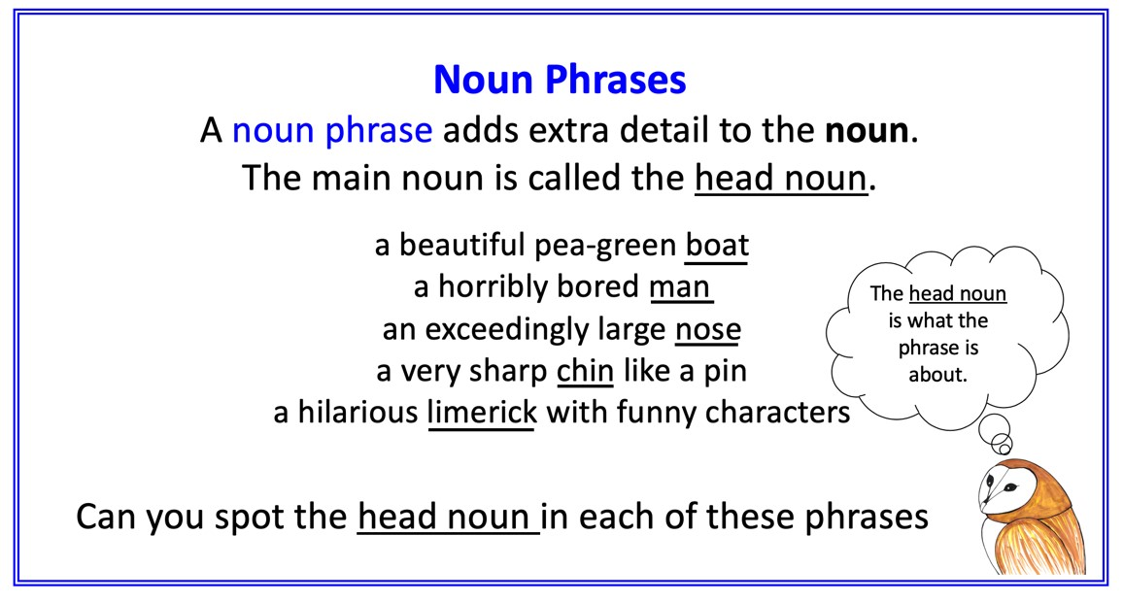 | 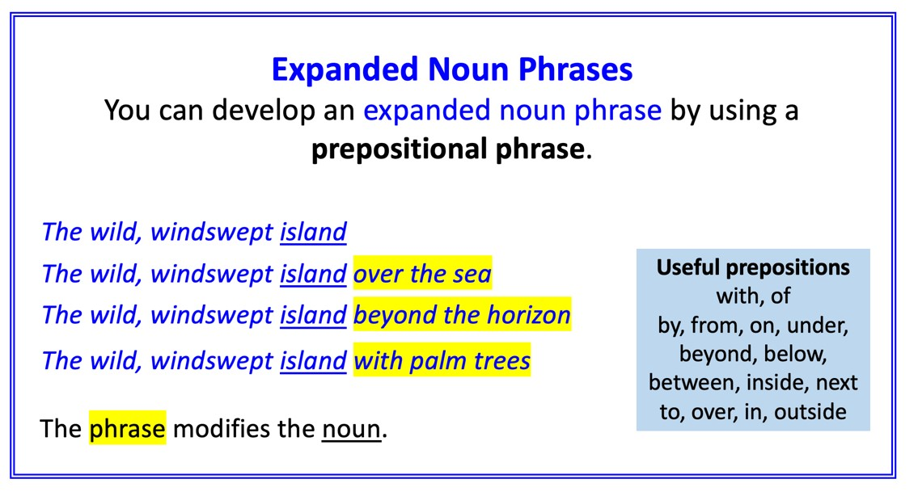

Owl’s Head Noun Hunt

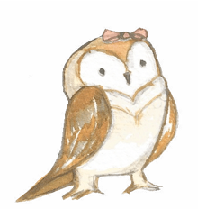

Owl is out looking for head nouns.
Underline the head noun in each of these phrases so that he can pounce on them!
Remember – phrases may contain more than one noun. Owl is hunting for the head nouns.

the elegant owl the beautiful pussycat

the small wooden guitar the silver runcible spoon

the wise old turkey with a book in his claws juicy fruits on the branches of the bong tree

a friendly young pig on the sandy beach

the large hairy nose with a light beneath its nostrils

very tall and leafy trees beside a wide river a kind but buzzing bee next to two wasps

the timid and shivering bird inside the bush a funny woman beside a curious old harp

Now help Owl to build noun phrases.
Using lined paper, select a head noun and write it down.

e.g. honey

Now add an adjective.

e.g. sticky honey

Now add a second adjective.

e.g. sticky, golden honey

Write a noun phrase like this for each head noun.

*CHALLENGE*
Try writing some sentences using your noun phrases.

e.g. The owl brought some sticky, golden honey in a jar.

Owl’s Expanded Noun Phrases
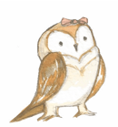

Owl’s noun phrases have become separated from their prepositional phrases.
Can you help him join them back together? Owl has managed to do one himself.
The twinkly stars | on the flower
An irritated bee | around the moon
Some sticky honey | with a ring on its nose
A shiny pound coin | by the hill
A wriggling Pig | on a plate
The wise old Turkey | inside a jar
The sweet, juicy quince | under a £5 note

Now Owl wants to finish these noun phrases with prepositional phrases.
Owl has managed the first one but now he needs your help!
Circle the preposition you have used for each.

The beautiful pea green boat near the harbour

The sandy beach ____________________________________________________________________

A tall and leafy bong tree ________________________________________________________

Two funny old ladies ___________________________________________________________

The quiet old man _____________________________________________________________

Edward Lear’s long beard _______________________________________________________

in on under above next to besides with through between
inside below by from of near

Quangle Wangle Creatures

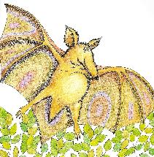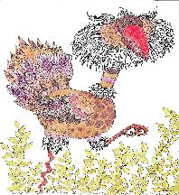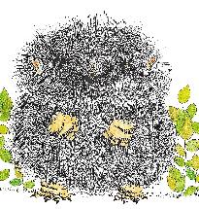
The Bisky Bat The Fimble Fowl The Attery Squash

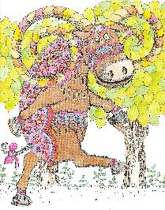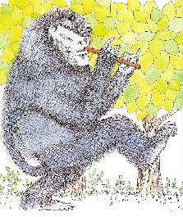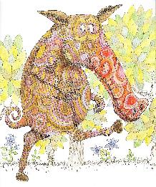
The Orient Calf The Blue Baboon The Dong

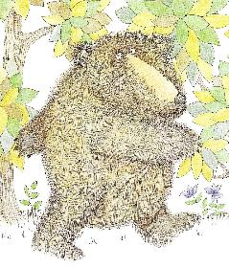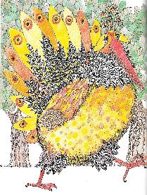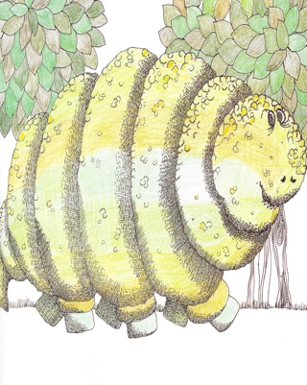
The Olympian Bear The Golden Grouse The Pobble

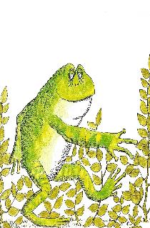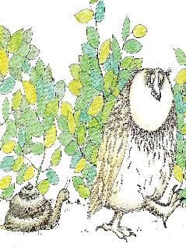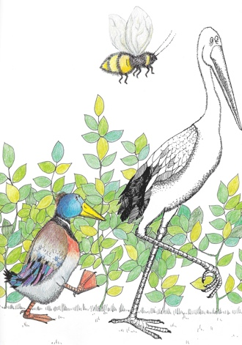

The Frog The Snail The Owl The Duck The Bee The Stork

Spotter’s Guide

Name: _____________________________________

Description:
______________________________________________________________
______________________________________________________________
______________________________________________________________
______________________________________________________________
______________________________________________________________
______________________________________________________________
______________________________________________________________
______________________________________________________________
______________________________________________________________
______________________________________________________________
______________________________________________________________
Spotted on (date): Location
Answers to Poetry Questions

What do you like about the poem? Is there anything you dislike? What does it remind you of? What mood would you say this poem has?
It has a cheerful, bright and breezy mood.
It is telling a story, and not probing deep emotions or dealing with tricky subjects.
Comment on the features of this poem.
Is there a regular rhyme? Yes – it is the same rhyming pattern in each verse.
Describe the rhyming pattern by giving each line a letter. E.g. A & C rhyme.
It is A & C, B & D, E & F and G & H
Can you find any examples of alliteration*?
There are lots: Frog/Fimble Fowl; Golden/Grouse; Blue/Baboon; Mulberry/Moon; Jam/Jelly; Bisky/Bat
Of assonance*?
Several examples: blue/who/flute; at night by the light/ flute of blue …
What repetition is there? What purpose does it serve?
Quangle Wangle Quee / Mr Quangle Wangle Quee / His name is repeated in every verse at least twice. This has the effect of reminding you who the central character is in this poem.
What is the rhythm? Is it regular?
It is very regular. Each verse has more or less the same number of syllables in each of its lines, so that the verses all have the same rhythm.
What interesting vocabulary words or phrases can you find?
Find some unusual words/phrases. What do they mean?
Any spot so charmingly airy suggesting a pleasant and uncrowded situation
We humbly beg – suggesting that they are asking VERY politely
Luminous nose – meaning that the nose shines as if it is lit up
The Orient calf – suggesting that the calf comes from the far east.
Are there any vivid descriptions? Write examples.
The description of the hat itself is very detailed. For his Hat was a hundred and two feet wide, /With ribbons and bibbons on every side /And bells, and buttons, and loops, and lace…. Also the descriptions of the animals, e.g. Blue baboon who played the flute or Fimble fowl with the cork-screw leg.
What types of word does Edward Lear like to invent? Circle those you think.
verb adverb noun adjective preposition pronoun
Lear invents new animals and new words to describe them

ANSWERS to Owl’s Head Noun Hunt/Expanded Noun Phrases

Underline the head noun in each of these phrases so that he can pounce on them! Remember – phrases may contain more than one noun. Owl is hunting for the head nouns.

the elegant owl the beautiful pussycat

the small wooden guitar the silver runcible spoon

the wise old turkey with a book in his claws the juicy fruits on the branches of the bong tree

a friendly young pig on the sandy beach

the large hairy nose with a light beneath its nostrils

very tall and leafy trees beside a wide river a kind but buzzing bee next to two wasps

the timid and shivering young bird inside the bush a funny woman beside a curious old harp

An irritated bee on the flower
The twinkly stars around the moon
A wriggling Pig with a ring on its nose
The wise old Turkey by the hill
The sweet, juicy quince on a plate
Some sticky honey inside a jar
A shiny pound coin under a £5 note

