What to do today
Dear Year 5,
Today you will learn more about Victorian writer, Edward Lear. You will also read his famous poem, ‘The Owl and the Pussycat’ and evaluate some animations of it.
Mrs Lines

1. Read about a writer
- Read Edward Lear – Biography and Edward Lear Facts.
- Which of these pieces of writing do you think gives the best information? Why? Which three facts about Edward Lear do you find most interesting?
- What other information would you like to research about Edward Lear? Write 3-4 questions. Use Edward Lear – my questions answered to do the research and write the answers.

2. Read and listen to a poem
- Read The Owl and the Pussycat by Edward Lear. Read it twice -in your head and out loud.
- Watch two very different animations of the poem
https://vimeo.com/8159096
https://www.youtube.com/watch?v=0YUuWSKm67c
- Think about which of the two you prefer and why. Write about your opinions on The Owl and the Pussycat Opinions.

3. Now for some writing
- Imagine your own magical journey. Answer the questions on Magical Journey Planner.
- Write about your magical journey. You can write it as a story or you could try writing it as a poem.

Well done. Show your writing to a grown-up. Find out from them where they would like to go on a magical journey.

Try the Fun-Time Extra
Choose one of the Owl and Pussycat Events. Illustrate it.
Edward Lear – Biography

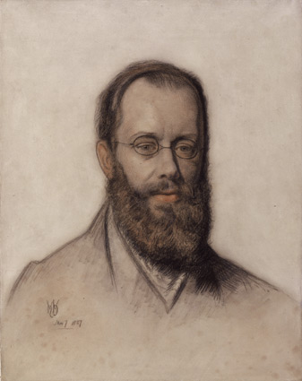

Edward Lear lived from 1812 to 1888, in the Victorian period. He was good at all sorts of things. He illustrated books about birds and animals with beautiful drawings, and painted colourful pictures of all the places he travelled to in the world. He played the guitar and the flute and wrote lots of songs. He was also a well-known writer of stories and poems. He is most famous nowadays for writing ‘nonsense verse’ – quirky poems full of funny ideas and words that have a strong rhythm and lots of rhyming. Lear also liked writing a special kind of funny poem called a ‘limerick’.

Edward Lear - Five Facts

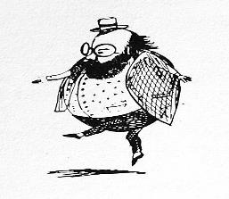

Because Edward Lear had so many brothers and sisters (twenty of them altogether!), he was mainly looked-after by his big sister, Ann. His tired Mum was too busy with all the other children! | Poor Edward was not a very healthy person. He suffered from a disease called epilepsy and he did not have very good eyesight. That is why most photographs or drawings of Lear show him wearing little round glasses. | Edward Lear was only 19 years old when he wrote his first book. Funnily enough, for someone who became famous for nonsense verse and limericks, it was a serious book about parrots. | When you mention limericks, everyone thinks of Edward Lear. In fact, Lear did not invent limericks and he never even called his poems limericks, preferring to say they were ‘nonsense poems’. | Edward loved travelling. During his life he visited Italy, Greece, Egypt, Switzerland and Malta. He did all his travelling before cars, aeroplanes or coaches had been invented, so it took Lear weeks and weeks to get to these countries from England.

Edward Lear – my questions answered

First write your questions – you should have at least 3

- ________________________________________________________
________________________________________________________
- ________________________________________________________
________________________________________________________
- ________________________________________________________
________________________________________________________
- ________________________________________________________
________________________________________________________

Here are some useful websites
https://www.softschools.com/facts/authors/edward_lear_facts/1919/
https://primaryfacts.com/8193/edward-lear-facts-and-information/

Write your answers here
____________________________________________________________
____________________________________________________________
____________________________________________________________
____________________________________________________________
____________________________________________________________
____________________________________________________________
____________________________________________________________
____________________________________________________________
____________________________________________________________

The Owl and the Pussy-cat

The Owl and the Pussy-cat went to sea
In a beautiful pea-green boat,
They took some honey and plenty of money,
Wrapped up in a five-pound note.
The Owl looked up to the stars above,
And sang to a small guitar,
“O lovely Pussy, O Pussy my love,
What a beautiful Pussy you are,
You are,
You are!
What a beautiful Pussy you are!”

Pussy said to the Owl, “You elegant fowl!
How charmingly sweet you sing!
O let us be married! Too long we have tarried:
But what shall we do for a ring?”
They sailed away, for a year and a day,
To the land where the Bong-Tree grows
And there in a wood a Piggy-wig stood
With a ring at the end of his nose,
His nose,
His nose,
With a ring at the end of his nose.

“Dear Pig, are you willing to sell for one shilling
Your ring?” said the Piggy, “I will.”
So they took it away, and were married next day
By the Turkey who lives on the hill.
They dined on mince, and slices of quince,
Which they ate with a runcible spoon;
And hand in hand, on the edge of the sand,
They danced by the light of the moon,
The moon,
The moon,
They danced by the light of the moon.

Edward Lear

The Owl and the Pussycat Opinions

What I liked about the first video

What I disliked about this video

What I liked about the second video

What I disliked about this video

Which one I thought was best and why

The Owl and the Pussycat is one of the most famous and well-loved poems in English. What do you think it is about it that has kept it so popular?

Magical Journey Planner
Where would you go?
Who would you take?
How would you get there?
What would happen?

Your magical journey
Write about your magical journey here.

