What to do today
IMPORTANT! Parent or Carer – Read this page with your child and check that you are happy with what they have to do and with any weblinks or use of the Internet required.

1. Story time
Go back to https://youtu.be/b9zcjE2RDME
- Listen for the last time to This Book Just Ate My Dog.
- Where do you think the dog actually goes to when it disappears inside the book?
- What words could you use to describe Bella? Would bold be a good word to describe her? Why/not?

2. Heads, Bodies and Legs
Shaking the book jumbles everything up – just look at the picture of Bella’s Dog from the end of the story!
- Follow the instructions and play a game of Heads, Bodies and Legs.
- On each bit of Heads, Bodies and Legs paper, write short paragraphs containing expanded noun phrases (two big, bulging eyes...; a long, thin nose with hairs sprouting out of it...) to describe your creatures.

3. Writing funny stories
Shaking a book probably jumbles up the story too!
- Read the instructions and play a game of What a Jumbled Story!
- Carry on your jumbled story on the Story Paper.

Now try this Fun-Time Extra
Bella had a very strange day.
- What is the strangest thing that has ever happened to you?
- Draw a picture of what happened.
- Write a paragraph describing what happened.

Bella’s Dog

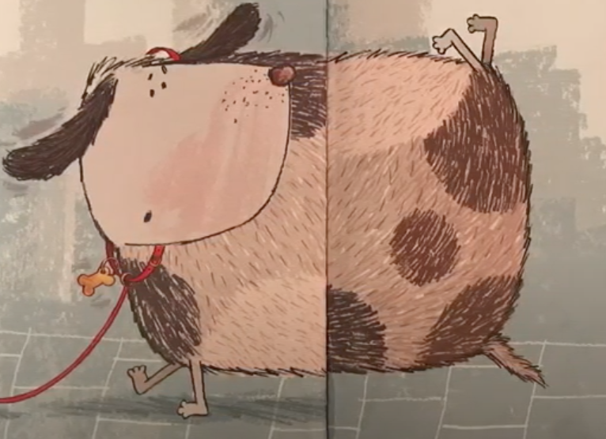

Playing Heads, Bodies and Legs

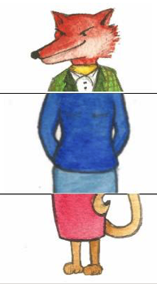

With one or two other people
- Print off a page of Heads, Bodies and Legs paper for each player or fold a blank piece of paper into thirds.
- In the top box of your piece of paper, draw a head without letting the other players see it. This can be any sort of head – an animal’s, a person’s... even a monster’s head!
- Make sure the neck lines go just over the dotted fold line so that it is easier for the next player to see where they should start their drawing of the body.
- Carefully fold the paper back along the dotted line so that the head is hidden and hand the paper on so that everyone has a new bit of paper.
- In the second box on the paper you have been handed, draw a body, carefully joining it to the neck. Make sure the edges of the body go just over the dotted line to the legs box.
- Fold the paper over and pass on one more time for people to draw the legs.
- Unfold the paper and see what amazing creature you have made between you!

On your own
- Print off three copies of the Heads, Bodies and Legs page or fold pieces of blank paper into thirds.
- In the top box of each page draw a different head. This can be any sort of head – an animal’s, a person’s... even a monster’s!
- Make sure the neck lines goes just over the dotted fold line so that it is easier for you to see where to start drawing bodies in a moment.
- Fold the papers back along the dotted lines so you can’t see your heads and then shuffle the bits of paper.
- Now draw three different bodies in the second boxes down.
- Fold these back too when you are done, shuffle again and finish by drawing three different sets of legs in the last boxes.
- Unfold each of the three bits of paper and see what amazing creatures you have created!

Heads, Bodies and Legs

What a Jumbled Story!

1. | was | when s/he met | and they decided to
2. | was | when s/he met | and they decided to
3. | was | when s/he met | and they decided to
4. | was | when s/he met | and they decided to

Instructions for playing What a Jumbled Story!

With a partner or several other people

Give each player a print-off of the What a Jumbled Story! page.

- Start on Row 1, and fill in the name of any story character or real person in the first box, e.g. Mr Fox.  - Fold your paper back along the dotted line so the next player can’t see who you have written.  - Hand the paper on.  - In the top row of the 2nd box write what someone was doing, e.g. was cooking tea on a campfire. This can be anything at all and should have nothing to do with the character you first wrote down!  - Fold back your paper along the dotted line again and hand on to the next player.  - In the third box of the top row say who they met, e.g. when he met our Headteacher. | 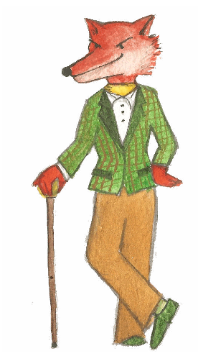

- Fold back and pass on as before.

- In the final box write what they decided to do, e.g. and they decided to go on holiday to France together.

Repeat this for the second, third and fourth rows!

What you have written is just the beginning of a very strange story indeed! Choose one beginning and, on the Story Paper, carry on writing the tale, saying what happened next to your characters. Maybe they meet further unexpected people or things? What odd and unusual situations do they all end up getting into?
Jumbled Story Ideas

Character | was... | when they met | and they decided to
Harry Potter  Cinderella  My teacher  My Mum  Snow White  My Dad  Mickey Mouse  The Queen | playing football  sleeping in a tent  going to London  smelling a flower  going fishing  walking in the park  climbing a tree  flying a kite  running | the big bad wolf  My head teacher  Little Red Riding Hood  the Lord Mayor of London  a talking monkey  the man in the moon  my brother  a clown | cook a huge meal.  build a space rocket.  shout hello at the tops of their voices.  run round the park till dark.  do their teeth with sawdust.  eat flowers.  jump into a river.  fly to the Moon.

Story Paper
The Strangest Thing That Ever Happened To Me!

