What to do today: Tuesday 14th July, 2020
Dear Parents and Carers,
Read this page with your child and check that you are happy with what they have to do and with any weblinks or use of the Internet required.
Ms Varga and Mrs McNamara

1. Story time
- Go back to https://youtu.be/b9zcjE2RDME.
Listen again to This Book Just Ate My Dog.
- List the different characters and vehicles that feature in the story. In what order do they appear?
- Of the vehicles in the story, which would you most like to drive or ride in? Use the word because to explain your answer.

2. Playing Pairs.
You are going to play a game of Vehicle and Transport Pairs.
- Look at the set of Vehicles and Transport Cards.
- Read the Instructions for How to Play Pairs. Have a go!

3. Make cards for your own game of Pairs
You are going to make your own Pairs game cards.
- Read the Instructions for Making Pairs Cards.
- Draw and write your cards and play a game of Pairs using your cards.

Now try this Fun-Time Extra
- Look at the picture of the bookplate from This Book Just Ate My Dog. A bookplate shows who a book belongs to.
- Design your own bookplate to use in all your books: This ______ Book Belongs To... What words could you use to describe your books – brilliant, amazing, cool, fantastic, ace, wicked, etc.
- Use Post-it notes if you don’t want to stick your bookplate down permanently.

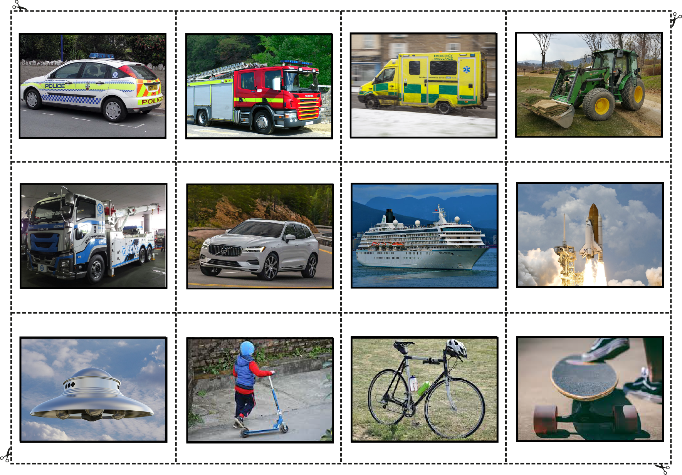

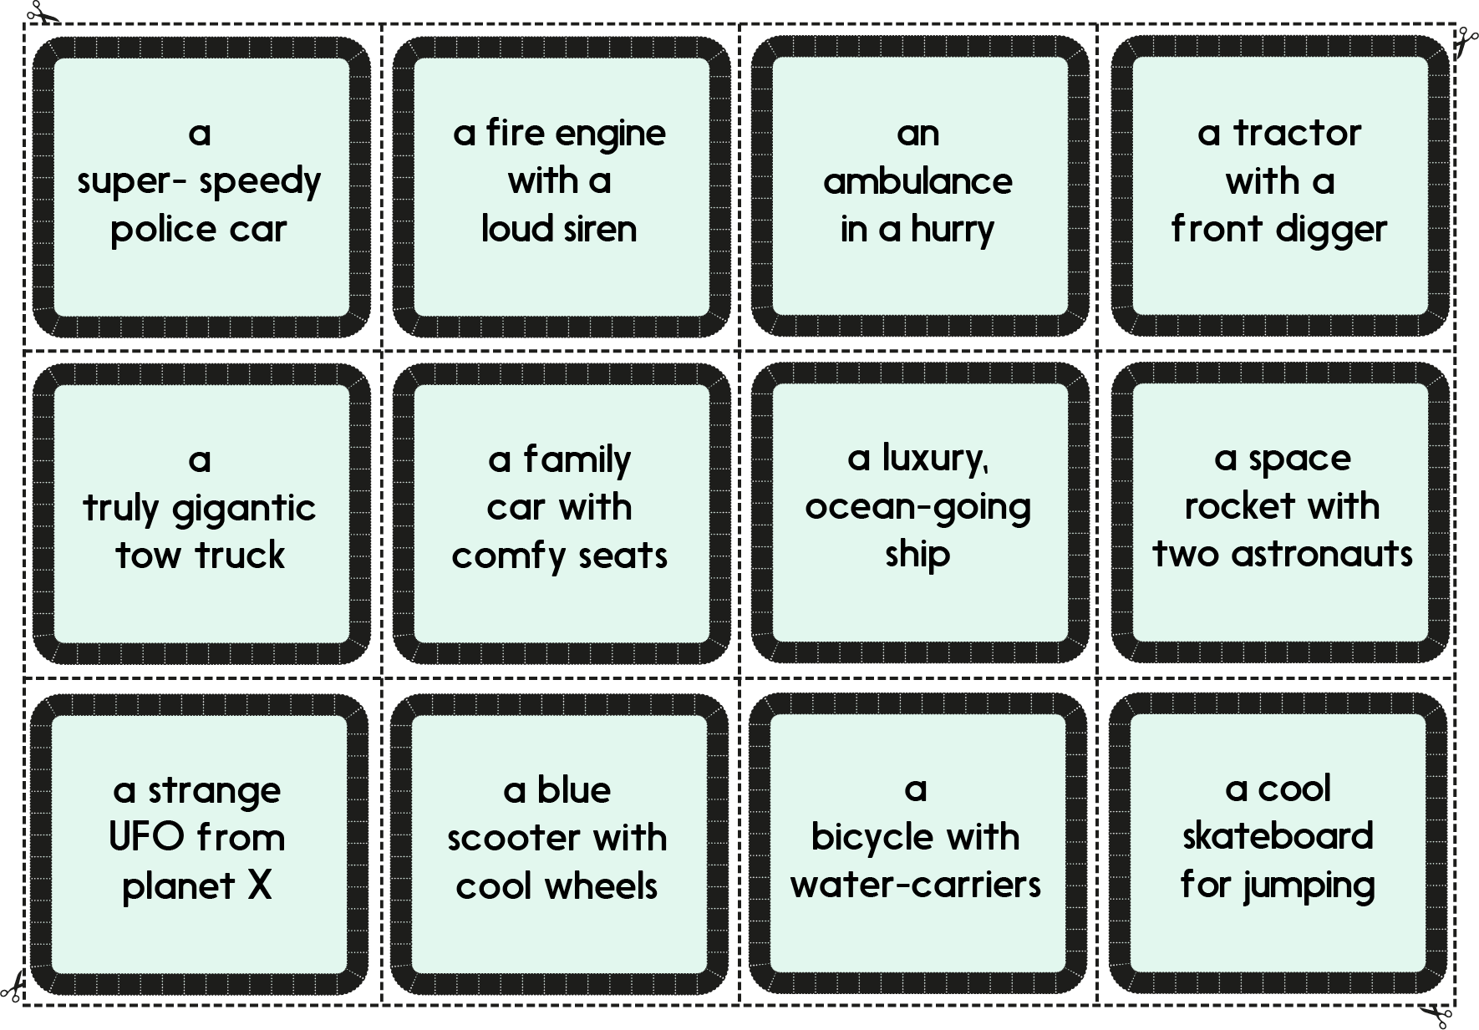
How to Play Pairs
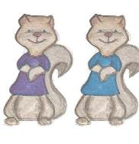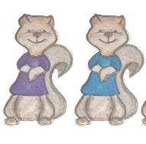

With a partner

- Shuffle together the 12 picture cards and the 12 name cards.
- Lay them out face up in a grid on the table or carpet.
- Have a really good look at all the cards. Try and remember where each one is.
- Turn all the cards over so that you can’t see any pictures or read any names.
- The first player turns over any two cards they like. If you turn over a pair that match (a picture card and a name card) keep that pair and have another go.
- If you don’t turn over a pair, carefully turn the two cards back face down and let the next person have a go.
- Try really hard to remember which cards you have seen and where they are so that you can use them in your next go.
- The winner is the person with the most pairs when all the cards have gone.
- Have another go but this time shuffle the cards and lay them face down straight away so that you don’t see where each card is to start with.

On your own

- Shuffle together the 12 picture cards and the 12 name cards.
- Lay them out face up in a grid on the table or carpet.
- Have a really good look at all the cards. Try and remember where each one is.
- Turn all the cards over so that you can’t see any pictures or read any names.
- Press go on a timer or stopwatch.
- Turn over any two cards. Are they a matching pair (a picture card and a name card)? If they are, put the cards aside and turn over another two cards.
- Keep turning over two cards at a time until you have found all the pairs.
- Stop the timer or stopwatch. How long did it take you?
- Have another go but this time shuffle the cards and lay them face down straight away so that you don’t see where each card is to start with.

Instructions for making your own set of Pairs cards

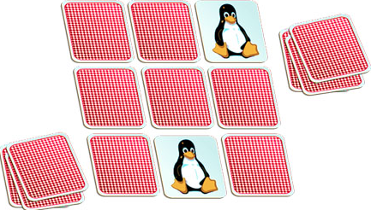

You are going to make cards for your own game of Pairs.

What to do:

- Think of a topic or category where you know lots of different examples of the thing in question. Animals, fruits, colours, items of clothing or things like Disney characters are good, because there are lots of different ones of each and they are quite easy to draw.

- Print off and carefully cut out the blank Pairs cards.

- Draw 12 different examples from your category or topic on the blank cards. So, if you chose fruit as a topic you could draw cards for an apple, an orange, a lemon, a pear, a grapefruit, a kiwi, a strawberry, and so on.

- For the name cards use two adjectives (describing words) for your item – A juicy, red strawberry; A long, thin banana; A sweet, crunchy apple. Use a comma between your two describing words.

- Check your spellings. Use your best handwriting. Use an initial capital letter for the A or An.

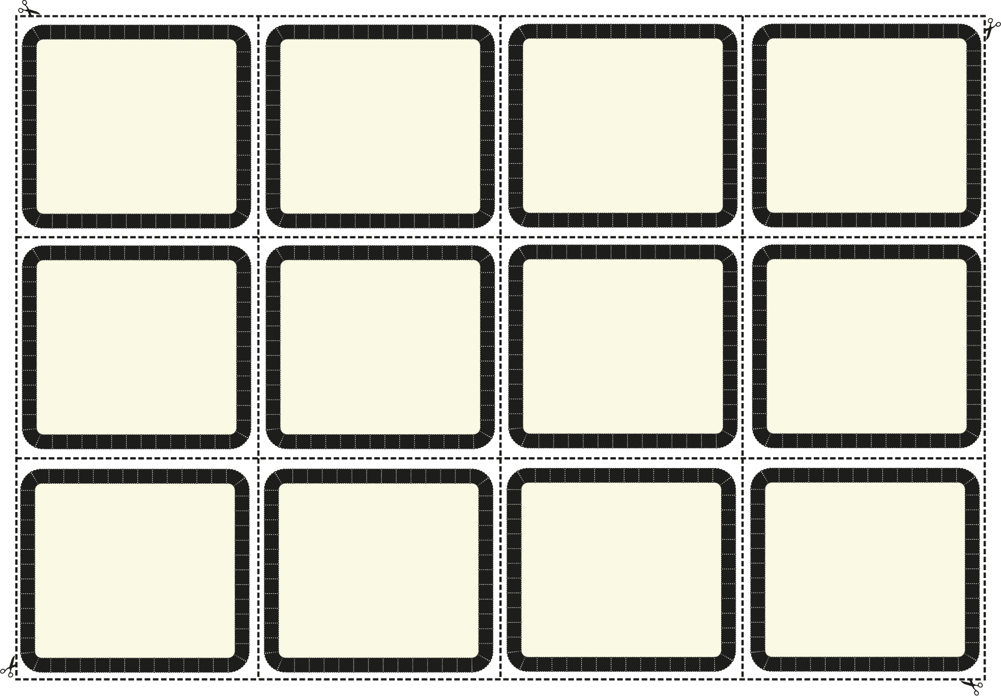

The bookplate from This Book Just Ate My Dog

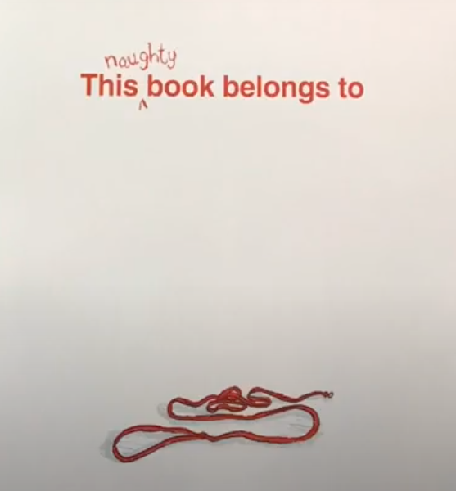

Bookplate design

___________________________________
___________________________________
___________________________________

