Pope Paul Primary School Home learning
Week beginning 6th July 2020
Dear Pope Paul children,
For this week, your afternoon learning features activities to celebrate the year you’ve had and to ease your transition to your new year group in September. Each day, there is an activity for KS1 and KS2 that focuses on a different aspect of the transition process.
From
 | HOPES AND WORRIES
EYFS and KS1 – Worry Monster | - Make a Worry Monster out of recyclable materials.  - The Worry Monster will eat/take/hold/have the worries.  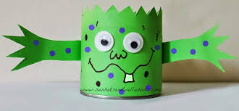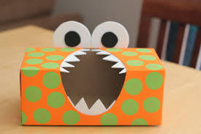
KS2 – Hope and Worries Box | - This can be a box for hopes, worries or both.  - Make the box using this template.  - Decorate the box.  - The box can store the hopes and/or worries.
Mrs Theo, Mrs Carey, Ms Davey, Miss Pringle, Miss Varga, Mrs McNamara, Mrs Lines and Miss Donatantonio.
 | REFLECTION OF THE YEAR
EYFS and KS1 – Postcard | - Draw a picture of what you have most enjoyed this year on the front.  - On the back, write about what you most enjoyed and why.  - Give the postcard to a friend as a reminder of what you have done and enjoyed this year.  - Template here.
KS2 – Letter | - Write a letter to a child in the year below.  - Tell them about what to expect, what to look forward to, year highlights, things they could do over the summer to prepare, any tips, etc.…  - Explore the ideas of reflection, memory and recall.
 | GOODBYE
All – Thank You Cards | - Make thank you cards for your teachers and parents.  - Reflect on what you particularly enjoyed and are your proudest moments from the year.  - Discuss the feelings of moving on and moving up.

 | HELLO
EYFS and KS1 – Letter | - Write a letter to your new teacher/teachers.  - Tell them all about yourself – your name, what you like to be called, age, birthday, favourite subjects, subjects you find tricky, hobbies, interests, pets, favourite colour, who you work well with, etc.…  - Write any questions you have for your new teacher/teachers.
KS2 – Postcard | - Write a postcard to your new teacher/teachers.  - Draw pictures that relate to you on the front.  - Write about yourself on the back – your name, what you like to be called, age, birthday, favourite subjects, subjects you find tricky, hobbies, interests, pets, favourite colour, who you work well with, who do not work well with, etc.…  - Write any questions you have for your new teacher/teachers.
 | LOOKING FORWARD
EYFS and KS1 – Poster | - Create a poster of your summer holiday plans.  - Things you would like to do in the summer and what you are looking forward to.
KS2 – Letter | - Write a letter to your future self.  - Include your hopes, dreams, aspirations and goals for the year ahead.  - Give the letter to your new teacher. These will be opened at the end of the academic year.

