What to do today
IMPORTANT Parent or Carer – Read this page with your child and check that you are happy with what they have to do and any weblinks or use of internet.

1. Read and learn a poem
- Read the poem Revenge. Read it three times so you are really familiar with the words.
- Now cover up the words. Can you say the poem using just the pictures at the bottom? If you can’t, look at the words and try again.

2. Remind yourself about poetry vocabulary
- Read Poetry Vocabulary.
- Now cut up the cards and turn them upside down. Play pairs, turning the cards and matching them.

3. Perform a poem
- Read Snow, Mrs Sprockett’s Strange Machine and The Moon.
- Choose your favourite of these three poems.
- Read Performance Questions. Think about your answers for your favourite poem and make notes about them.
- Practise performing your poem until you are really confident.

Well done. Show someone else your performance. What helps you to do it really well?

Try these Fun-Time Extras

Can you teach somebody else to memorise the poem, ‘Revenge’?
Can you carefully handwrite your favourite poem?

Revenge
My brother chased me with a crab,
He found it by a rock,
But now I will get my own back –
It’s now inside his sock!
Coral Rumble
P14, Off By Heart – Poems for YOU to remember
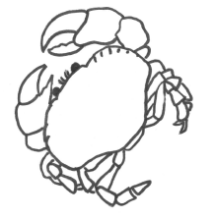 | 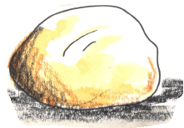 | 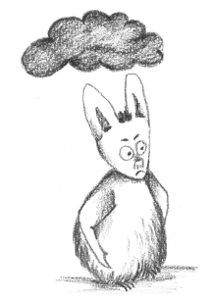 | 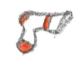

Poetry Glossary Cards
Print enlarged and cut up so that children can match terms and definitions.
Stanza | A group of lines that sit together in a poem. Sometimes referred to as a verse.
Line | A group of words that sit together in a single row.
Rhythm | The beat of the poem.
Rhyme | Words that have the same end sound, often found at the end of a line.
Alliteration | Using words that start with the same sound.
Onomatopoeia | Words that describe a sound by actually sounding like it.

Snow

White snow,
bright snow,
silent in the night snow.
Crystal petal
snowflakes settle.
Sparkle in the light snow.

Deep snow,
heaped snow,
leap about and sweep snow.
Snowmen, snowballs,
snowdrifts, snowfalls.
Hands and feet aglow snow.

Cold snow,
old snow,
melting as you hold snow.
Icy, slushy
dirty mushy
Time for you to go snow.

Jane Clarke
Mrs Sprockett’s Strange Machine

Mrs Sprockett has a strange machine
It will thrill you through and through
It's got wheels and springs and seven strings
And this is what they do.

Pull string number one... ...
it begins to hum mmmmmmmmmmmmm

Pull string number two...
...it goes COCK A DOODLE DOO.

Pull string number three...
...it will buzz like a bee zzzzzzzzzzzzzzzzzzzzzz

Pull string number four...
...it will start to ROAR.

Pull string number five...
...it will dip and dive.

Pull string number six...
...it will play silly tricks.

Pull string number seven...
...it will fly up to heaven.

Mrs Sprockett has a strange machine
It will thrill you through and through
It's got wheels and springs and seven strings
And... I WISH I HAD ONE TOO! Michaela Morgan

The Moon

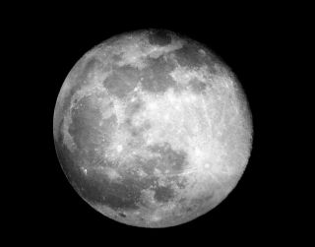

The moon has a face like the clock in the hall;
She shines on thieves on the garden wall,
On streets and fields and harbour quays,
And birdies asleep in the forks of the trees.

The squalling cat and the squeaking mouse,
The howling dog by the door of the house,
The bat that lies in bed at noon,
All love to be out by the light of the moon.

But all of the things that belong to the day
Cuddle to sleep to be out of her way;
And flowers and children close their eyes
Till up in the morning the sun shall arise.

Robert Louis Stevenson
Performance questions
Describe the rhythm. How does it help you when you read it aloud?
Look at the rhyme scheme. What is the pattern? How could it help you learn and perform the poem?
What is each stanza about? How could this help you memorise the poem?

How would you perform the poem – is it upbeat or more serious or sad?
Find some alliteration and onomatopoeia. Can you spot any other clever use of language that enhances the poem’s performance?

Which lines of the poem would you change the pace or volume in a performance? Why?

Handwriting

Carefully copy your favourite poem here.

