Holiday Learning
Home Learning Ideas | Weblink | Information
Summer Challenge  To support those looking for ways to educate and entertain children aged 5-11 and keep them active, we are making school curriculum-linked resources available for home learning, with no registration. | https://plprimarystars.com/resources/summer-challenge#m-resource-2480-link | See how many activities you can complete this summer! By clicking on the activity, it will take you to the relevant resource pack. | Print and colour this poster and stick it up on your wall. If you can't print the poster, download and save it to your computer. Click on the stars and footballs once you have completed the activity and see what happens!
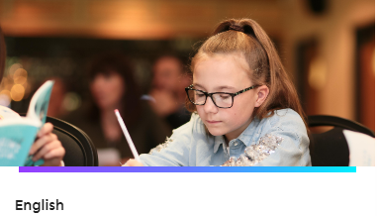 | https://plprimarystars.com/home-learning/english | A variety of English resources to do at home. Poetry, reading, spelling challenges | English
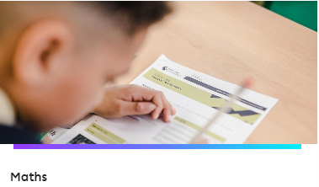 | https://plprimarystars.com/home-learning/maths | A variety of fun maths resources using the inspiration of the premier league. | Maths
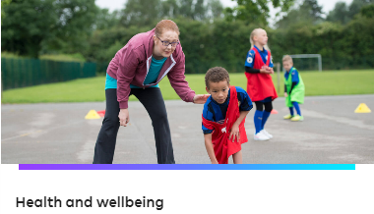 | https://plprimarystars.com/home-learning/health-wellbeing | The Premier League Primary Stars team has selected some resources to improve and support health and positive wellbeing while at home. | Health and Wellbeing

