Pope Paul Primary School Home learning
Week beginning 22nd June 2020
Dear Pope Paul children,
For this week, your afternoon learning will focus on computing. We have divided the activities into those that need a computer/tablet (plugged) and those that don’t require any electronic access (unplugged). Each day, try and complete at least one of the activities.
From
Mrs Carey, Ms Davey, Miss Pringle, Miss Varga, Mrs McNamara, Mrs Lines and Miss Donatantonio.
Plugged | Unplugged
Interland

Have a go at this adventure-packed online game that will remind you about how to treat others online.
https://beinternetawesome.withgoogle.com/en_us/interland/kind-kingdom
Get Coding  Visit https://scratch.mit.edu/projects/editor/?tutorial=all  and create an animation that explains the key rules about how you can stay safe online. Use this image as a guide to create your animation:  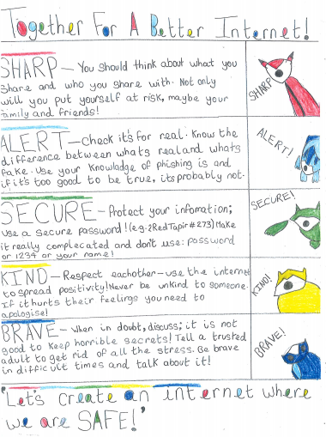  Parents/Carers PLEASE NOTE: There is no need to create a scratch account to complete this task. However, if you would like to save your child’s work then an account is needed. Please be advised that account holders are able to communicate with other scratch users. With this in mind, it is important to ensure that the proper guidance is given for the use of a scratch account if you chose to allow your child to create one. Please do not allow your child to use identifiable information in their username, posts or projects. | Pixel Art  You will need: squared paper, colouring pens/pencils  Choose an easily-identifiable image. Using the squares on the grid, make a picture by colouring in the squares.  How does the definition of the image change when you look at it up close compared to when you stand back?  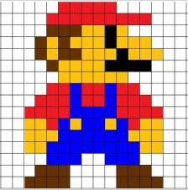  Did you know?  Computer screens are divided into a grid of thousands of tiny coloured squares, which are called pixels. The colour of each pixel can be set by a computer and they are used to display images on a computer screen.
Feed the Mouse

You will need: a deck of cards, a toy mouse, a few yummy treats

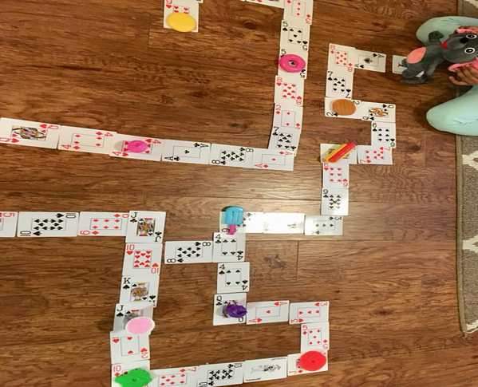
Design a path for the mouse using a deck of cards, and place some yummy treats for him throughout the path.
The objective of the game is to move the mouse through the path without missing any treats on its way.
One person acts as the Computer (who moves the mouse by listening to the programmer’s instructions ). Another person acts as the Programmer (who gives the commands). The Programmer gives verbal instructions like 'Move Forward' (state how many card spaces), 'Move Backward' (state how many card spaces), and 'Turn Right' or 'Turn Left' to guide the computer/mouse throughout the path, without missing any of the yummy treats.
The challenge level of the game can be increased by creating a more complex maze and putting obstacles in pathways that the mouse has to escape from or manoeuvre around.

Did you know?
A group of instructions written by the programmer to tell the computer what to do is called an algorithm.

Treasure Hunt

You will need: a small prize, lots of outdoor space

Somebody calls out a set of instructions that will lead to the ‘treasure’. These can be as basic or as creative as you like, eg.
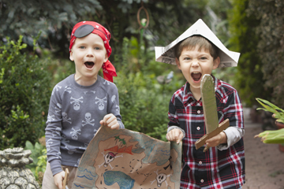
- Take 10 steps forward
- Bunny hop 5 hops to the left
- Take 7 skips forward
- Roly-poly twice to the right
You can also use landmarks in your directions, eg. “Bunny hop forward until you reach the wheelie bin; skip LEFT until you reach the tree stump”.

Another person works through the sequence all the way to find the ‘treasure’.

As an extra challenge, can the person who found the treasure then describe the steps they are taking to get back to the starting point?

Did you know?
In computer programming, the coder has to break down each step of the task, or it won’t be followed correctly. This is called decomposition.

Necklace Designer

Design your necklace using charms in repeated patterns.
Write down the complete design in words. How many words did you use?
Now create a name for the repeated pattern.
Write out the design again using the pattern name.
How many words did you use?
Finally, write the complete design using ‘repeat,’ the name of the sequence and a number.

Write Your Name in Binary

Below is an ASCII table; it shows us how letters are represented in binary.
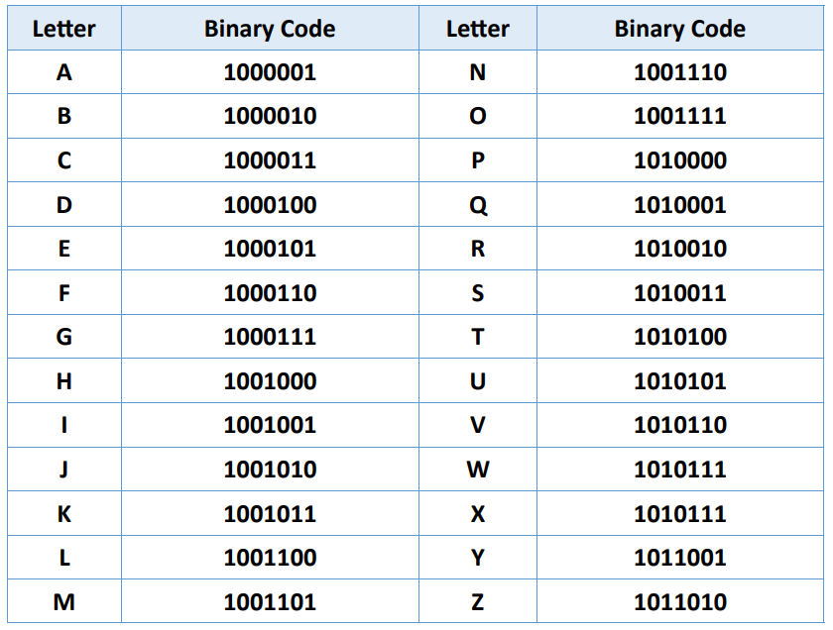
Can you write your name or initials in binary?

Did you know?
Binary is the language that computers use. It is a series of 1s and 0s.
Inside my Mobile
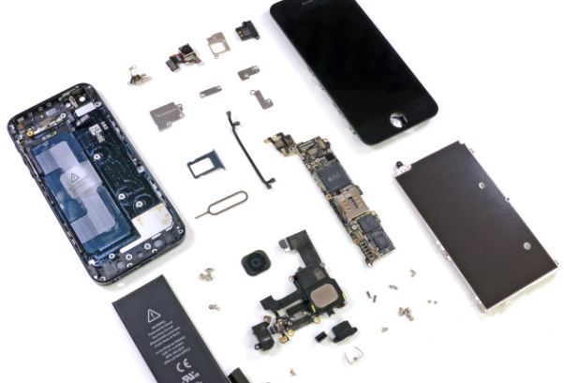

Ever wondered how mobile phones work? Here you can find out what is inside a mobile phone by building your own paper one and placing the components inside.

