Spelling | To continue...  Please ask someone to test you on these spelling words, print a copy of the image (if possible) and colour in those words that you can spell correctly. Revise the words that you make mistakes on - focusing on 6 at a time so that it is managable. Repeat this for the rst of this week and next week. You can find this sheet at  https://www.twinkl.co.uk/resource/t-l-647-year-3-and-4-common-exception-words-colouring-fish-activity-sheet-  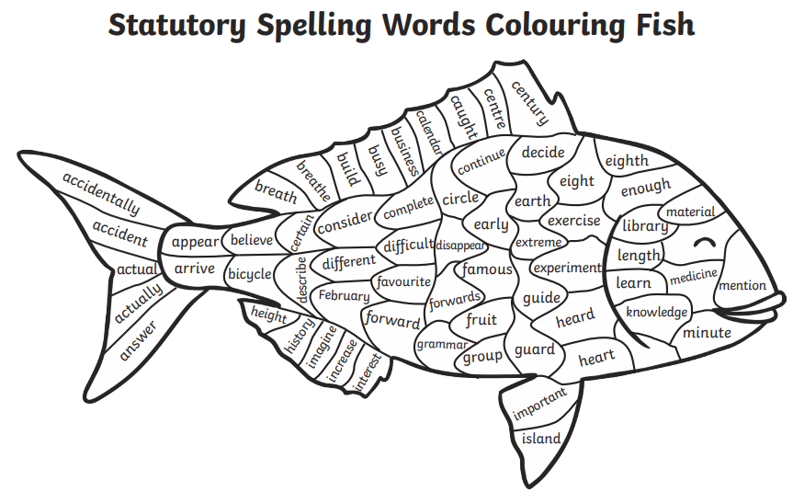
English | Please complete the SPAG.com activities set.
Maths | Please complete the Mathletics activities set.
Reading | Read for at least 15 minutes and record this in your record.
Transition activity  Postcards | - Write a postcard to your new teacher/teachers.  - Draw pictures that relate to you on the front.  - Write about yourself on the back – your name, what you like to be called, age, birthday, favourite subjects, subjects you find tricky, hobbies, interests, pets, favourite colour, who you work well with, who do not work well with, etc.…  - Write any questions you have for your new teacher/teachers.

