Spelling | Please ask someone to test you on these spelling words, print a copy of the image (if possible) and colour in those words that you can spell correctly. Revise the words that you make mistakes on - focusing on 6 at a time so that it is managable. Repeat this for the rst of this week and next week. You can find this sheet at  https://www.twinkl.co.uk/resource/t-l-647-year-3-and-4-common-exception-words-colouring-fish-activity-sheet-  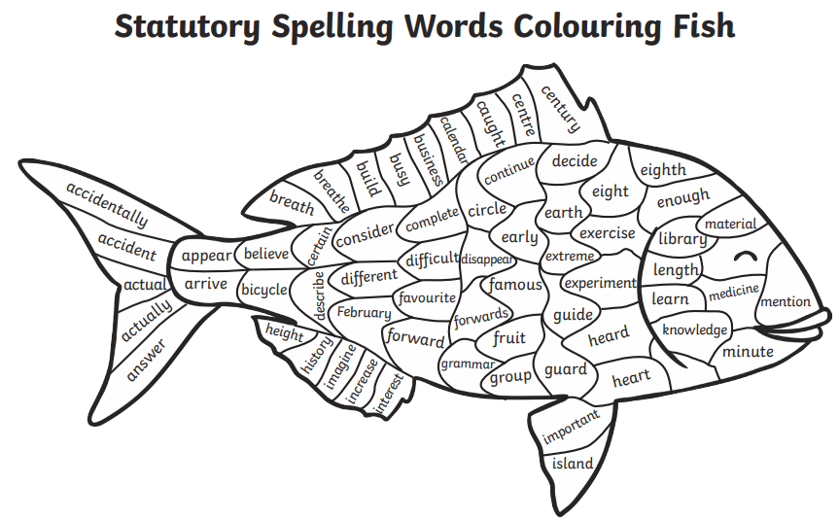
English | Paint or sketch a detailed picture of your favourite setting of a story and write a descriptive paragraph about it.
Maths | Complete and complete these money word problems and remember to show your working out.  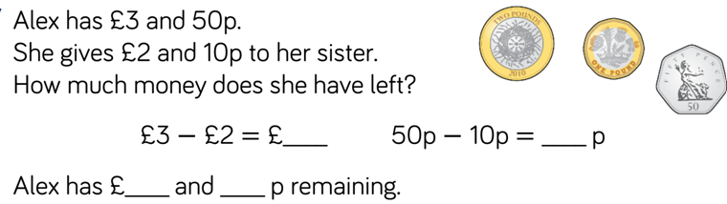  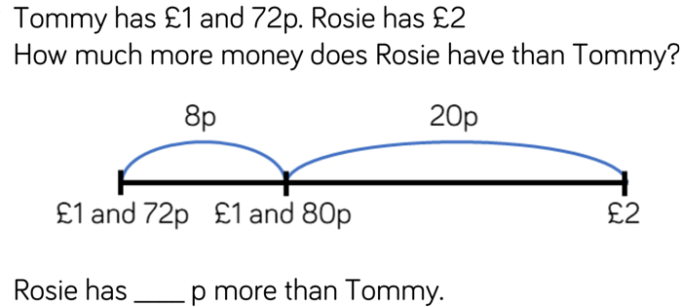  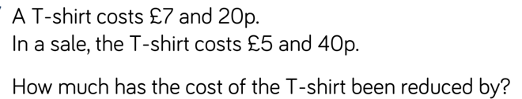
Reading | Read for at least 15 minutes , record this in your record.
Music | Explore these music lessons and make a poster explaining what you have learnt.  https://www.bbc.co.uk/bitesize/subjects/zwxhfg8

