Spelling | To continue...  Please ask someone to test you on these spelling words, print a copy of the image (if possible) and colour in those words that you can spell correctly. Revise the words that you make mistakes on - focusing on 6 at a time so that it is managable. Repeat this for the rst of this week and next week. You can find this sheet at  https://www.twinkl.co.uk/resource/t-l-647-year-3-and-4-common-exception-words-colouring-fish-activity-sheet-  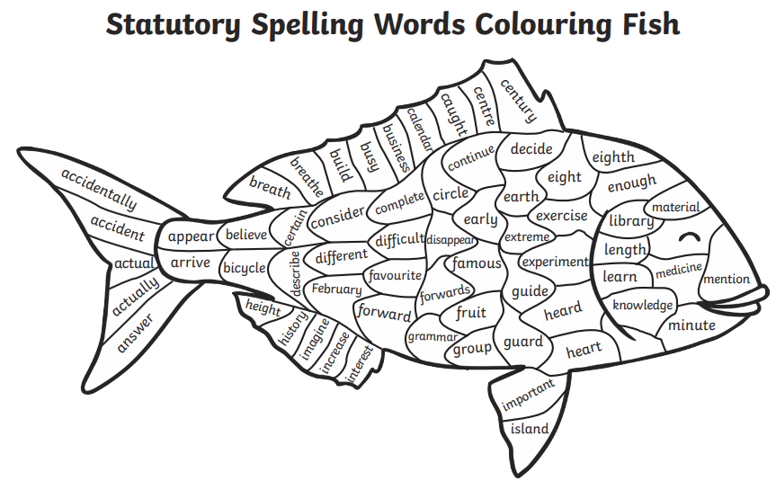
English | Please complete the SPAG.com activities set.
Maths | Please complete the Mathletics activities set.
Reading | Read for at least 15 minutes and record this in your record.
Transition activity  Looking forward letter | - Write a letter to your future self.  - Include your hopes, dreams, aspirations and goals for the year ahead.  - Give the letter to your new teacher. These will be opened at the end of the academic year.

