What to do today
Dear Year 5,
You will use your word classifications today to make vivid descriptions of your chosen creature. Use a thesaurus to help you.
Mrs Lines

1. Read a poem
- Read Long, Lone. Read the poem twice, once in your head and once out loud.
- What do you like about this poem? Is there anything that you dislike about it? What patterns can you find? What puzzles and questions does it leave?

2. Remind yourself about word classes
- Use the Revision Cards 1 and 2 to remind yourself about word classes.
- Write about the sea-creature that you chose to research on Day 4. Complete the Description Builder and then use your ideas to write sentences about the sea-creature.

3. Write some ideas for a poem
- Read Example. Try re-writing Long, Lone with new words from the same word-classes. Write on Your Ideas.
- Now choose whether to copy out a verse of Long, Lone in your best handwriting or to copy out your own new poem.

Try these Fun-Time Extras
- Make an illustration for Long, Lone or for your new poem.
- Practise reading Long, Lone or your new poem and film and share your reading with somebody else.

Long, Lone

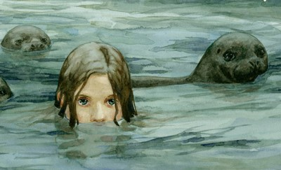

Long, long, long and lone
is the selkie’s song when the storm winds moan,
is the sigh of the sea as it rubs the stone,
is the word of the sea that lives in the bone.

Long and lone is the gliding flight
of the albatross in the dawn’s grey light
on its wide white wings where the winds blow high
over the waves where the sea-ghosts cry.

Long and lone is the sea I find
that sighs on the shore at the edge of my mind;
long, long, long and lone
Is the word of the sea that lives in the bone.

Russell Hoban

From My First Oxford Book of Poems compiled by John Foster
Revision Card 1 – Word Classes

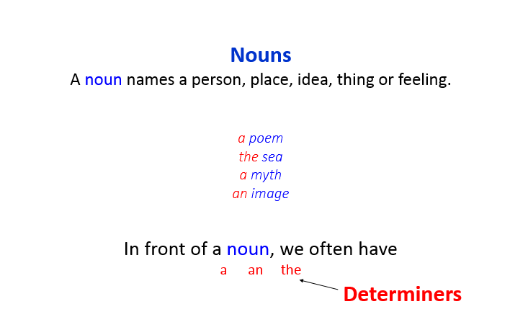 | 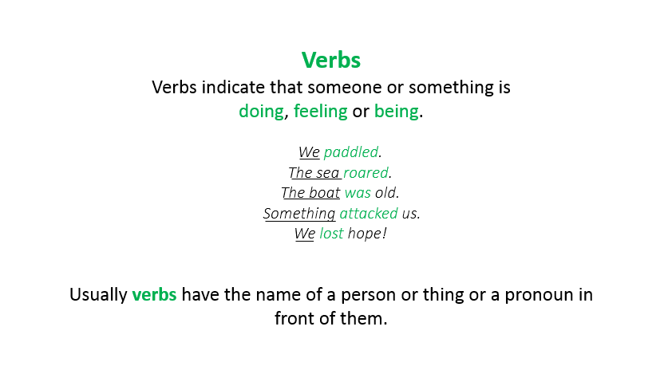
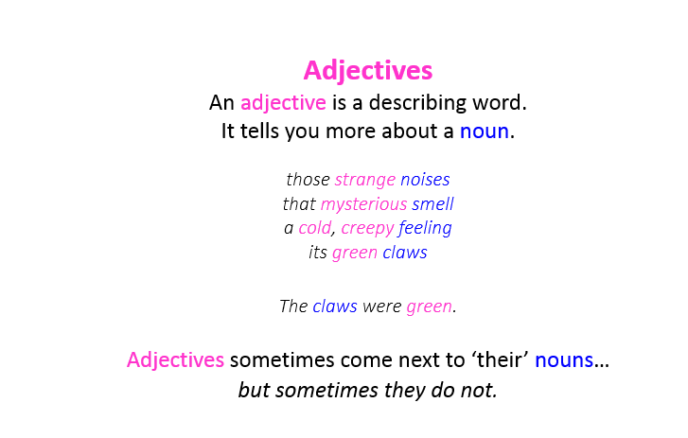 | 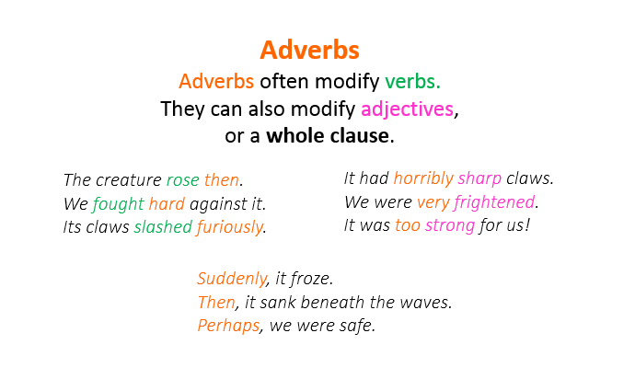

Revision Card 2 – Word Classes

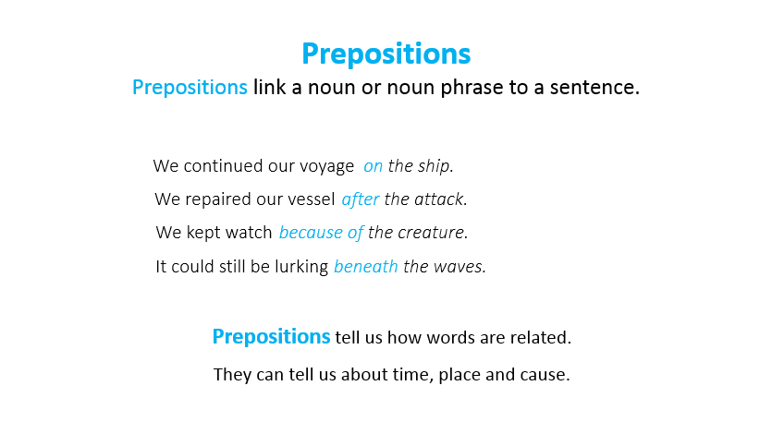 | 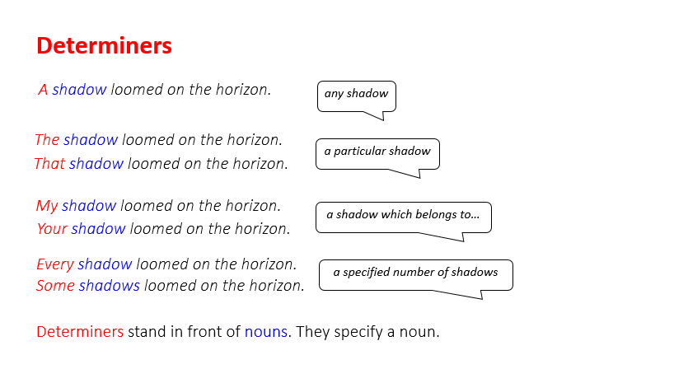
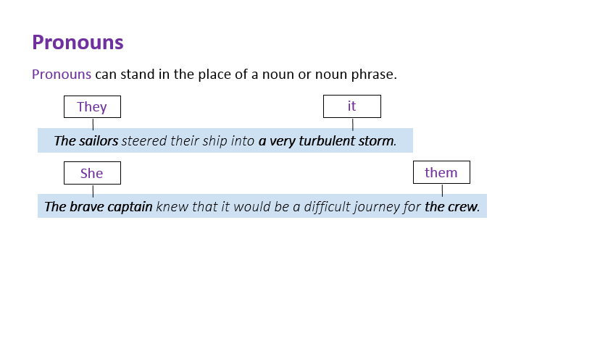 | 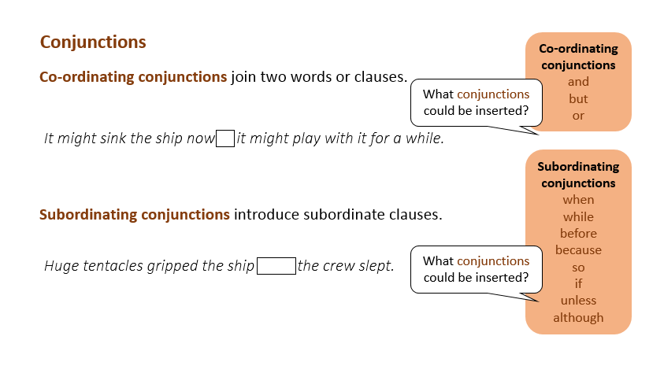

Description Builder

Build descriptions using the word classes in the table

Determiner | Noun | Verb | Adverbs | Adjective | Preposition | Adjective | Noun
many  these | dragons  creatures | are  swim | rather  fast | ferocious  ͞ | with  like | sharp  scaly | teeth  bullets

Once you have collected some good ideas, write some sentences describing your sea creature from Day 4. Use pronouns to avoid repeating nouns and conjunctions to link some of your clauses.

Example
The subject and mood of the poem has been changed by swapping words for new ones of the same class.

Sharp, Light
Sharp, sharp, sharp and light
are the serpent’s eyes when the hard hunger bites,
is the gnash of the teeth as they display the might,
is the point of the tongue that flicks in the night.

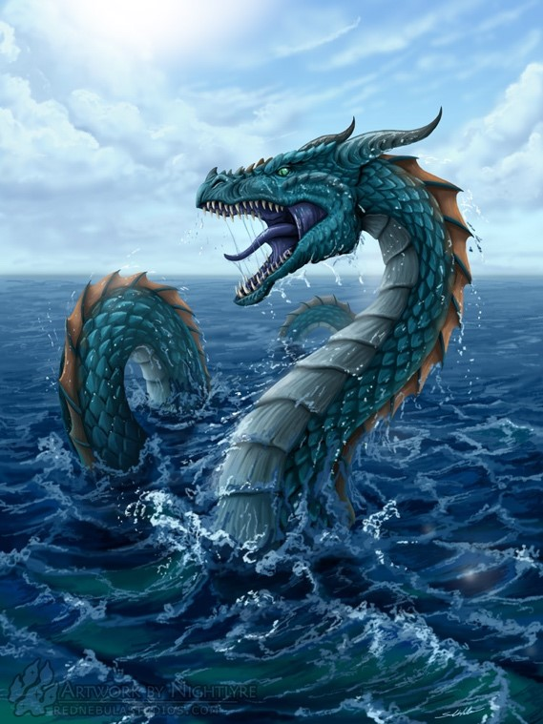

Your Ideas
Change the mood or subject of the poem by swapping words for new ones of the same class. Write your ideas on this sheet.

Long, Lone
Long, long, long and lone
is the selkie’s song when the storm winds moan,
is the sigh of the sea as it rubs the stone,
is the word of the sea that lives in the bone.

Long and lone is the gliding flight
of the albatross in the dawn’s grey light
on its wide white wings where the winds blow high
over the waves where the sea-ghosts cry.

Long and lone is the sea I find
that sighs on the shore at the edge of my mind;
long, long, long and lone
Is the word of the sea that lives in the bone.

Poem
Either copy out your new poem, or copy your favourite verse of Long, Lone. Use your very best handwriting.

