What to do today
Dear Year 5,
In order to retell the story of the promise, you will be using a lot of cohesive language. Remember that your listener may not have heard the story at all and you need to make sure you are clear.
Mrs Lines

1. Read a profile
- Read Black Redstart. What are the five most important facts in this report? Write a sentence to summarise each one in your own words. (Check the Answers at the end.)
- How does this article fit with the story, ‘The Promise’?

2. Tell the story of The Promise
- Fill in Story Structure with some notes to tell the story of The Promise.
- Practise using these to tell the story. Try to include some Story-Telling Language and use some of the memorable phrases from Day 1.
- Practise until you are really fluent with your story-telling.

Well done! Now tell the story to somebody else.

3. Summarise the story.
- Look at the Endpapers. These are the pictures at the start and the end of the book.
- Write 3-5 sentences about each of these pictures, that will summarise how the world was and how it became.

Try these Fun-Time Extras
- Find out more about the writer, Nicola Davies. Her website is
https://www.nicola-davies.com/
- Find out more about the illustrator, Laura Carlin. Her website is
http://www.lauracarlin.com/
- Find out more about Black Redstarts

Black Redstart
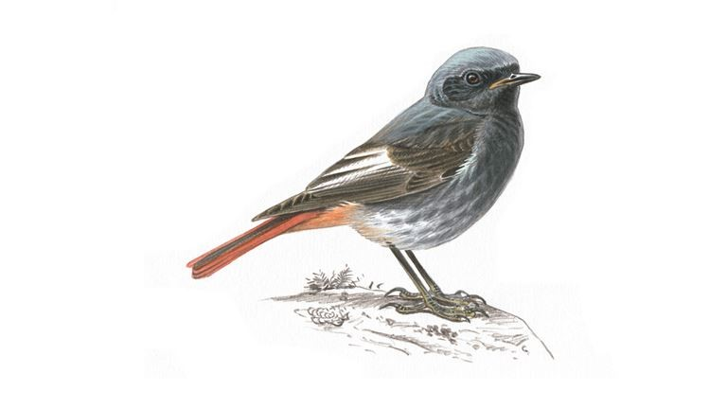
The middle of London’s West End doesn’t seem like the likeliest location for one of the UK’s rarest birds. There are only an estimated 20-40 breeding pairs of black redstarts in the country. But in recent years, without being artificially introduced into the area, this rare bird has started to make a home in this crowded part of Central London.

The black redstart isn’t the only unexpected species of wildlife to start living in urban landscapes. Moths, butterflies, woodpeckers and even serotine bats, more commonly found in rural pastures, have also been on the rise in this part of London.

You don’t have to completely redesign a city’s layout to achieve this, says Emily Woodason, an architect. Sometimes creating pockets of greenery at sufficiently regular intervals is enough to tempt wildlife back into an area. The Wild West End project, involving six of London’s largest landowners, is seeking to create small patches of green space.

“It’s an ambitious objective,” says Woodason. “Ultimately the aim is to create a green corridor between London’s parks.”

As well as planning more green areas, many of the landowners are choosing to fit existing buildings with green walls or roofs. So far, it appears to be working. Several unexpected species have returned to the area, including the black redstart.

“Rock piles and log piles have been created, which are great at attracting different insects and allow more natural colonisation of species over time,” says Woodason. “Those conditions are perfect for this type of bird.”

Adapted from http://www.bbc.com/future/story/20190118-how-do-you-bring-wildlife-back-to-the-city

Story Structure

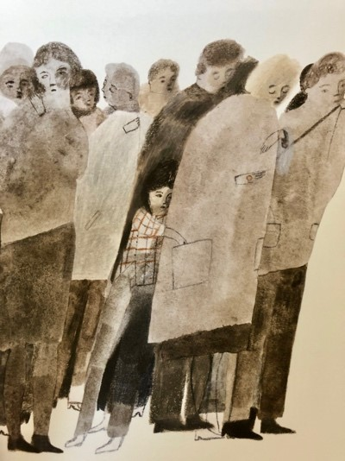 | 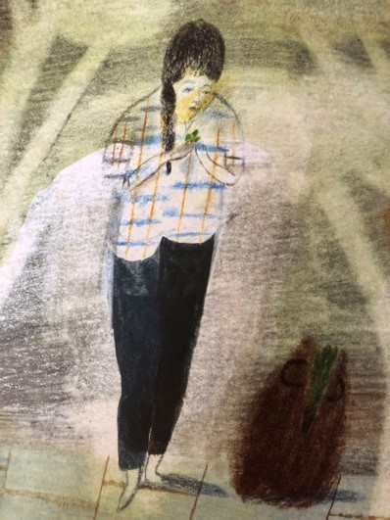 | 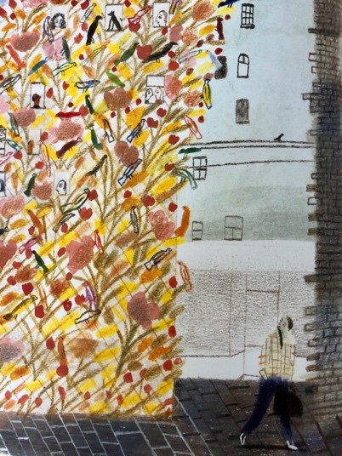 | 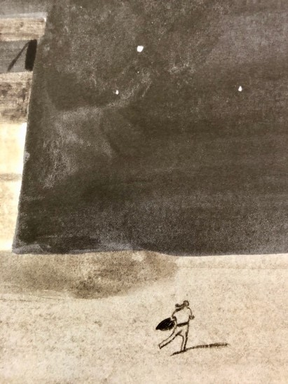
Normal Life | The Discovery | The Journey | What happens next
Story-Telling language

At first…
In the beginning…
One day…

Next…
Soon after…
Suddenly…

Subsequently…
Then…
Very quickly…
Finally…
In the end…

However…
Later on…
After a while…
After that…

End Papers

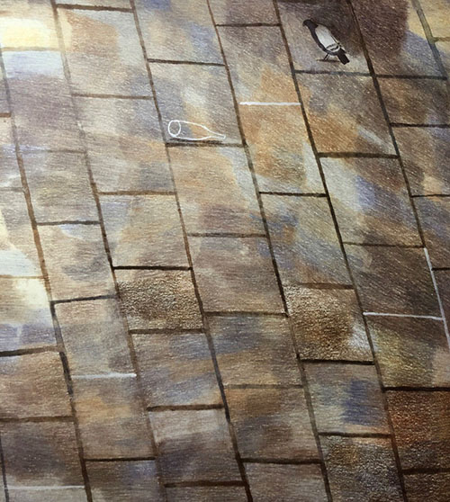 | 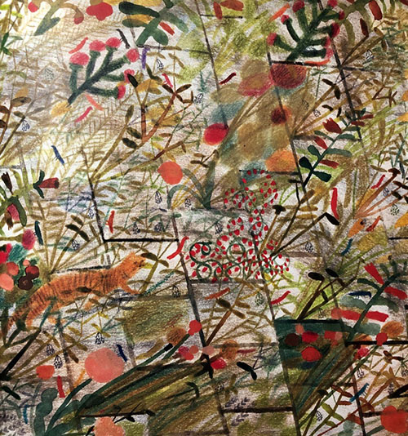

from The Promise by Laura Carlin
Endpapers Writing

Write 3-5 Sentences about each of the pictures that will summarise how the world was and how it became.

Black Redstart – Five Facts – Answers

Suggested facts can be drawn from….

- One of the UK’s rarest birds with only 20 – 40 breeding pairs.
- Redstarts are coming to live in the West End of London.
- Other rural creatures are also returning to inhabit central London.
- Creating pockets of greenery at regular intervals is enough to tempt wildlife back.
- Wild West End Project involves six of London’s largest landowners and is creating wild life spaces.
- The aim is to create a green corridor between London’s parks.
- Many landowners fit existing buildings with green walls or roofs.
- Several unexpected species, including the Black Redstart, have returned to the area.

Answers must be complete sentences with correct punctuation.

