What to do today Year 5
Dear Year 5,
Today you will need to think about your own response to this text. To engage in a story this way is a really important part of being a reader. I hope you enjoy it.
Mrs Lines

1. Listen to a story
- Listen to Nicola Davies read her book: The Promise
https://vimeo.com/73026206
- What did you notice about the story and how she read it? Was it as you expected?

2. Answer questions about the story
- Read and think about The Promise – Questions.
- Write your answers in clear sentences.

Well done! Now show a grown-up the answers that you have written. Choose three answers to explain to them in detail.

3. Practise reading the story out loud
- Read Performance Reading Techniques.
- Practise reading the Opening of the story using some of these techniques.
- Challenge yourself to read Further Extract this way as well.
- Share your performance with someone else and ask them to feedback good points using the Feedback Sheet.

Try this Fun-Time Extra
- Record your performance and share it with somebody else.

The Promise – Questions

- How did the story make you feel? Can you explain why?
- What does the story make you think about?
- What has happened to you that is most like this story?
- How is the main character changed in the story?
- What changes does the main character cause?
- In what ways is this story realistic?
- In what ways is this story imaginary?
- What lessons could someone learn from this story?
Can you think of five different ideas?

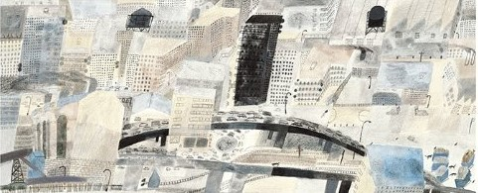
The Promise – Answers

Write your answers in clear sentences.

Performance Reading Techniques

Movement
Make movements, actions or gestures to match words.

Voice quality
Make voice expressive: light and dark. Express emotions and reactions.

Pitch
Vary the musical note of your voice – high or low.

Power
Use volume or force to express meanings. Sometimes gradually build or decrease power through a sentence.

Tempo/Rhythm
Control the speed and the beat of your reading.

Sound effects
Add some sound effects to the words.

Opening

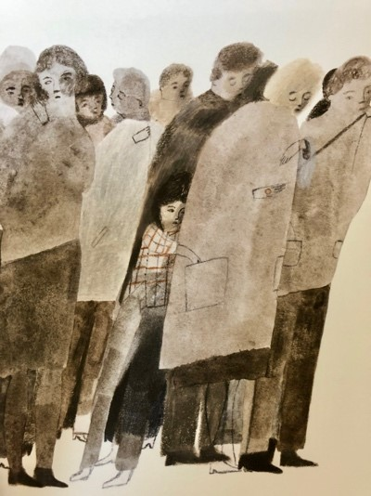

When I was young, I lived in a city that was mean and hard and ugly. Its streets were dry as dust, cracked by heat and cold,
and never blessed with rain.

A gritty, yellow wind blew constantly, scratching around the building like a hungry dog.

Nothing grew. Everything was broken. No one ever smiled.
The people had grown as mean and hard and ugly as their city, and I was mean and hard and ugly too.

I lived by stealing from those who had almost as little as I did.
My heart was as shrivelled as the dead trees in the park.

from The Promise by Nicola Davies
Further extract

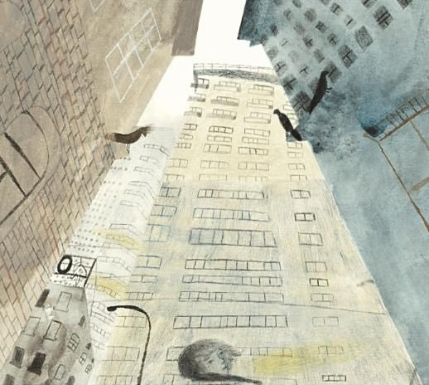

And then, one night,
I met an old lady down a dark street.
She was frail and alone, an easy victim.
Her bag was fat and full,
but when I tried to snatch it from her,
she held on with the strength of heroes.

To and fro we pulled that bag until at last she said,
“If you promise to plant them, I’ll let go.”

What did she mean? I didn’t know or care,
I just wanted the bag, so I said,
“All right, I promise.”
She loosened her grip at once and smiled at me.

I ran off without a backward look,
thinking of the food and money in her bag.

from The Promise by Nicola Davies
Feedback Sheet

Movement
How well did I make movements, actions or gestures to match words?

Voice quality
How did I make my voice expressive: light and dark. Did I express emotions and reactions?

Pitch
Did I vary the musical note of my voice – high or low?

Power
Did I use volume or force to express meanings?

Tempo/Rhythm
Did I control the speed and the beat of my reading?

Sound effects
How well did I add some sound effects to the words?

