What to do today
Hello, Year 5. Today you will think of an addition scene for Old Deuteronomy. I look forward to hearing what you come up with.
Mrs Lines

1. Read the third verse of the poem
- Read Old Deuteronomy – Third Verse.
- Answer Third Verse Questions.

2. Compare performances of the poem
- Listen to and watch two versions of the poem. One is the poet reading the poem himself, one is from a musical based on the poem.
https://www.youtube.com/watch?v=zYiPsc6cAYM
https://www.youtube.com/watch?v=8qZcl6nEsRg
- Write Notes about what you notice about each performance. What do you like about them? Is there anything that you dislike? Which parts of the poem do they help you to notice?

3. Now for some writing
- Read Writing Brief. Imagine a fourth scene for Old Deuteronomy. Where might he sleep? What problems could he cause there? What will the villagers do?
- Write about your fourth scene carefully using relative clauses in some of your sentences. Use the Relative Pronoun List to help you.

Well done! Share your writing with a grown-up. Show them the features that you have included.

Try the Fun-Time Extras
- Make an illustration to match your new scene.
- Act out your scene.
- Find out about some of T.S. Eliot’s other poems about cats.

Old Deuteronomy – Third Verse

Old Deuteronomy lies on the floor
Of the Fox and French Horn for his afternoon sleep;
And when the men say: "There's just time for one more,"
Then the landlady from her back parlour will peep
And say: "Now then, out you go, by the back door,
For Old Deuteronomy mustn't be woken -
I'll have the police if there's any uproar" -
And out they all shuffle, without a word spoken.
The digestive repose of that feline's gastronomy
Must never be broken, whatever befall:
And the Oldest Inhabitant croaks: "Well, of all . . .
Things. . . Can it be . . . really! . . . No!. . . Yes!. . .
Ho! Hi!
Oh, my eye!
My legs may be tottery, I must go slow
And be careful of Old Deuteronomy!"
by T.S. Eliot
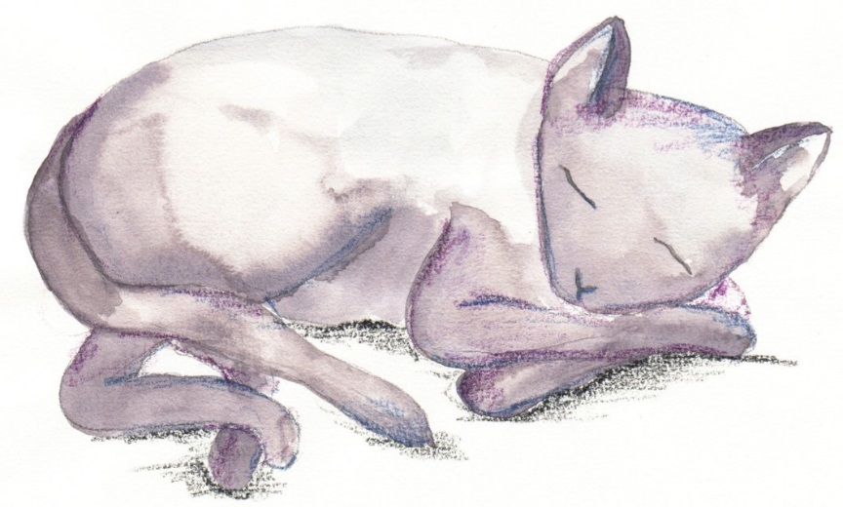
Third Verse Questions

- Where does Old Deuteronomy sleep this time?

- What does the landlady do when he falls asleep in her pub?

- What do you think ‘digestive repose’ might mean?

- How does this verse fit the pattern of the other two verses?
Notes
T.S. Eliot reading
Cats the Musical

Writing Brief

Think of a fourth scene for Old Deuteronomy. Think about:

- Where he falls asleep
- Why this is comfortable for him
- Why this is inconvenient to others
- What people do to prevent him from being disturbed
- What ailment the Oldest Inhabitant feels this time

Write sentences to describe your scenario. Include:

- Relative pronouns, introducing relative clauses.
- Embedded relative clauses

Remember to use commas to keep the meaning clear.

Relative Pronouns List

who

which

where

when

whose

that

Where Old Deuteronomy slept next
Think of another place for Old Deuteronomy to sleep. What problems will he cause? What will the villagers do? What will the oldest inhabitant say?

Third Verse - ANSWERS

- Where does Old Deuteronomy sleep this time?
In a pub called ‘The Fox and French Horn’

- What does the landlady do when he falls asleep in her pub?
She makes sure he is undisturbed. She sends customers away.

- What do you think ‘digestive repose’ might mean?
It means a rest after a meal to help the body to digest the meal.

- How does this verse fit the pattern of the other two verses?

The rhyme pattern is the same. The cat sleeps in a place which he finds comfortable but which is inconvenient to others. The villagers don’t disturb him. The oldest villager says almost the same thing again.

