What to do today
Dear Year 5. Today the lesson focuses on relative clauses. We have already done these in class and so should be familiar.
Mrs Lines

1. Read part of a poem
- Read the first two verses of Old Deuteronomy by TS Eliot. Even though some of the words are tricky, can you work out what is happening?
- Answer Old Deuteronomy Questions.
- Watch a reading of the poem. Does it sound like you expected?
https://www.youtube.com/watch?v=2b1Wsy3XfA0

2. Revise Relative Clauses
- Use the PowerPoint: Relative Clauses to hear the teaching or, if that isn’t possible, remind yourself using the Revision Card.
- Complete Relative Clause 1.
- Challenge yourself to complete Relative Clause 2.

3. Now for some writing
- Look closely at the illustration of Old Deuteronomy on market day.
- Use the Relative Pronouns List and write some sentences with relative clauses about what you can see in the illustration.

Well done! Share your writing with a grown-up. Show them the illustration. Point out the relative pronouns that you have used in your writing.

Try the Fun-Time Extras
- Can you create an illustration to go with the first verse of the poem?
- Can you practise reading the poem out loud? You could even try to learn one of the verses off by heart.

Old Deuteronomy – First Verse

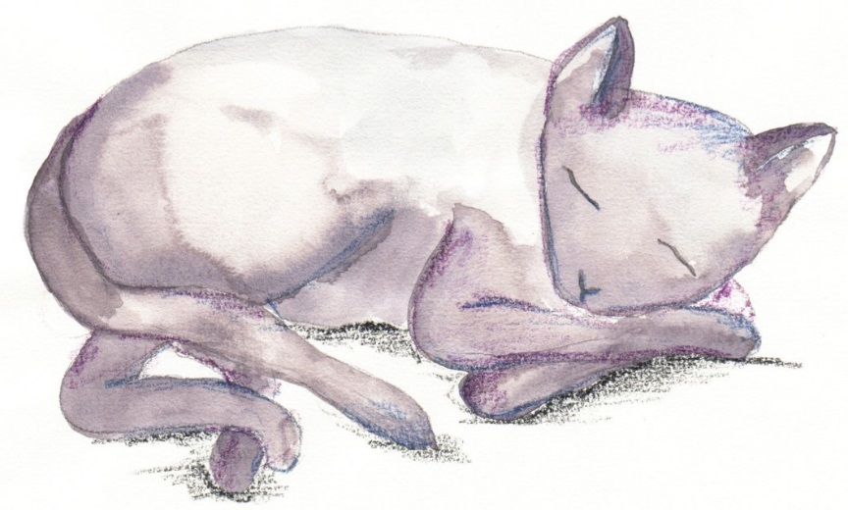

Old Deuteronomy's lived a long time;
He's a Cat who has lived many lives in succession.
He was famous in proverb and famous in rhyme
A long while before Queen Victoria's accession.
Old Deuteronomy's buried nine wives
And more - I am tempted to say, ninety-nine;
And his numerous progeny prospers and thrives
And the village is proud of him in his decline.
At the sight of that placid and bland physiognomy,
When he sits in the sun on the vicarage wall,
The Oldest Inhabitant croaks: "Well, of all . . .
Things. . . Can it be . . . really! . . . No!. . . Yes!. . .
Ho! Hi!
Oh, my eye!
My sight may be failing, but yet I confess
I believe it is Old Deuteronomy!"
by T.S. Eliot

Old Deuteronomy – Second Verse
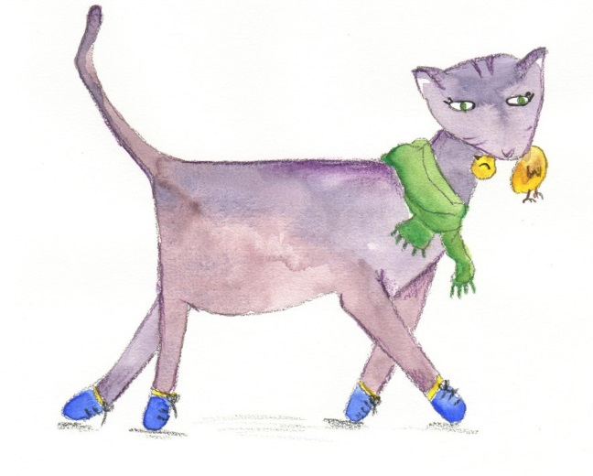

Old Deuteronomy sits in the street,
He sits in the High Street on market day;
The bullocks may bellow, the sheep they may bleat,
But the dogs and the herdsmen will turn them away.
The cars and the lorries run over the kerb,
And the villagers put up a notice: ROAD CLOSED -
So that nothing untoward may chance to disturb
Deuteronomy's rest when he feels so disposed
Or when he's engaged in domestic economy:
And the Oldest Inhabitant croaks: "Well, of all . . .
Things. . . Can it be . . . really! . . . No!. . . Yes!. . .
Ho! Hi!
Oh, my eye!
I’m deaf of an ear now but yet I can guess
That the cause of the trouble is Old Deuteronomy!"
by T.S. Eliot
Old Deuteronomy Questions

- What phrases tell you that Old Deuteronomy is an old cat?

- What do the people of the village feel about this very old cat?

- What does the oldest person in the village say when they see Old Deuteronomy?

- Where does the cat sit on market day?

- What do the villagers do?
Revision Card – Relative Clauses

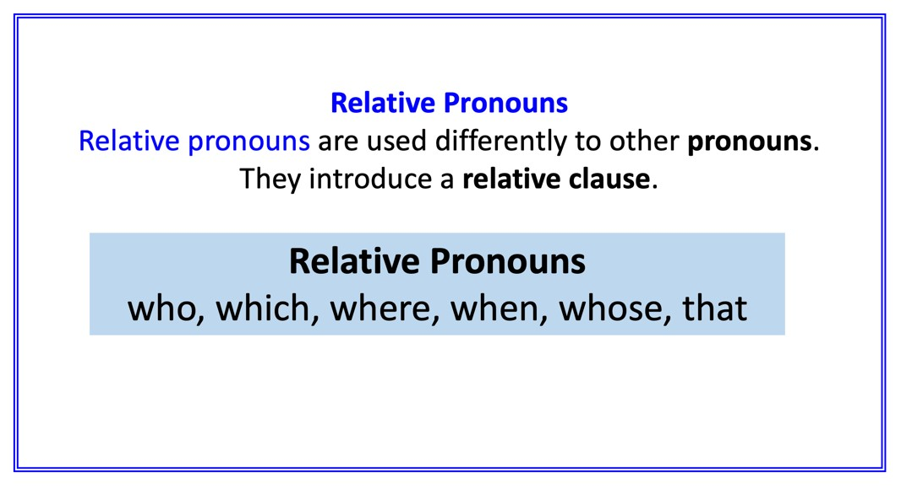
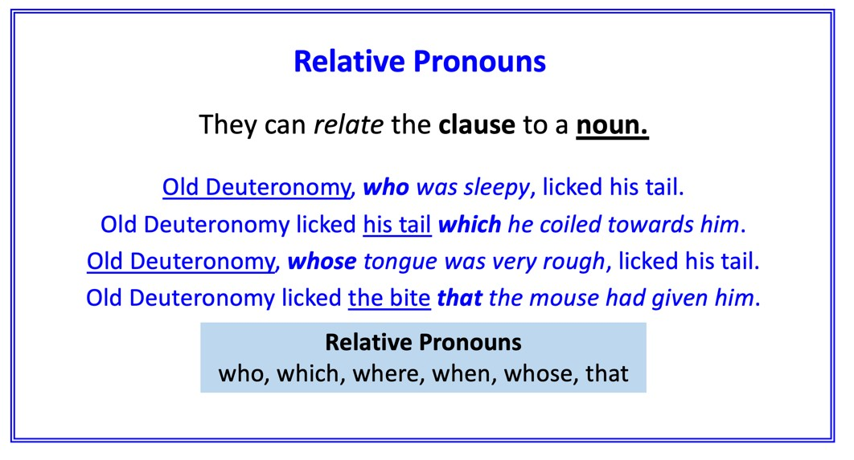

Relative Clauses 1

1) Can you add a relative clause to any of these sentences? Look at the pronouns in the box and try to use a different one each time.

e.g. Old Deuteronomy sat on the wall, which he
found very comfortable.

He has had nine wives ….

He was famous before Queen Victoria…

The villagers are glad to see him…

He sits in the street….

The villagers put up a notice…

Relative pronouns
which
who
where
when
whose
that

Relative Clauses 2

Can you embed a relative clause in these sentences?
You could use one of the clauses from the box.

Old Deuteronomy, …, has lived a very long time.

The village, …., is very proud of him.

The wall, …, is flooded with the sunshine.

The Oldest Inhabitant, …. , croaked ‘Well of all things!’

Queen Victoria, …, came to the throne in 1837.

when seeing old Deuteronomy
which he sits upon
who is the hero of this poem
where he lives
whose reign was after old Deuteronomy was famous

3) Can you make up your own relative clause to embed in these sentences?

On market day, …., he sits in the street.
The sheep, ...., start to bleat.
The villagers, …., close the road.
Old Deuteronomy, …, simply sleeps and sleeps.
The Oldest Inhabitant, …, is deaf in one ear.
Old Deuteronomy Illustration

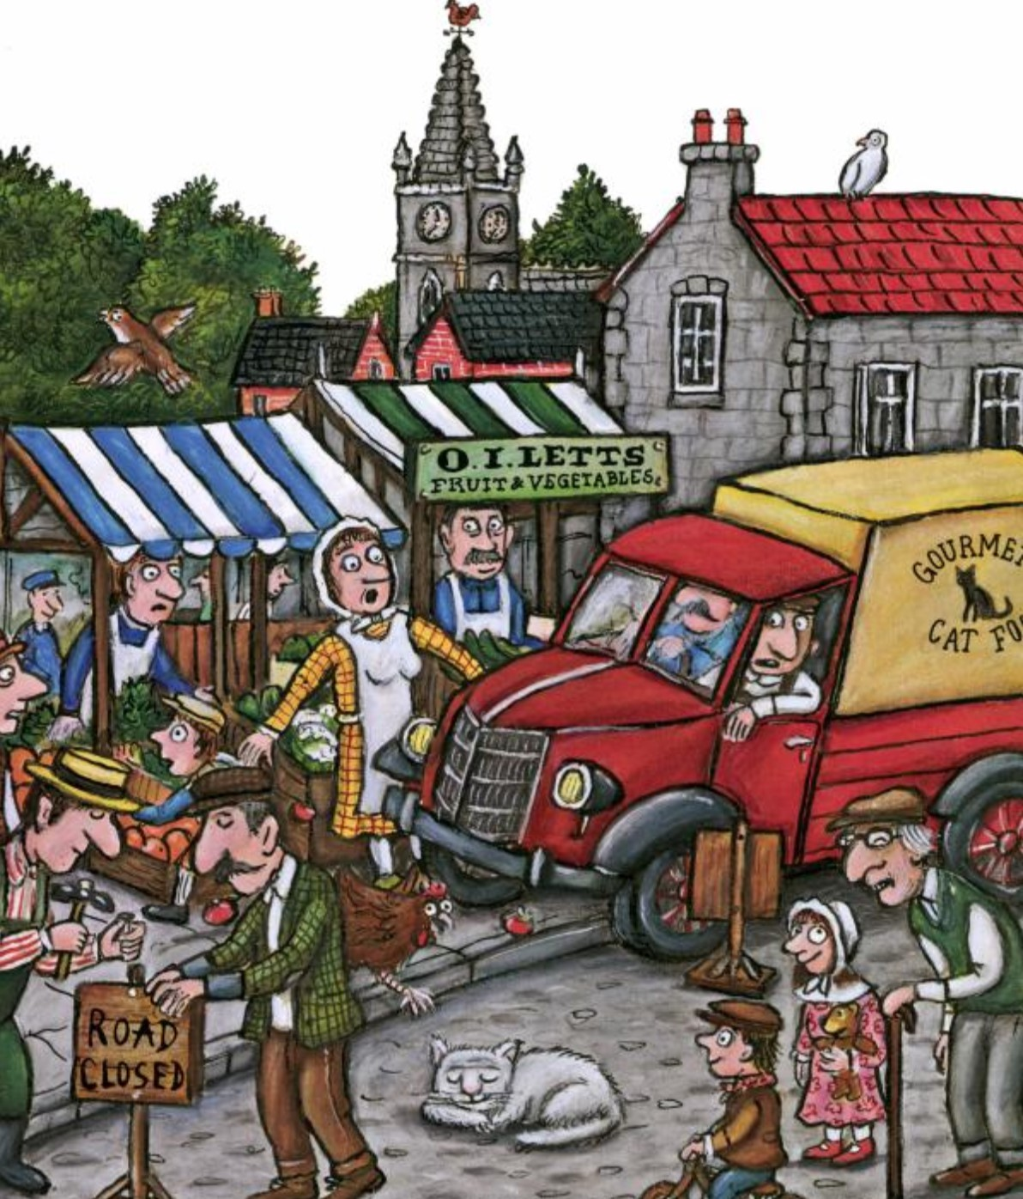
By Axel Schefller – from Old Possum’s Book of Practical Cats
Relative Pronouns List

who

which

where

when

whose

that

Sentences

Write some sentences about the illustration. Include relative clauses in your sentences.

