What to do today
Dear Year 5,
Today you will write a play script. Use the checklist to edit your writing to ensure you have all the required features.
Mrs Lines

1. Listen to two different readings of the poem
- Listen to two readings of Macavity. Follow the words as you do.
https://www.youtube.com/watch?v=QY3V0s8eRcs&t=105s
https://www.youtube.com/watch?v=7LjaTP0T3Ew&t=12s
- Can you describe 3-5 differences between the two readings? Which do you prefer? Why?

2. Read and write a Play Script
- Read Macavity Play Script. Try reading what each of the characters say, using different voices to show the characters.
- Read Play Script Features. Use highlighting and notes to show these features on the play script.

3. Now for some writing
- Write a playscript based on the poem, ‘Macavity’.
- If you want to, you could carry on the courtroom scene in the Macavity Play Script.
- You could use another scene from the poem – the Arthur Robbins Illustrations may help you.
- Use Play Script Features as you write out your playscript.

Well done! Now show a grown-up your play script and show them the play script features which you have included.

Try this Fun-Time Extra
- Find a way of acting out your playscript. Persuade people in your house to help you, or make a film with toys or you might even be able to act it out with friends on video-chat!

Macavity – The Mystery Cat

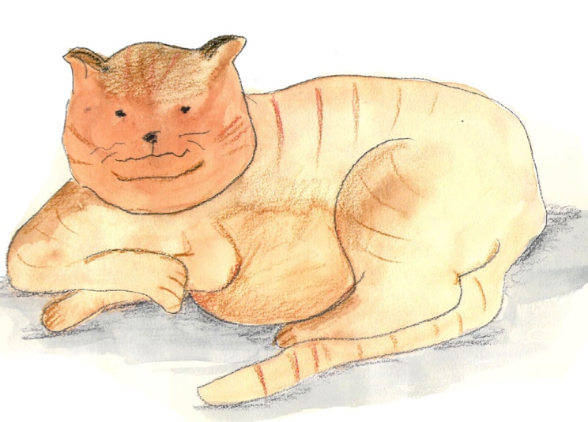
By T.S. Eliot

Macavity's a Mystery Cat: he's called the Hidden Paw—
For he's the master criminal who can defy the Law.
He's the bafflement of Scotland Yard, the Flying Squad's despair:
For when they reach the scene of crime—Macavity's not there!
Macavity, Macavity, there's no one like Macavity,
He's broken every human law, he breaks the law of gravity.
His powers of levitation would make a fakir stare,
And when you reach the scene of crime—Macavity's not there!
You may seek him in the basement, you may look up in the air—
But I tell you once and once again, Macavity's not there!
Macavity's a ginger cat, he's very tall and thin;
You would know him if you saw him, for his eyes are sunken in.
His brow is deeply lined with thought, his head is highly domed;
His coat is dusty from neglect, his whiskers are uncombed.
He sways his head from side to side, with movements like a snake;
And when you think he's half asleep, he's always wide awake.
Macavity, Macavity, there's no one like Macavity,
For he's a fiend in feline shape, a monster of depravity.
You may meet him in a by-street, you may see him in the square—
But when a crime's discovered, then Macavity's not there!

He's outwardly respectable. (They say he cheats at cards.)
And his footprints are not found in any file of Scotland Yard's
And when the larder's looted, or the jewel-case is rifled,
Or when the milk is missing, or another Peke's been stifled,
Or the greenhouse glass is broken, and the trellis past repair
Ay, there's the wonder of the thing! Macavity's not there!
And when the Foreign Office find a Treaty's gone astray,
Or the Admiralty lose some plans and drawings by the way,
There may be a scrap of paper in the hall or on the stair—
But it's useless to investigate—Macavity's not there!
And when the loss has been disclosed, the Secret Service say:
It must have been Macavity!'—but he's a mile away.
You'll be sure to find him resting, or a-licking of his thumb;
Or engaged in doing complicated long division sums.
Macavity, Macavity, there's no one like Macavity,
There never was a Cat of such deceitfulness and suavity.
He always has an alibi, and one or two to spare:
At whatever time the deed took place—Macavity wasn’t there!
And they say that all the Cats whose wicked deeds are widely known
(I might mention Mungojerrie, I might mention Griddlebone)
Are nothing more than agents for the Cat who all the time
Just controls their operations: the Napoleon of Crime!

Macavity Scene

The scene is a courtroom. Macavity is in the dock. He looks defiant and unafraid. Beside him is a lawyer. They are both facing the judge.

Prosecuting Lawyer: | Your worship, we shall be alleging that the defendant, Macavity, is not an innocent cat but is in fact the brains behind a series of terrible crimes …
Judge: | (Scratching his chin and looking doubtful)  When you say the ‘brains’, what exactly do you mean?
Prosecuting Lawyer: | The mastermind, your worship. The very ‘Napoleon’ of crime.  (Everyone in court gasps)
Judge: | Well, what do you have to say about this Macavity?
Macavity: | I’d just like to know where I was supposed to be and when.  Because, I’m pretty sure that you’ll actually find I wasn’t there (wherever that was)  And even if I was, I’m certain that I wasn’t there then (whenever that might have been).
Judge: | (Looks puzzled)

Playscripts Features

- Write the characters’ names clearly on the left-hand side.

- Separate these from what is said using a colon.

- Include any instructions for the actors (stage directions) in brackets. It is useful to write these in a different colour.

- Instructions can include:
  - How something is to be said
  - Movements or gestures
  - Scene changes

- Write information about the setting of the scene at the start of the script.
Arthur Robbins’ Illustrations
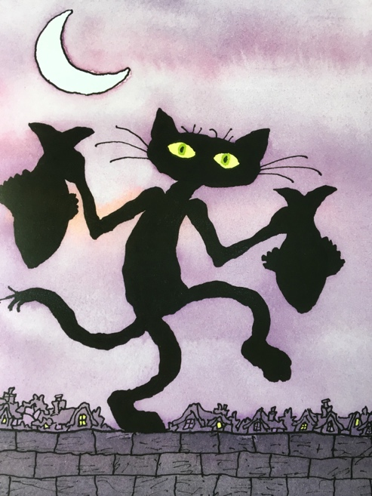 | 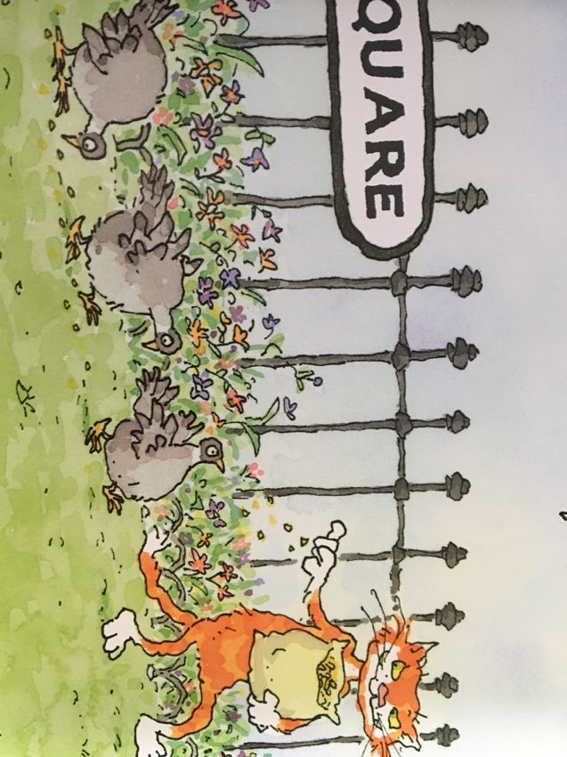 | 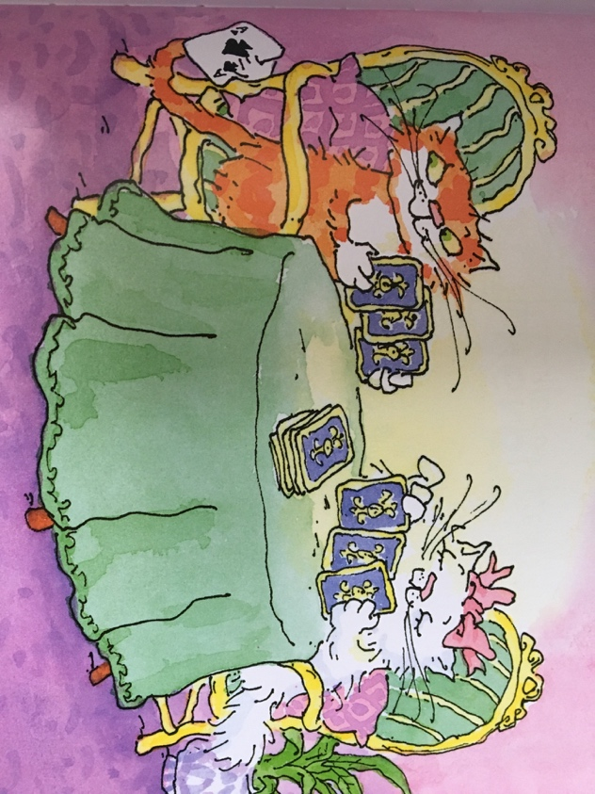
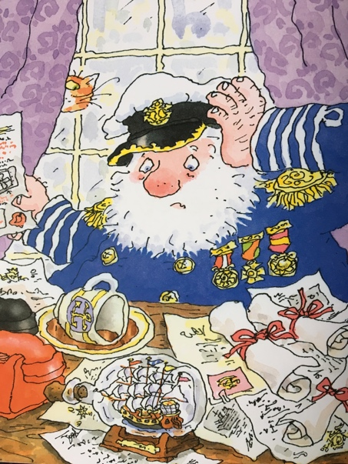 | 