What to do today
Dear Year 5,
Today you will take on the role of a police officer. Be sure to use a formal tone in your record.
Mrs Lines

1. Fill in missing words
- Read Cloze. Try to think of the words that could go in the black spaces. You might remember the original words or you might think of new words that could work as well.
- When you have finished, check the original version of the poem.

2. Write a custody record!
- Go through the poem and highlight all the descriptions of Macavity’s appearance.
- Now highlight any details of Macavity’s crimes.
- Use this information to fill in the Police Custody Record for Macavity. Give a clear description and describe the crime. Imagine what Macavity might say!

Well done! Show a grown-up the custody record you wrote. Show them where in the poem you got your ideas from.

3. Learn some of the poem by heart
- Read Tips for Learning a Poem by Heart.
- Try learning some of the poem by heart. Pick just one verse at first. Challenge yourself to learn more verses.
- Play the recording. Join in with verses you’ve learnt by heart:
https://www.youtube.com/watch?v=Mz29e3lv3Js

Try this Fun-Time Extra
- Ask someone to test you on the verses that you have learnt. Get them to read the verses but to leave out words. Say the words they miss.
Macavity - Cloze

Macavity's a Mystery Cat: he's called the Hidden Paw—
For he's the master criminal who can defy the Law.
He's the bafflement of Scotland Yard, the Flying Squad's despair:
For when they reach the scene of crime—Macavity's not there!
Macavity, Macavity, there's no one like Macavity,
He's broken every human law, he breaks the law of gravity.
His powers of levitation would make a fakir stare,
And when you reach the scene of crime—Macavity's not there!
You may seek him in the basement, you may look up in the air—
But I tell you once and once again, Macavity's not there!
Macavity's a ginger cat, he's very tall and thin;
You would know him if you saw him, for his eyes are sunken in.
His brow is deeply lined with thought, his head is highly domed;
His coat is dusty from neglect, his whiskers are uncombed.

Macavity – The Mystery Cat

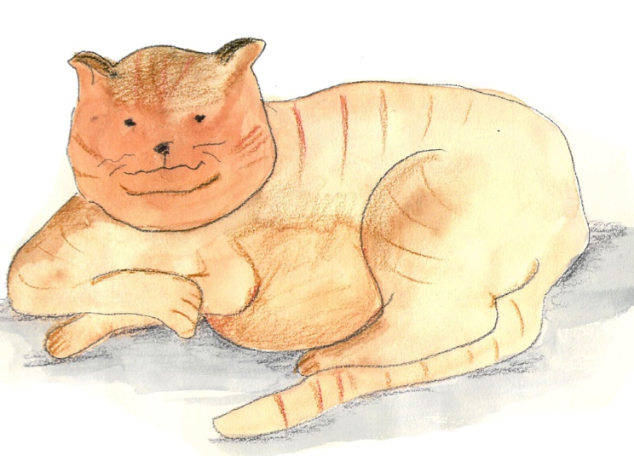
By T.S. Eliot

Macavity's a Mystery Cat: he's called the Hidden Paw—
For he's the master criminal who can defy the Law.
He's the bafflement of Scotland Yard, the Flying Squad's despair:
For when they reach the scene of crime—Macavity's not there!
Macavity, Macavity, there's no one like Macavity,
He's broken every human law, he breaks the law of gravity.
His powers of levitation would make a fakir stare,
And when you reach the scene of crime—Macavity's not there!
You may seek him in the basement, you may look up in the air—
But I tell you once and once again, Macavity's not there!
Macavity's a ginger cat, he's very tall and thin;
You would know him if you saw him, for his eyes are sunken in.
His brow is deeply lined with thought, his head is highly domed;
His coat is dusty from neglect, his whiskers are uncombed.
He sways his head from side to side, with movements like a snake;
And when you think he's half asleep, he's always wide awake.
Macavity, Macavity, there's no one like Macavity,
For he's a fiend in feline shape, a monster of depravity.
You may meet him in a by-street, you may see him in the square—
But when a crime's discovered, then Macavity's not there!

He's outwardly respectable. (They say he cheats at cards.)
And his footprints are not found in any file of Scotland Yard's
And when the larder's looted, or the jewel-case is rifled,
Or when the milk is missing, or another Peke's been stifled,
Or the greenhouse glass is broken, and the trellis past repair
Ay, there's the wonder of the thing! Macavity's not there!
And when the Foreign Office find a Treaty's gone astray,
Or the Admiralty lose some plans and drawings by the way,
There may be a scrap of paper in the hall or on the stair—
But it's useless to investigate—Macavity's not there!
And when the loss has been disclosed, the Secret Service say:
It must have been Macavity!'—but he's a mile away.
You'll be sure to find him resting, or a-licking of his thumb;
Or engaged in doing complicated long division sums.
Macavity, Macavity, there's no one like Macavity,
There never was a Cat of such deceitfulness and suavity.
He always has an alibi, and one or two to spare:
At whatever time the deed took place—Macavity wasn’t there!
And they say that all the Cats whose wicked deeds are widely known
(I might mention Mungojerrie, I might mention Griddlebone)
Are nothing more than agents for the Cat who all the time
Just controls their operations: the Napoleon of Crime!

Police Custody Record
Personal Details (Name, Address, Gender, Age, Height, Other Descriptors)
Reasons for arrest
 | Date | Time | Arresting Officers
Arrested at
Arrived station
Comments made by person at time of arrest
Declaration of Rights  A notice setting out my rights has been read to me and I have been given a copy. |  |  | Signature:  Time:  Date:

Top tips for learning a poem by heart

- Read the poem aloud several times slowly.
- Copy the poem out a couple of times.
- Be strategic. Pick a poem with a pattern, metre and rhyme are much easier to learn by heart than free verse.
- Learn and internalise the “story” in the poem
- Understand the poem by knowing every word’s meaning
- With a card, cover everything but the first line of the poem. Read it. Look away, see the line in the air, and say it. Look back. Repeat until you’ve “got it.”
- Uncover the second line. Learn it as you did the first line, but also add second line to first, until you’ve got the two.
- Then it’s on to three. Always repeat the first line on down, till the whole poem sings.
