What to do today
Dear Year 5,
Today you will revise parenthesis. It is important that you use it in all writing now that you are in Year 5. If you remember it from our lessons, that’s great. If not, you have a PowerPoint to guide you. Enjoy your learning.
Mrs Lines

1. Read the Lost Thing
- Read the Text of the Lost Thing.
- Practise reading out loud so that you can make the story sound intriguing and mysterious.

2. Remind yourself about parenthesis
- Use the PowerPoint on Parenthesis. If this is not possible, remind yourself using the Revision Card.
- Complete Lost Thing Sentences 1 and 2. You could challenge yourself to complete Lost Thing Sentences 3.

3. Write a book review
- Read Example Book Review. Highlight the examples of parenthesis that you can find.
- Write your own answers to the four book review questions. Try to include some parentheses in your sentences.

Well done! Now read your book review to a grown-up. Can you show them the parentheses that you have used? You can check your answers to Lost Thing Sentences at the end of this pack.

Try these Fun-Time Extras
- Watch the trailer for The Lost Thing film: https://www.youtube.com/watch?v=kikA9pUAnWs
You might be able to find the whole film to watch online (ask an adult to help).
- Look at Shaun Tan’s design for the boy from The Lost Thing. Can you learn to draw him?
https://www.acmi.net.au/ideas/watch/shaun-tan-boy/

Text of the Lost Thing by Shaun Tan

So you want to hear a story?
Well, I used to know a whole lot of pretty interesting ones. Some of them so funny you’d laugh yourself unconscious, others so terrible you’d never want to repeat them. But I can’t remember any of those. So I’ll just tell you about the time I found that lost thing.
This all happened a few summers ago, one rather ordinary day by the beach. Not much was going on. I was, as usual, working tirelessly on my bottle-top collection and stopped to look up for no particular reason. That’s when I first saw the thing.
I must have stared at it for a while. I mean, it had a really weird look about it – a sad, lost sort of look. Nobody else seemed to notice it was there. Too busy doing beach stuff, I guess. Naturally, I was intrigued. I decided to investigate.
Sure didn’t do much. It just sat there, looking out of place. I was baffled. It was quite friendly though, once I started talking to it. I played with the thing for most of the afternoon. It was great fun, yet I couldn’t help feeling that something wasn’t quite right.
As the hours slouched by, it seemed less and less likely that anybody was coming to take the thing home. There was no denying the unhappy truth of the situation. It was lost.
I asked a few people if they knew anything about it, but nobody was very helpful.
I took the lost thing over to Pete’s place. Pete has an opinion on just about everything.
“Cool,” he said.
“I’m trying to find out who owns it,” I told him.
“I dunno man,” said Pete. “It’s pretty weird. Maybe it doesn’t belong to anyone. Maybe it doesn’t come from anywhere. Some things are like that…” He paused for dramatic effect, “…just plain lost.”
There was nothing left to do but take the thing home with me. I mean, I couldn’t just leave it wandering the streets. Plus I felt kind of sorry for it. My parents didn’t really notice it at first. Too busy discussing current events, I guess. Eventually I had to point it out to them
“Its feet are filthy!” shrieked Mum.
“It could have all kinds of strange diseases,” warned Dad.
“Take it back to where you found it,” they demanded, both at the same time.
“It’s lost,” I said, but they had already started talking about something else. I hid the thing in our back shed and gave it something to eat, once I found out what it liked. It seemed a bit happier then, even though it was still lost.
I checked the local paper for any lost pet notices, but only found a lot of good deals on refrigerator repairs. I remember thinking then that Pete was probably right, that some things were just plain lost. In any case, I sure couldn’t keep the thing in the shed forever. Mum or Dad would eventually notice it when they came out looking for a hammer or something.
It was a real dilemma. I was wondering what to do when a small advertisement on the last page of the paper happened to catch my eye. The next morning we caught a tram into the city.
We arrived at a tall grey building with no windows. It was pretty dark in there, and it smelt like disinfectant. “I have a lost thing,” I called to the receptionist at the front desk. “Fill in these forms,” she said. The lost thing made a small, sad noise. I was looking around for a pen when I felt something tug the back of my shirt.
“If you really care about that thing you shouldn’t leave it here,” said a tiny voice. “This is a place for forgetting, leaving behind, smoothing over. Here take this.”
It was business card with a kind of sign on it. It wasn’t very important looking but it did seem to point somewhere. “Cheers,” I said.
At this point we left that tall grey building and hunted all over the place for this sign. It wasn’t an easy job and I can’t say I knew what it all meant.
Eventually, we found what seemed to be the right place, in a dark little gap off some anonymous little street. The sort of place you’d never know existed unless you were actually looking for it. I pressed a buzzer on the wall and this big door opened up. I didn’t know what to think, but the lost thing made an approving sort of noise. It seemed as good a time as any to say goodbye to each other. So we did.
Then I went home to classify my bottle-top collection. Well, that’s it. That’s the story. Not especially profound, I know, but I never said it was.
And don’t ask me what the moral is. I mean, I can’t say that the thing actually belonged in the place where it ended up. In fact, none of the things there really belonged. They all seemed happy enough though, so maybe that didn’t matter. I don’t know…
I still think about that lost thing from time to time. Especially when I see something out of the corner of my eye that doesn’t quite fit. You know, something with a weird, sad, lost sort of look. I see that sort of thing less and less these days though. Maybe there aren’t many lost things around anymore.
Or maybe I’ve just stopped noticing them. Too busy doing other stuff, I guess.

Revision Card – Parenthesis

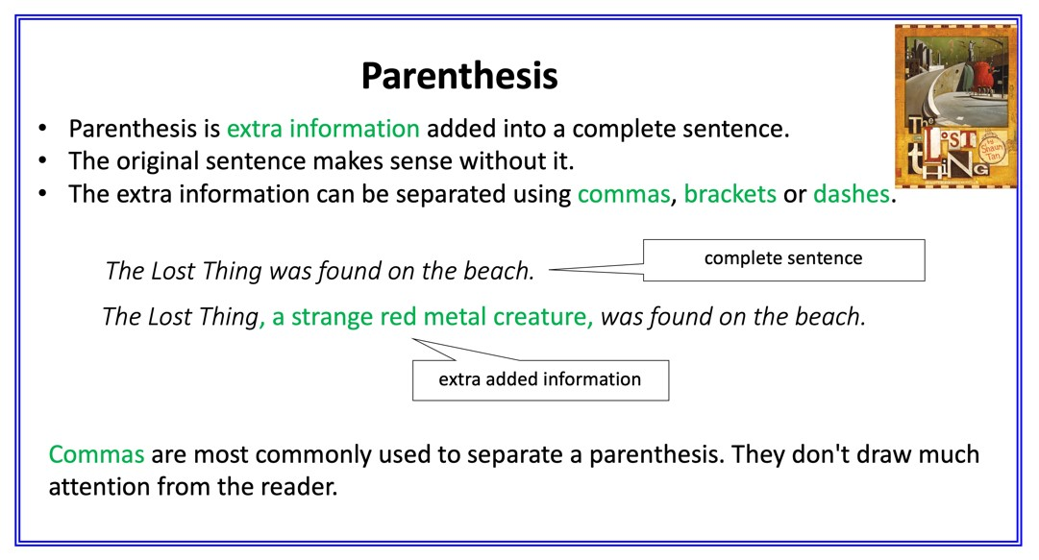 | 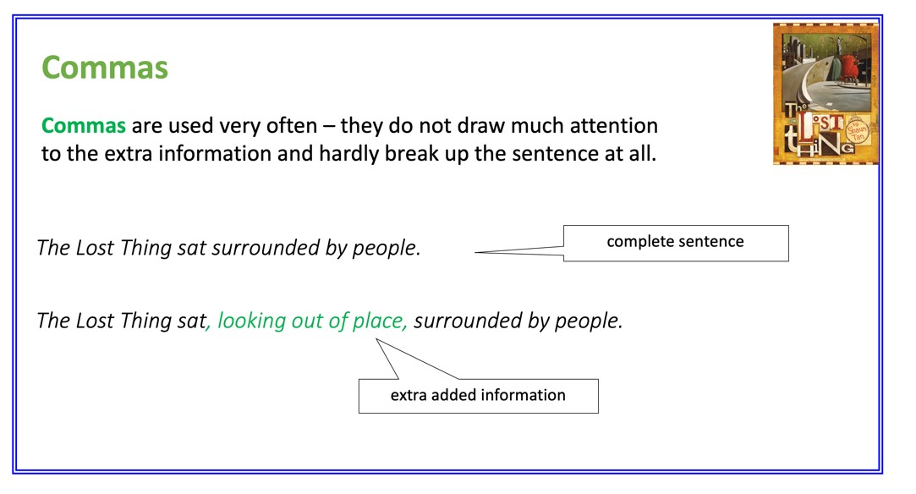
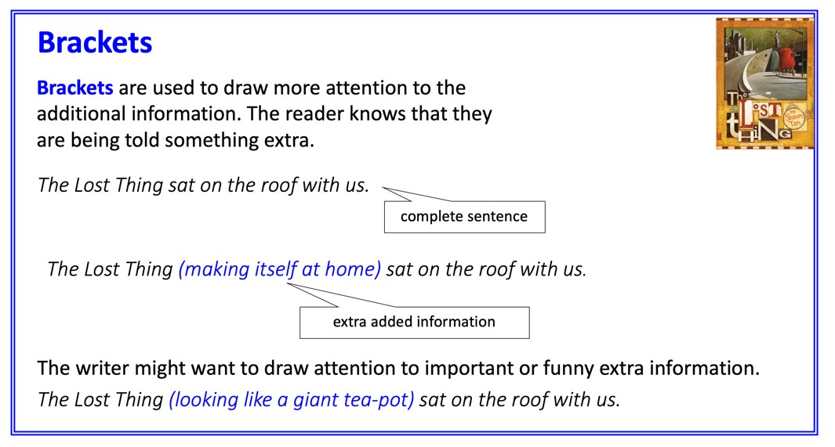 | 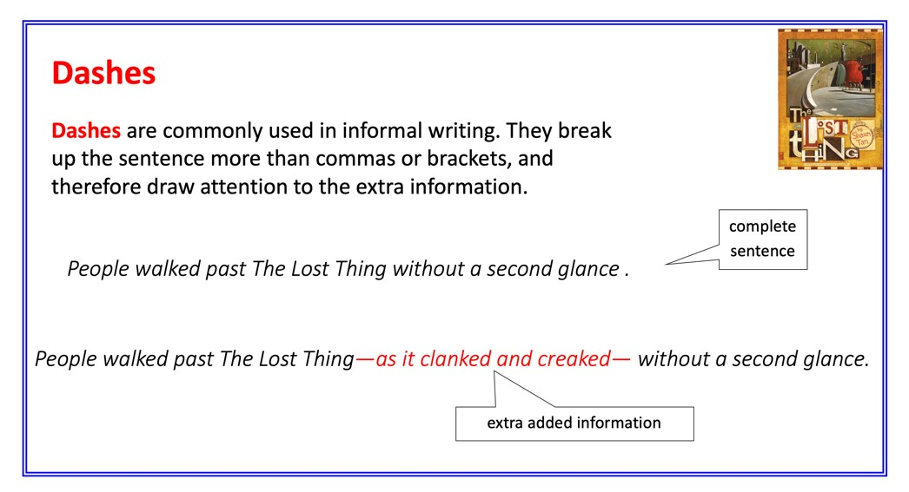

Lost Thing Sentences 1

- Add information to these sentences, using parenthesis.
- Put the extra information in the place marked with an arrow.
- Choose punctuation to make your addition clear.
- There are suggestions (underneath) of phrases to add. Or you can make up your own
- Be careful because these suggestions are in the wrong order.

1. I used ↑ to know a whole lot of stories.
2. I was working ↑ on my bottle-top collection.
3. Nobody else ↑ seemed to notice it was there.
4. I decided ↑ to investigate.
5. It was ↑ quite friendly.

Suggested phrases

once I started talking to it
though the beach was crowded
as hard as usual
feeling intrigued
a long time ago

Lost Thing Sentences 2

- Add information to these sentences using parenthesis.
- You will have to decide where to put the extra information.
- Choose punctuation to make your addition clear.
- There are suggestions (underneath) of phrases to add. They are in the right order. Or you can make up your own!

1. It just sat on the beach.
2. We played for most of the afternoon.
3. It seemed less and less likely that anybody was coming to take the thing home.
4. I asked a few people if they knew anything about it.
5. I took the lost thing over to Pete’s place.

Suggested phrases

looking out of place
chasing and building sandcastles
the longer the hours slouched by
who were waiting around
which happily followed me

Lost Thing Sentences 3

- Add information to these sentences, using parenthesis.
- You will have to decide what extra information to add and where, in the sentence, to add it.
- Choose punctuation to make your addition clear.

1. Pete has an opinion on just about everything.
2. Pete suggested that it didn’t come from anywhere.
3. My parents didn’t really notice it at first.
4. I hid the thing in our back shed.
5. The next morning we caught a tram.

Make up some sentences (including parenthesis) of your own about the Lost Thing.

Example - Book Review

How would you summarise the plot of The Lost Thing?
A boy, interested in little more than bottle-tops, one day spots an unusual creature on the beach. He befriends him and plays with him. He soon decides, since no-one comes to collect him, that the creature is lost. He tries to take him to all sorts of places (none successfully) before discovering an unimaginable place (after a long journey). The meeting doesn’t change his life, which soon returns to normality, but is something he always remembers.

What do you think about the characters in the story?
I like the boy. He reminds me, a little bit, of myself. He seems kind but he doesn’t quite know what to do for the lost thing. The other characters that are memorable to me were Pete (smug and annoying) and the boy’s parents (remote and uncaring). I think the janitor, who gave the arrow card, is quite mysterious.

What do you notice especially?
I see that the background of the pages, cut out of newspaper, is often about plumbing. So are the shops (when they go to the city) and the other creatures (when they reach the safe-place). I think Shaun Tan must be interested in plumbing!

Would you recommend this book to others?
I would because, though it seems simple, it’s a story that has got lodged in my brain.
Book Review

How would you summarise the plot of The Lost Thing?

What do you think about the characters in the story?

What do you notice especially?

Would you recommend this book to others?

Lost Thing Sentences – Possible Answers

Lost Thing Sentences 1

I used, a long time ago, to know a whole lot of stories.
I was working, as hard as usual, on my bottle-top collection.
Nobody else, though the beach was crowded, seemed to notice it was there.
I decided, feeling intrigued, to investigate.
It was, once I started talking to it, quite friendly.

Lost Thing Sentences 2 (Possible answers)

It just sat, looking out of place, on the beach.
We played, chasing and building sandcastles, for most of the afternoon.
It seemed less and less likely, the longer the hours slouched by, that anybody was coming to take the thing home.
I asked a few people, who were waiting around, if they knew anything about it.
I took the lost thing, which happily followed me, over to Pete’s place.

Lost Thing Sentences 3 (Possible answers)

Pete, who is quite laid-back, has an opinion on just about everything.
Pete suggested, when I asked him, that it didn’t come from anywhere.
My parents, too busy discussing current events, didn’t really notice it at first.
I hid the thing, after finding it some food, in our back shed.
The next morning, having read the advert, we caught a tram.

