What to do today
Dear Year 5,
Today you read the second part of the story. How does it compare with what you imaged? Our grammar focus today is on adverbials. Follow the PowerPoint to help you.
Mrs Lines

1. Read the end of a story
- Read Jabu and the Lion Part 2. What was the biggest surprise about the story? What did you like about the story? Was there anything you didn’t like? What did it remind you of?
- Write 2 or 3 sentences about each of the characters in the story on Character Summary. How can you best describe them?

2. Revise adverbials
- Use the PowerPoint to remind yourself about adverbials or, if this is not possible, use the Revision Card.
- Complete Adverbial Tasks to practise using adverbials.

3. Watch another version of the story
- Watch this version of the story. How is it different to the written version?
https://www.youtube.com/watch?v=JelF8axBaRU
- Make a story-map. Use words and pictures to make yourself a reminder of the main events of the story.
- Use your story-map to either practise telling the story out-loud yourself OR to help you make a Comic-strip version of the story.

Well done. Tell the story to a grown-up or show them your comic strip version. You can check your answers to some of the Adverbial Tasks at the end of this pack.

Try the Fun-Time Extras
Make a recording of yourself telling the story and share it with someone else OR share a photo of your comic-strip version with someone else.

Jabu and The Lion Part 2

But the longer he listened, the more he came to the conclusion that the lion was crying for help. Cautiously he tiptoed in the direction of the roaring sound. As Jabu crept into the clearing, he saw Bhubesi firmly wedged in a cage. The more the lion struggled and wriggled, the tighter the snare became. Jabu had never seen a lion so close. What a magnificent sight! It wasn’t surprising that he was called the ‘King of the Beasts.’ Jabu felt a pang of sadness on seeing the lion ensnared in this terrifying trap. His sympathy went out to him when he saw his heart-rendering plight. In that instant, the lion saw Jabu.

“Oh! Mfana!” he exclaimed (which is the Zulu word for ‘boy’) “I am overjoyed to see you. Please, oh please, will you help me? As you can see, I’m hopelessly trapped – the more I struggle the tighter the bar holding my neck becomes. Could you please raise the bar so that I can escape?”
Jabu could hear the desperation in Bhubesi’s voice as he pleaded again, “Please Mfana! Please, before the hunters return!”

Jabu felt so sad, but he knew that he lion could easily turn on him if he were set free.
“I would love to set you free, Bhubesi! But how do I know that I can trust you? How do I know that I will not be your next dinner?”
“If you set me free I shall be your friend,” Bhubesi replied in a pleading voice, “friends take care of one another. I promise I will never harm you in any way.”

Jabu looked into Bhubesi’s sorrowful eyes as he pleaded so pitifully and he believed him. Carefully he crept up to the cage and raised the heavy wooden bar that trapped the lion’s head. The lion rushed out of the cage and tossed his handsome, golden mane with enormous relief.  “Thank you! Thank you Mfana, my friend! You have released me just when I thought my head would be parted from my body. Now, Mfana just one thing… I’m so very thirsty, would you please direct me to the river?” | 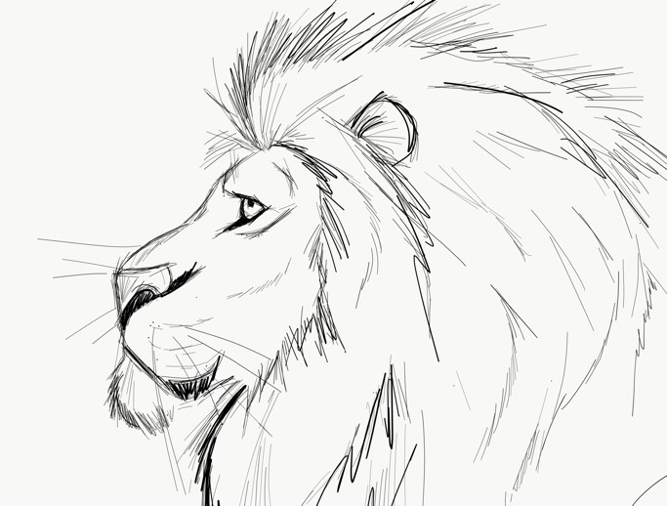

Jabu guided Bhubesi towards the river, taking a route well away from his father’s cattle, just in case, as the lion hadn’t promised not to eat the cows! The lion slurped the water thirstily, then raised his eyes and gazed longingly at Jabu. “Hmmm…what delicious looking legs…long and meaty…young and succulent. What a waste to ignore such a feast!”

Jabu saw that Bhubesi had narrowed his eyes and was staring at him hungrily.

“But you promised Bhubesi!” he pleaded. “I saved you from the hunters and you promised.”
“Yes,” sighed Bhubesi, edging towards Jabu. “I did promise, but now that I’m free I do feel so ravenously hungry.”
Jabu stood up straight and glared bravely at Bhubesi. “If you break your word, the pieces of the shattered promise will return to pierce you.”
“Hah! What utter nonsense! How can a promise return to pierce the King of the Beasts? I’m getting hungrier by the minute listening to such rubbish!” jeered the lion.

Mercifully, just at that moment, an old donkey appeared. “Ask the donkey,” said Jabu, “and he will explain how disastrous it will be if you break your promise”.

The lion turned to the old donkey, “I’m hungry and I want to eat this boy. That’s fine, isn’t it?” he asked.  “But he promised not to eat me,” Jabu interjected, “in return for being freed from the trap. He cannot break his promise!”  The donkey raised his weary eyes to look at Bhubesi.  “Eat the boy!” he said, “I’ve worked hard all my life for these humans, and now that I’m old and worn-out they have abandoned me to look after myself. I hate humans! Eat the boy!” | 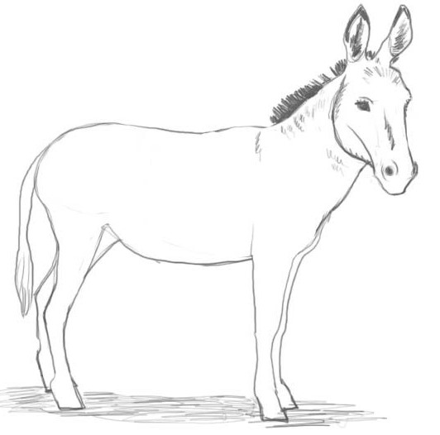
Bhubesi stared straight ahead and growled. “Well that settles the problem.”

But at the precise moment that the lion was preparing to pounce on Jabu, Mpungushe, the jackal, raced into the clearing.
“Oh, I’m so sorry, did I disturb you? I must be on my way,” panted Mpungushe nervously.
“NO! Don’t go!” shouted Jabu. “Please stay! I need to ask you a question. Could you please explain to Bhubesi how dreadful it is to break a promise?”
“A promise?” asked Mpungushe.
While Jabu relayed the whole story to the jackal, Bhubesi lay dreaming of the moment when he would be feasting on the boy.

“Oh, what a ridiculous story!” sniggered Mpungushe. “Just imagine – the King of the Beasts trapped in a cage made by mere humans! This cannot possibly be true!”
“But it is true,” snarled Bhubesi. “It was a terrible trap. A strong trap.”
“Nothing can possibly be stronger than the King of the Beasts! I need to see this amazing snare. You must show me now, before you have your dinner,” insisted Mpungushe.
In single file, with Jabu leading, followed by the growling lion, and with the jackal bringing up the rear, they climbed the steep pathway up to the clearing.

The jackal sniggered sarcastically when he saw the trap.
“You mean to tell me that this makeshift contraption ensnared the noble King of the Beasts. NEVER! I don’t believe it!”

“Let me show you what a dreadful position I was in,” explained Bhubesi, “and then I will eat my dinner.” With these words Bhubesi stuck his head under the wooden bar and the jackal pulled it down firmly over his neck.

“Yes!” said the jackal, “the boy is right, broken promises will always catch up with you. Now I can see how you were trapped… what a pity that you are trapped again!”
Bhubesi gave out a dreadful roar of anger.

Jabu thanked the jackal and raced off safely to his father’s cattle, who were still waiting patiently for him. He drove them gently and carefully into the corral for the night. As he walked home, he thought about the amazing events of his day. When he returned to the village he met his friend Sipho.

“Jabu! Jabu!” called Sipho excitedly. “Guess what? The hunters have caught a fierce lion near the river in their trap! What a shame you missed the day’s adventures. Don’t you wish that you had come along with me for some excitement, instead of looking after your father’s cattle?”
Jabu smiled to himself but said nothing. He was so relieved that he and his cattle were safe from Bhubesi, the King of the Beasts.
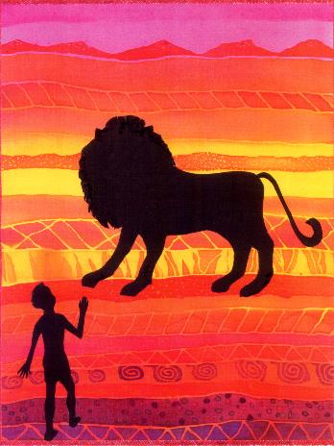

Character Summary

Jabu
Sipho
Bhubesi
(the lion)
The donkey
Mpungushe
(the jackal)

Revision Card - Adverbials
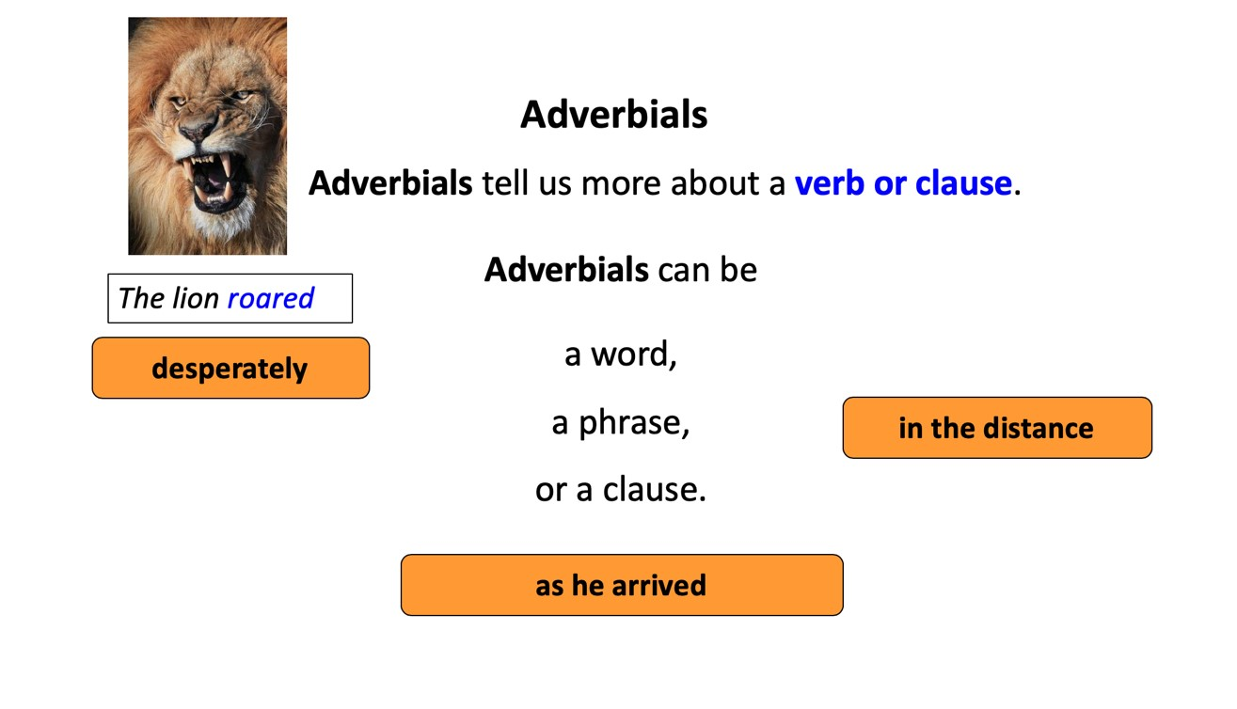
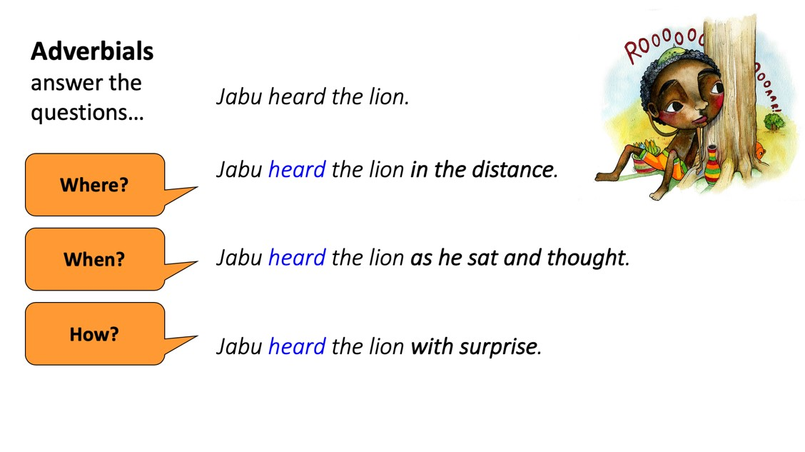
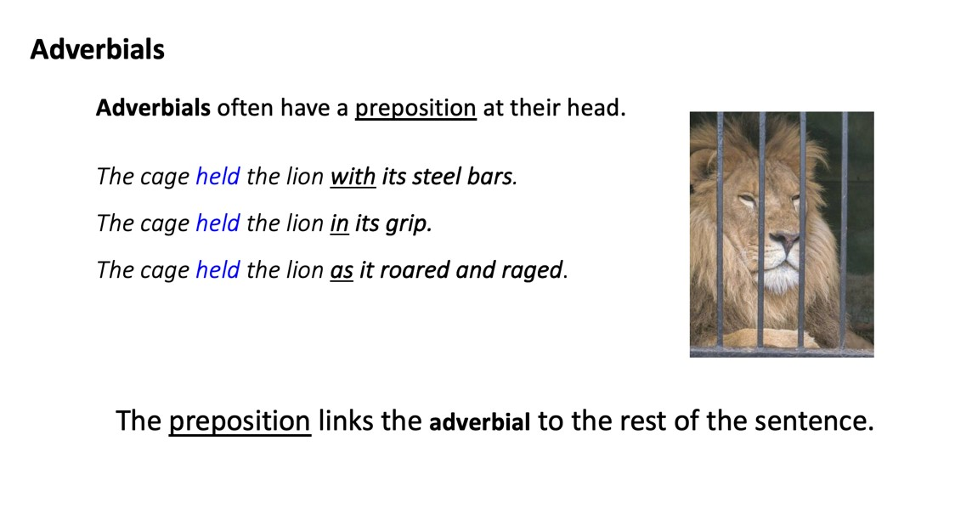

Adverbials Tasks

Underline the adverbials in these sentences

1. Jabu guards the cattle as they lazily graze.
2. Patiently, Jabu watches the cattle.
3. Dangerous animals could lurk in the shadows.
4. There was corn in the adjoining field.
5. Jabu was the most reliable son in the whole neighbourhood.

Make up an ending to these sentences

6. Jabu frowned as
7. The cattle started plodding towards
8. The lion struggled in
9. An old donkey appeared from
10. The jackal answered the lion with

Now write five sentences about the scene where Jabu and the Lion talk together. Use an adverbial in each of your sentences. Underline your adverbial. The Useful Prepositions list might help you.

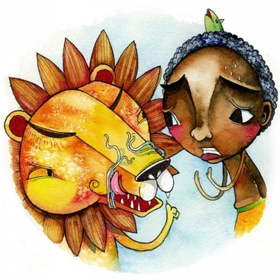
Useful Prepositions

Where?  above / below  over / under  from / to  between / against  outside / inside  on / off / at / by  towards / away  behind / in front | When?  before / after  during  between  on / in / at  until  as / while | How?  with  like  in  by  as  in  on

Comic Strip Version

Adverbials Tasks - Answers

Underline the adverbials in these sentences

1. Jabu guards the cattle as they lazily graze.
2. Patiently, Jabu watches the cattle.
3. Dangerous animals could lurk in the shadows.
4. There was corn in the adjoining field.
5. Jabu was the most reliable son in the whole neighbourhood.

