What to do today
Dear Year 5,
Today you will listen to/read the writing of Shaun Tan. He is a famous author but has also won an Oscar for a short animation. I hope you will do the fun time extras today and learn how to draw the Lost Thing.
Mrs Lines

1. Listen to a story
- Listen to the reading of The Lost Thing by Shaun Tan.
https://www.youtube.com/watch?v=WAHTsBGhues
- What do you like about the story? Is there anything that you dislike? Does it remind you of anything that you have ever read or seen?

2. Think about the story
- Read Reflection Questions.
- Think carefully about your answers to these questions. You could read the Text of the story to help you.
- Write some of your answers as sentences in the Speech Bubbles.

3. Look at art that inspired the book
- Look at Pictures 1-3. These are pieces of art that inspired the illustrations in The Lost Thing.
- Choose your favourite picture. Read Picture Prompts. Think about your answers and then write them as sentences.

Well done! Now show a grown-up the picture you have chosen and your answers to Picture Prompts. Would they pick the same picture? What would they say about their picture?

Try these Fun-Time Extras
- Share the story with a grown-up and ask them the Reflection Questions. Do they give the same answers as you did?
- Watch Shaun Tan drawing the Lost Thing. Can you learn to draw it?
https://www.youtube.com/watch?v=a_xoudh_cdU&t=57s

Text of the Lost Thing by Shaun Tan
So you want to hear a story?
Well, I used to know a whole lot of pretty interesting ones. Some of them so funny you’d laugh yourself unconscious, others so terrible you’d never want to repeat them. But I can’t remember any of those. So I’ll just tell you about the time I found that lost thing.
This all happened a few summers ago, one rather ordinary day by the beach. Not much was going on. I was, as usual, working tirelessly on my bottle-top collection and stopped to look up for no particular reason. That’s when I first saw the thing.
I must have stared at it for a while. I mean, it had a really weird look about it – a sad, lost sort of look. Nobody else seemed to notice it was there. Too busy doing beach stuff, I guess. Naturally, I was intrigued. I decided to investigate.
Sure didn’t do much. It just sat there, looking out of place. I was baffled. It was quite friendly though, once I started talking to it. I played with the thing for most of the afternoon. It was great fun, yet I couldn’t help feeling that something wasn’t quite right.
As the hours slouched by, it seemed less and less likely that anybody was coming to take the thing home. There was no denying the unhappy truth of the situation. It was lost.
I asked a few people if they knew anything about it, but nobody was very helpful.
I took the lost thing over to Pete’s place. Pete has an opinion on just about everything.
“Cool,” he said.
“I’m trying to find out who owns it,” I told him.
“I dunno man,” said Pete. “It’s pretty weird. Maybe it doesn’t belong to anyone. Maybe it doesn’t come from anywhere. Some things are like that…” He paused for dramatic effect, “…just plain lost.”
There was nothing left to do but take the thing home with me. I mean, I couldn’t just leave it wandering the streets. Plus I felt kind of sorry for it. My parents didn’t really notice it at first. Too busy discussing current events, I guess. Eventually I had to point it out to them
“Its feet are filthy!” shrieked Mum.
“It could have all kinds of strange diseases,” warned Dad.
“Take it back to where you found it,” they demanded, both at the same time.
“It’s lost,” I said, but they had already started talking about something else. I hid the thing in our back shed and gave it something to eat, once I found out what it liked. It seemed a bit happier then, even though it was still lost.
I checked the local paper for any lost pet notices, but only found a lot of good deals on refrigerator repairs. I remember thinking then that Pete was probably right, that some things were just plain lost. In any case, I sure couldn’t keep the thing in the shed forever. Mum or Dad would eventually notice it when they came out looking for a hammer or something.
It was a real dilemma. I was wondering what to do when a small advertisement on the last page of the paper happened to catch my eye. The next morning we caught a tram into the city.
We arrived at a tall grey building with no windows. It was pretty dark in there, and it smelt like disinfectant. “I have a lost thing,” I called to the receptionist at the front desk. “Fill in these forms,” she said. The lost thing made a small, sad noise. I was looking around for a pen when I felt something tug the back of my shirt.
“If you really care about that thing you shouldn’t leave it here,” said a tiny voice. “This is a place for forgetting, leaving behind, smoothing over. Here take this.”
It was business card with a kind of sign on it. It wasn’t very important looking but it did seem to point somewhere. “Cheers,” I said.
At this point we left that tall grey building and hunted all over the place for this sign. It wasn’t an easy job and I can’t say I knew what it all meant.
Eventually, we found what seemed to be the right place, in a dark little gap off some anonymous little street. The sort of place you’d never know existed unless you were actually looking for it. I pressed a buzzer on the wall and this big door opened up. I didn’t know what to think, but the lost thing made an approving sort of noise. It seemed as good a time as any to say goodbye to each other. So we did.
Then I went home to classify my bottle-top collection. Well, that’s it. That’s the story. Not especially profound, I know, but I never said it was.
And don’t ask me what the moral is. I mean, I can’t say that the thing actually belonged in the place where it ended up. In fact, none of the things there really belonged. They all seemed happy enough though, so maybe that didn’t matter. I don’t know…
I still think about that lost thing from time to time. Especially when I see something out of the corner of my eye that doesn’t quite fit. You know, something with a weird, sad, lost sort of look. I see that sort of thing less and less these days though. Maybe there aren’t many lost things around anymore.
Or maybe I’ve just stopped noticing them. Too busy doing other stuff, I guess.

Reflection Questions

How did the story make you feel? Can you explain why?

What does the story make you think about?
What happens to the Lost Thing?
What happens to the boy?
How do each of the other characters respond to the Lost Thing?
Where do you think the cleaner character has come from?
What is it?
Why has it ended up there?
Why does it direct the Lost Thing to the special place but not go there itself?

What adjectives are used in the story? What is the effect of these on the mood of the story?
Can you find examples of humour?
Can you find examples of informal language?

Speech Bubbles

What do you notice about the speech?

Picture 1 - Cahill Expressway by Jeffrey Smart

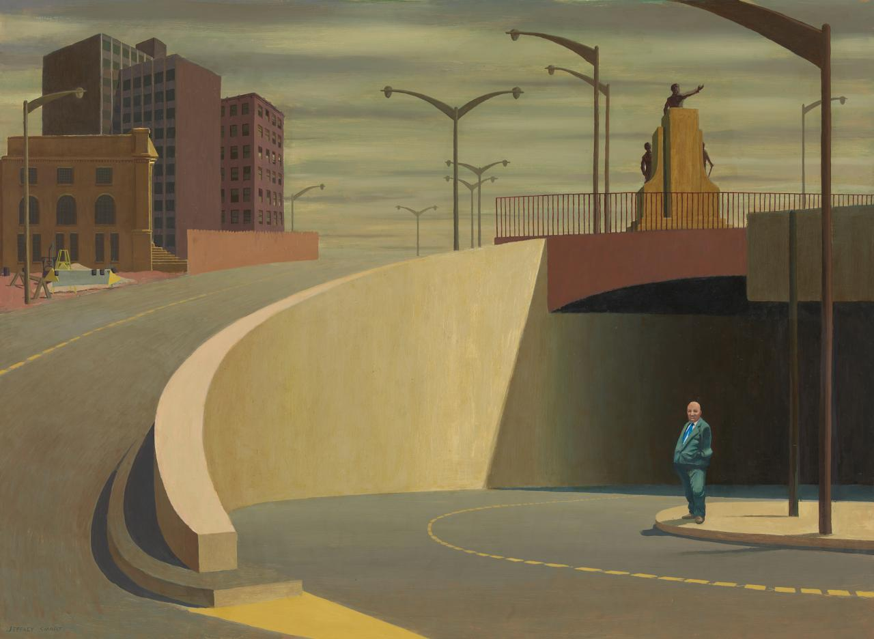
Picture 2 - Early Sunday Morning by Edward Hopper

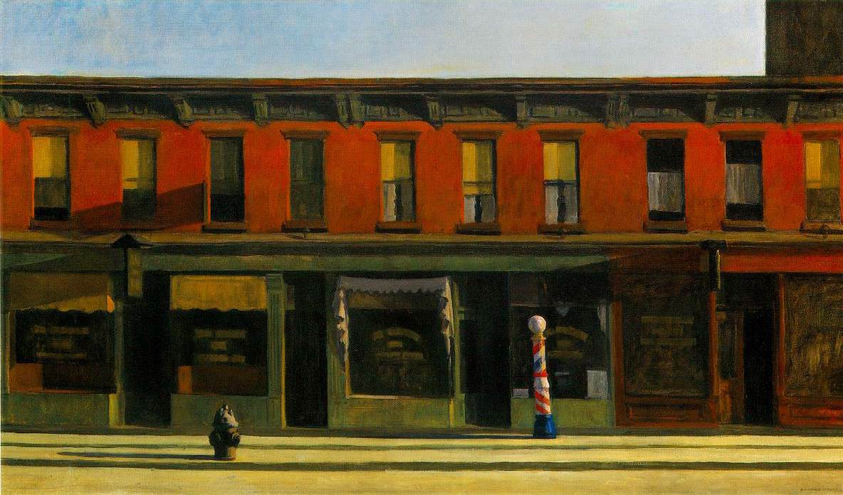

Picture 3 - Collins Street, 5pm by John Brack

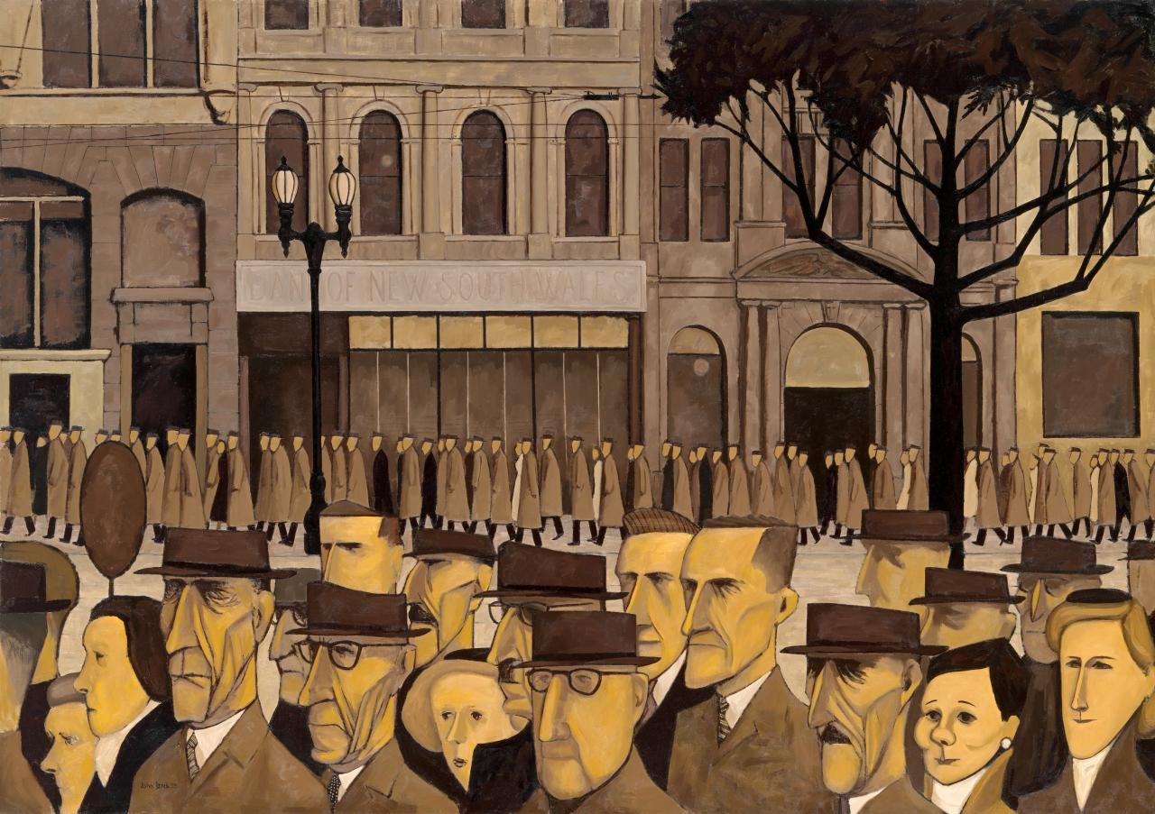

Picture Prompts

- What was your first reaction to this painting? Why do you think you had the reaction?
- Describe the lines in this painting.
- Describe the colours in the painting.
- Which area of the painting is most important? Why?
- What adjectives would you use to describe the painting?
- If you could ask the artist a question, what would you ask him/her?
- What emotions do you notice in the painting?
- Who do you know that would really like this painting? Why would they like it?
- Who do you know that would really dislike this painting? Why would they dislike it?
- If this painting were music, what would it sound like?
from https://artclasscurator.com/82-questions-to-ask-about-a-work-of-art/

