What to do today: Tuesday 2nd June
IMPORTANT Parent or Carer – Read this page with your child and check that you are happy with what they have to do and any weblinks or use of internet. Thank you.
Ms Varga and Mrs McNamara

If you didn’t watch this yesterday, you need to listen to it today: The Great Kapok Tree by Lynne Cherry. https://www.youtube.com/watch?v=J1Teb-_jTyI

1. Read what the animals said to the man in The Great Kapok Tree.
- Read Talking Animals.
- Which animal is the most persuasive in your opinion? Why?

2. Revise the Present Perfect Form
- Use the PowerPoint about the present perfect form and listen to the teaching. If this is not possible, remind yourself using the Revision Card.
- Complete What might they say? Choose verbs to match the animals and then write a sentence in the present perfect form.

3. Now for some writing
- Read Rainforest Animals 1. Write what these animals might say to the man as he slept. Try to include a sentence in the present perfect form.
- Challenge yourself to complete Rainforest Animals 2.

Well done. Share your writing with a grown-up. Show them the sentences that you have written in the present perfect form.

Try the Fun-Time Extras
- Research and write about some of the rainforest animals in this pack.
- Find out about canopies in the rainforest and make a labelled diagram to explain how they work.

Talking Animals
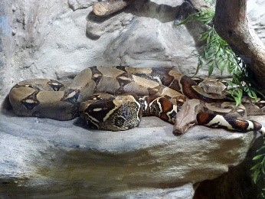 | The boa constrictor is a large snake that constricts its prey.  “Senhor, this tree is a tree of miracles. It is my home, where generations of my ancestors have lived. Do not chop it down.”
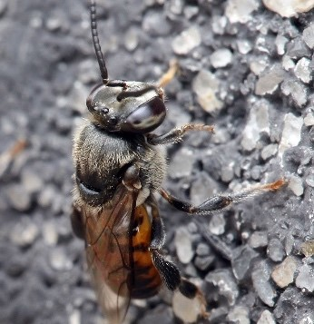 | This type of bee stores pollen and honey and has no sting.  “Senhor, my hive is in this Kapok tree, and I fly from tree to tree and flower to flower collecting pollen. In this way I pollinate the trees and flowers throughout the rain forest. You see, all living things depend on one another.”
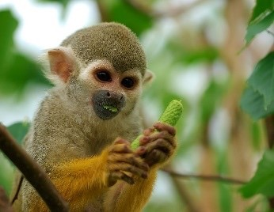 | Squirrel monkeys can live in massive groups, of up to 500 members!  “Senhor, we have seen the ways of man. You chop down one tree, then come back for another and another. The roots of these great trees will wither and die, and there will be nothing left to hold the earth in place. When the heavy rains come, the soil will be washed away and the forest will become a desert.”
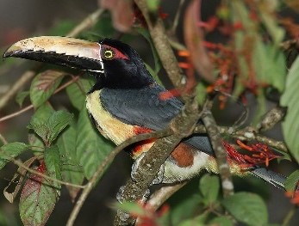 | Toucans mostly eat fruit, lizards and small insects.  “Senhor! You must not cut down this tree. We have flown over the rain forest and seen what happens once you begin to chop down the trees. Many people settle on the land. They set fires to clear the underbrush, and soon the forest disappears. Where once there was life and beauty only black and smouldering ruins remain.”
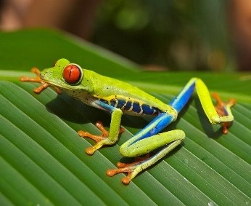 | The red-eyed tree frog is threatened by forestry and pollution.  “Senhor, a ruined rain forest means ruined lives… many ruined lives. You will leave many of us homeless if you chop down this great Kapok tree.”

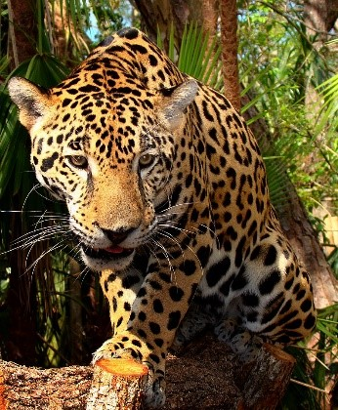 | The jaguar has a very powerful bite compared to the other big cats.  “Senhor, the Kapok tree is home to many birds and animals. If you cut it down, where will I find my dinner?”
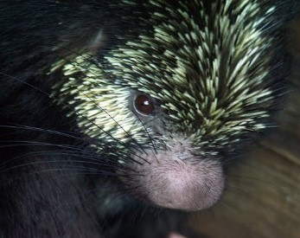 | Tree porcupines are much lighter than other kinds of porcupine.  “Senhor, do you know what we animals and humans need in order to live? Oxygen. And, Senhor, do you know what trees produce? Oxygen! If you cut down the forests you will destroy that which gives us all life.”
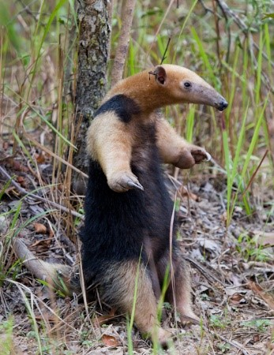 | This anteater has very strong front claws used to break insect nests.  “Senhor, you are chopping down this tree with no thought for the future. And surely you know that what happens tomorrow depends on what you do today. The big man tells you to chop down a beautiful tree. He does not think of his own children, who tomorrow must live in a world without trees.”
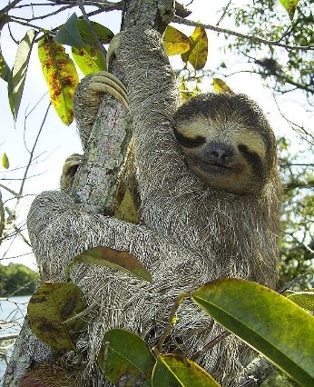 | Three-toed sloths are the size of a big cat and are agile swimmers.  “Senhor, how much is beauty worth? Can you live without it? If you destroy the beauty of the rain forest, on what would you feast your eyes?”

Present Perfect Form – Revision Card
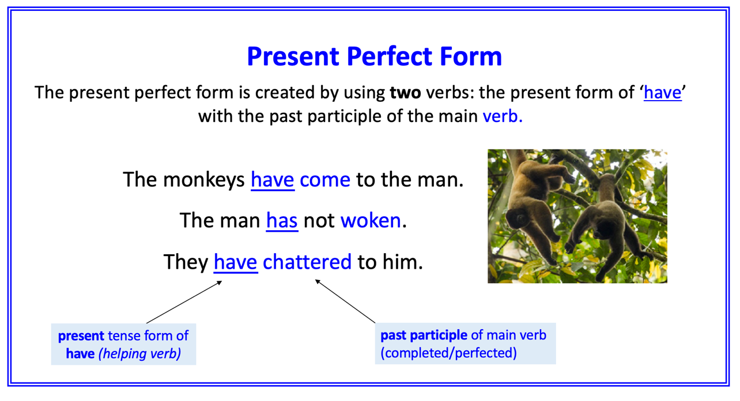
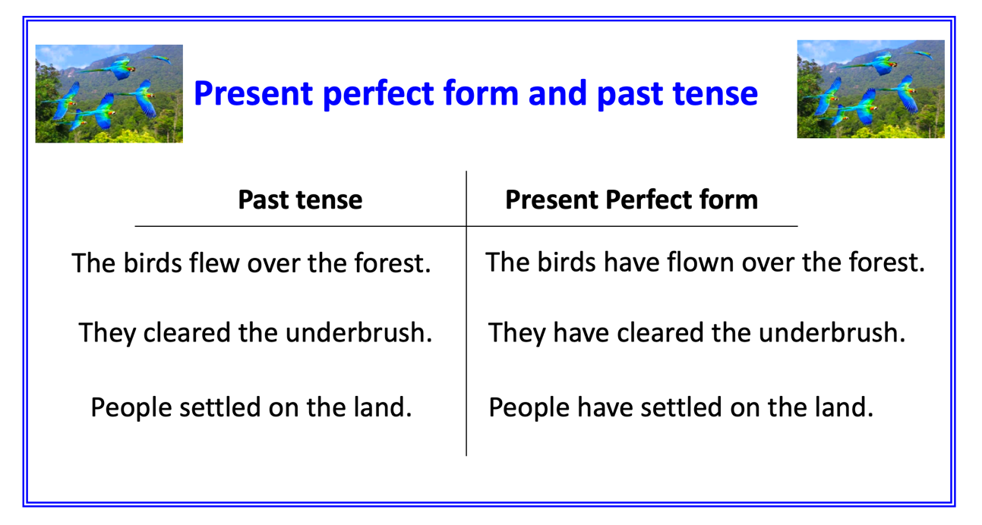

What might they say?
animal | verb | Sentence in present perfect form
frogs | sheltered | We have sheltered under the cover of the Kapok Tree.
jaguar | hunted | We have hunted …
porcupines | shuffled
anteaters
sloth
child

Rainforest Animals 1

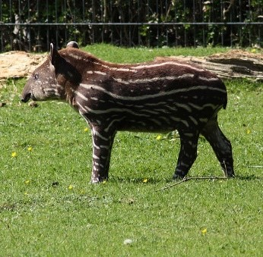
The Brazilian tapir is found near water and sleeps on riverbanks.

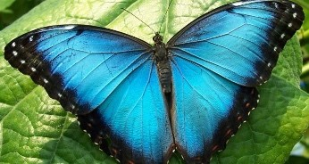
The blue morpho butterfly has enormous wings, around 15 cm across!

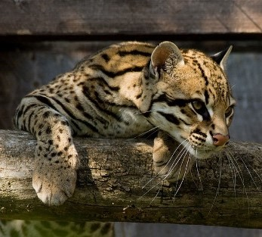
The ocelot is nocturnal. It will fight fiercely to defend its territory.

Rainforest Animals 2

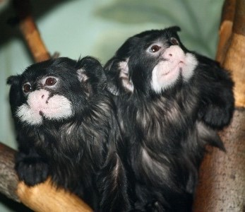
The moustached tamarin eats fruits, tree gum and insects.

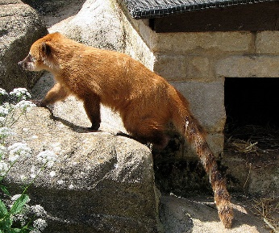
Coatis use their long tail for balance and signalling.

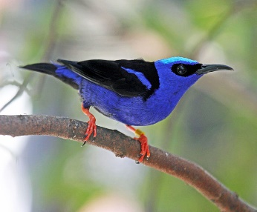
The red-legged honeycreeper builds a small cup nest in a tree.

