Pope Paul Primary School
Home learning Week beginning 22nd June 2020

Dear Pope Paul children,
Over the next few weeks, your afternoon learning will involve immersing yourself in a resource that engages your emotions, imagination and movements. We have been given free access to now>press>play AT HOME. You will be required to transform your living room in order to meet new people, discover new places, and solve problems!
http://nowpressplay.co.uk/learn-at-home/#Instructions
Password: nowpressplay
Once you have logged on, you will see an instruction video that shows you how to use this wonderful resource.
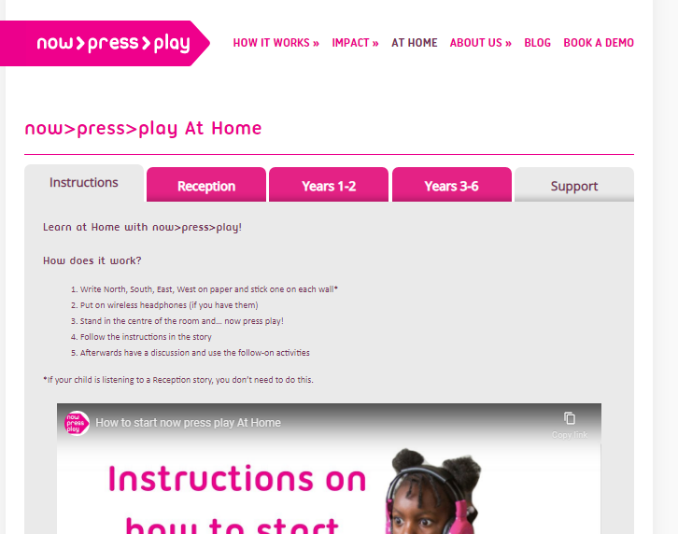
This week, our focus is on History. You can choose any History experience to follow but the grid below shows the recommended topics for each year group.
Year 1 | Year 2 | Year 3 | Year 4 | Year 5 | Year 6
- Castles  - Neil Armstrong | - Great Fire of London  - Florence Nightingale | - Stone Age  - Ancient Egypt | - Dinosaurs  - Stone Age | - Vikings  - Victorian Britain | - World War II  - Maya

Once you have completed the experience, there are tasks for you to complete. Your challenge is to become a History expert and complete as many as you can! Have fun and send us pictures of your learning.
From
Mrs Carey, Ms Davey, Miss Pringle, Miss Varga, Mrs McNamara, Mrs Lines and Miss Donatantonio.

