Pope Paul Primary School Home learning
Week beginning 8th June 2020
Dear Pope Paul children,
For this week, your afternoon learning will focus on wellbeing as we have had lots of feedback to say that this is an area you would like more activities on. Each day, try and complete at least one of the activities. At the bottom, there are details of a whole school challenge so please take a look.
Remember to keep sending us updates of your learning.
From
 | GIVE - ALL ABOUT KINDNESS, FRIENDSHIP, CARING, GENEROSITY AND GIVING
Make a friendship bracelet | https://www.youtube.com/watch?v=u5knLsLjlaE
Write a letter to a care home | During this time, people in care homes must be feeling particularly lonely and isolated, as no one is allowed to visit them. Brighten their day by sending a handwritten letter with kind words in.
Bake cupcakes for your neighbours | Do a spot of yummy baking, then leave on your neighbour’s doorstep with a note. Remember to wash your hands thoroughly before and after cooking.
Send a hug | Draw around yourself, colour it in and write a message to someone you’re are not able to see at the moment  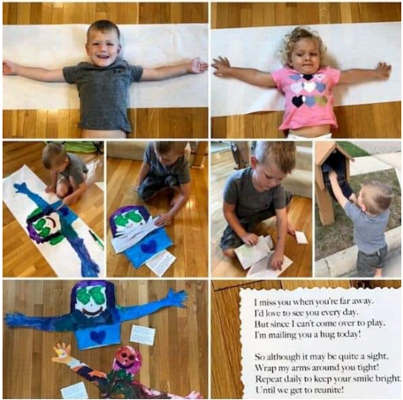
Give someone in your family a massage | Quickly learn how to give a neck and shoulder massage, then treat a family member to a few minutes relaxation! https://www.youtube.com/watch?v=CGcVy0dLF3o
Mrs Theo, Mrs Carey, Ms Davey, Miss Pringle, Miss Varga, Mrs McNamara, Mrs Lines and Miss Donatantonio.
 | BE ACTIVE - ALL ABOUT ENTHUSIASM, ENERGY AND CONFIDENCE
Yoga | Yoga is amazing for building strength, balance and confidence. Click on this link to try this fun yoga session: https://www.youtube.com/watch?v=inyw6mM4xTU
Organise a sports day for your family | What events would you like to challenge your family to? You might want to take on your dad in a sprint down the garden or have a go at the classic wheelbarrow race. Perhaps you could give the sack race a try!
Obstacle course | Using objects you can find around the house, make an obstacle course in your garden. Blindfold a family member, then see if you can guide them through the obstacle course by giving clear instructions. You could even make it more difficult by giving them a cup of water to pour into a bucket at the end of the course!
Newspaper dance | - Each player begins standing on a large piece of newspaper.  - When the music plays, children move off their newspaper and dance around the space.  - When the music stops, children get back on their newspaper and hold a balance.  - Each time, reduce the size of the newspaper by folding it.  - Keep playing until it’s the newspaper’s too small to stand on without touching the floor!
Find three things that are... | - One person says ‘find three things that are…. blue.’ etc.  - The other person then has to collect three things that are blue and bring them back to that person.  - Make this harder by timing the person to see how long it takes them.  - Other things that could be collected include ‘find three things that are…. spotty, start with the letter ‘C’, round, soft to touch.’
Cereal box challenge | - Place the cereal box on the floor  - Pick the cereal box up using only your mouth  - Nothing but your feet can touch the floor  - If successful, cut an inch from the top of the cereal box and play the game again  - How low can you go?

 | CONNECT - ALL ABOUT COMMUNICATION, TEAMWORK, CO-OPERATION AND TOGETHERNESS
Give someone a call | Voice or video call a friend or family member that you don’t live with. Ask how they are and really listen to them.
Meet a friend for a socially-distanced visit to the park | Now that restrictions have slightly lifted, go with an adult to a local park and see a friend face-to-face. Just make sure there are no more than 6 of you altogether and remember to keep 2 metres apart.
Send a picture to your teacher of something you’ve done or made | Share an activity you’ve enjoyed doing or something you’ve made that you’re proud of, then look out for it on Friday’s celebration blog.
Play a game with family | - Sticky-note Fun – write the name of an animal, person or object onto a sticky note. Put it on a family member’s head and ask each other questions to guess what’s written on your head.  - Throwaway Game – each family member explains if they could only keep one possession, what would it be and why?  - 5 Things – Write down five of your favourite things eg. Food, book/film, subject, animal, colour. Can you guess each other’s
Compliment Jar | Throughout the week, fill a jar with compliments about your family. On Sunday, sit down and share as a family.

 | TAKE NOTICE - ALL ABOUT LISTENING, OBSERVING AND REFLECTING
Open your eyes when you’re on your daily walk | Take photos of things you find beautiful or inspiring. When you get home, could you make a collage?
Listen to a song | Listen to Together by Sia and close your eyes. Think about the lyrics. What is the message of the song? What can you take from it?  https://www.youtube.com/watch?v=vjMeJi01crk
Look at a piece of art | 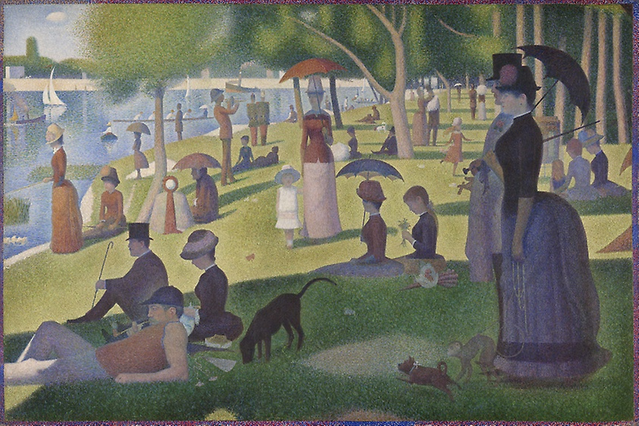  A Sunday on La Grande Jatte — Georges Seurat (1884)  - What colours has the artist used?  - What details can you see when looking closely?  - Is there any symbolism that you recognise?  - Do you like the art?  - What do you think the artist is trying to show?  - Can you try and recreate it?
Sit outside for 5 minutes | Close your eyes. Pay attention to your breathing and the sounds you can hear.
Eat a raisin mindfully | - Pick it up, noticing how it feels in your hand.  - Look at it carefully. See the shapes and think about the changes it has been through.  - Feel it and describe the texture to yourself.  - Smell it. Does it remind you of anything?  - Think about how it feels on your tongue.  - Chew it. How does the texture and taste change?
Nature art | Collect bits of nature from your walk today (stones, seeds, feathers, moss, leaves, twigs, petals, grasses) and make a collage with them when you get home.
 | KEEP LEARNING – ALL ABOUT CURIOSITY AND GAINING NEW SKILLS
Sew on a button | Have you got an item of clothing that has lost a button? If not, just practise on a piece of fabric. Learn how to do it here: https://www.youtube.com/watch?v=MjmUaWkzF-I
Learn your name or a song in sign language | Spell your name here: https://youtu.be/pWKkrllhOCc  Make Your Own Kind of Music in BSL: https://www.youtube.com/watch?v=SFFvxAdZSPk
Change the bed linen
Do origami
Plan the weekly shop | Ask your parents what they plan to cook and write down the ingredients they will need.
Know how to write your full name, date of birth and address
Do the washing up
Learn to put someone in the recovery position | https://www.youtube.com/watch?v=cHhjskRubbo
Learn what to do in an emergency situation | https://youtu.be/ZxzewVTDas0

Pope Paul Biking Challenge
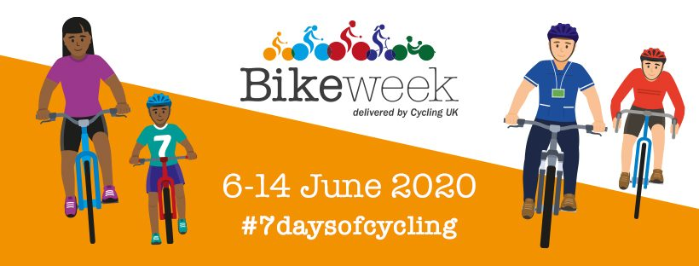
We want you to get on your bike and take part in a Pope Paul challenge! This week, try and get out and cycle as much as possible to help us reach our goal of completing a virtual cycle from John O’Groats to Lands End. At the end of the week, send your teacher the total number of miles you cycled and we will add them together. Our target is to complete the full 874 mile journey as a school.

