What to do today
IMPORTANT Parent or Carer – Read this page with your child and check that you are happy with what they have to do and any weblinks or use of internet.

1. Write some descriptions
- Look at the photo: Fox in the Snow.
- Write some descriptions of this photo. Try to make them as detailed as you can.
- Watch the video of foxes. Write a description of how they move. https://www.youtube.com/watch?v=J4ToHu1MM9E

2. Read a poem
- Read First Fox.
- Use the Visual Dictionary to help you to understand about the poem.
- Look carefully at the Secret Strings. Can you see the links that have been spotted?

Well done. Talk with a grown up about Secret Strings. They might like to read the Adult Reference Notes.

3. Find Secret Strings
- Read the poem: Fox
- Highlight and underline the poem to show any secret strings that you can find. Anything that links one word or phrase with another.

Well done! Share your secret strings with a grown-up.

Try the Fun-Time Extra
- Can you make an illustration for either of these poems?
- Can you write your own poem about foxes?

Fox in the snow

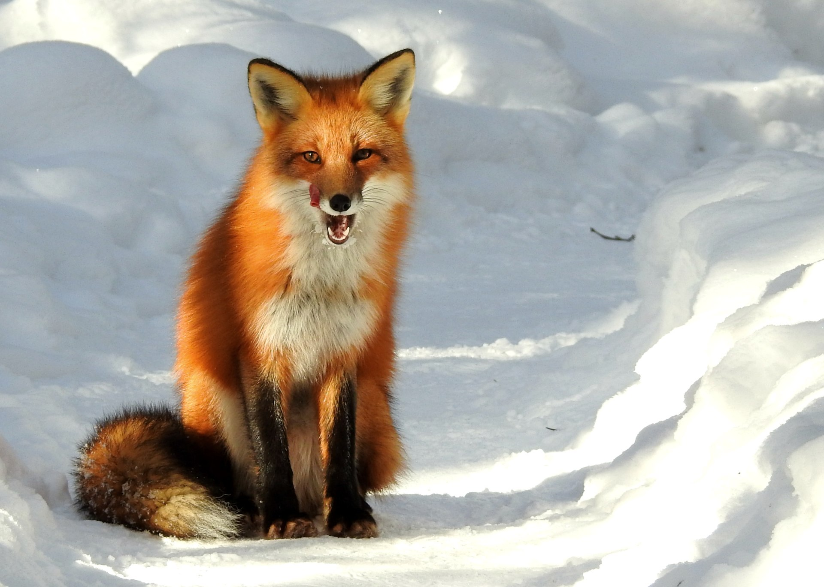

First Fox

A big fox stands in the spring grass,
Glossy in the sun, chestnut bright,
Plumb centre of the open meadow, a leaf
From a picture book.

Forepaws delicately nervous,
Thick brush on the grass
He rakes the air for the scent
Of the train rushing by,

My first fox,
Wiped from my eye,
In a moment of train-time.

Pamela Gillilan

Visual Dictionary

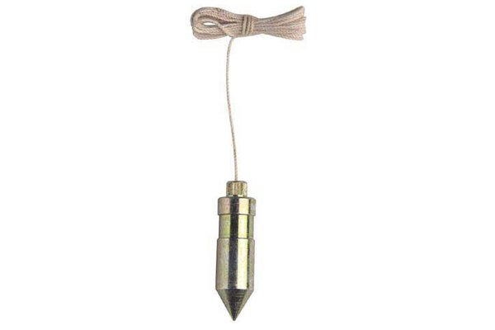  Plumb line | 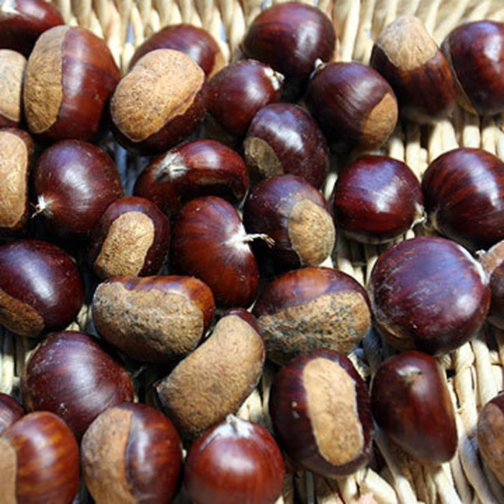  Chestnut
Leaf of a book | 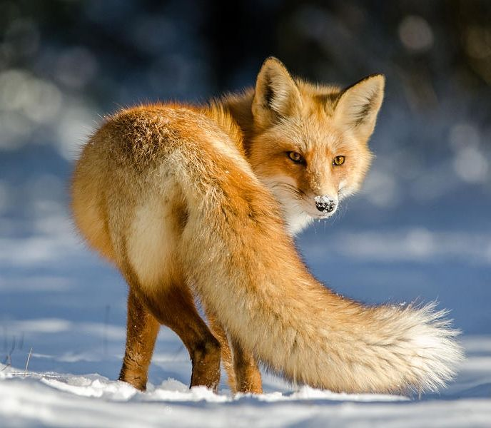  Brush
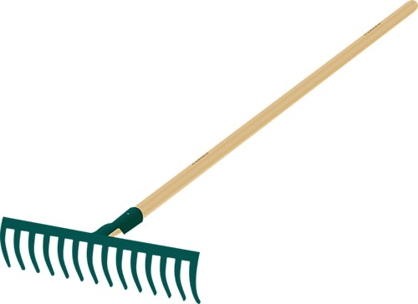  Rake | 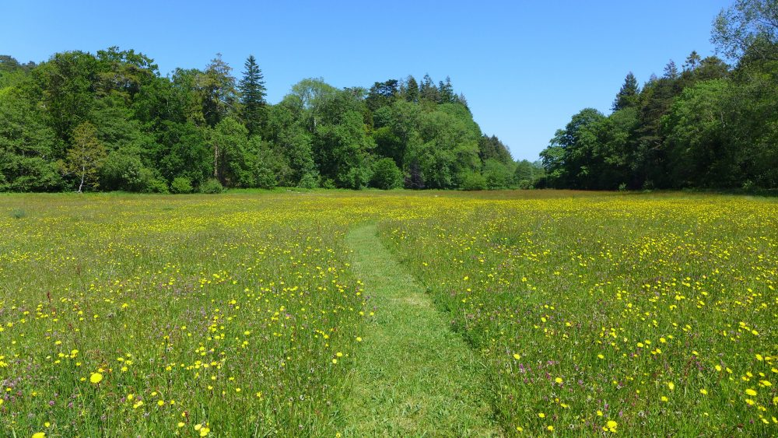  Meadow

Secret Strings

A secret string is anything that links one word or phrase to another.

A big fox stands in the spring grass,
Glossy in the sun, chestnut bright,
Plumb centre of the open meadow, a leaf ??page??
From a picture book.

- Alliteration – x and s making similar sounds
- Stands and grass echo one another because of the similar vowel sounds
- Nut and bright echo one another because they have the t sound at the end
- Open and book are linked words – the meadow is open like a book
- Why hasn’t the poet used the word page. Is it because leaf is also to do with nature?
- Chestnut bright is a shortened simile – as bright as a chestnut…

Secret Strings: Adult Reference

Secret Strings is a way of thinking about poems explained by Michael Rosen in his book: What is Poetry? (2016 Walker Books).

He explains them as the way that poems bring words together.

A secret string is anything that links one word or phrase to another.

They can include:

- Words sounding like another (for example rhyme, alliteration or assonance)
- One line’s rhythm echoing that of another
- Words or groups of words repeating
- Word pictures made by the similar or the same words being used (the picture or imagery of the poem)
- Opposites

Importantly, Michael Rosen says this:

“Remember, these strings belong to you. They may be strings that the poet had in mind – but maybe not.”

In First Fox example, these Secret Strings have been marked:

- Assonance

- Alliteration

- Echoing words

- Precise language

- Simile/Metaphor

Fox

After dark
when the cars park
and the streets are quiet
Fox comes
loping calmly over the wall.

He strolls
along the pavement
and
across the road
with his long nose,
sharp ears
and his feathery brush of a tail,
flows like water through the shadows and hard
spaces.

He goes alone.
This is his place
these trails of smells,
the bins and bags that are his pickings
the yards and parks,
back alleys and the hollows under cars.
If we pass by he turns and with one look
reminds us
that we’ve only borrowed it.
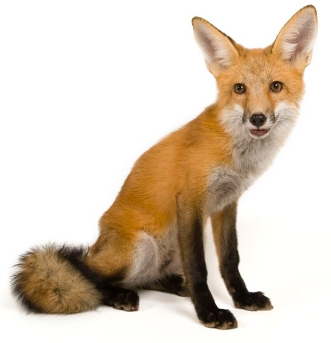

by Kathy Henderson

