What to do today
IMPORTANT Parent or Carer – Read this page with your child and check that you are happy with what they have to do and any weblinks or use of internet.

1. Look closely at an illustration.
- Look at Illustration 1.
- What can you notice in the picture? Try to make a note about ten things that you can see.
- Where in the story does this come? How would you explain it to somebody else in three sentences?
- Look at Illustration Verbs. Can you make up sentences about the illustration that use these verbs? Speak your sentences out loud.

2. Practise Present Perfect Form
- Use the Revision Card to remind yourself about the present perfect form.
- Complete the Cloze Activity and then read out loud the sentences you have written. They are in the present perfect form.

3. Now for some writing.
- Imagine that the man is writing to his family to explain why he has left his job. What will he say to them?
- Write a Postcard from the man to his family. Try to include at least one sentence in the present perfect form.

Well done. Share your writing with a grown-up. Show them the sentence that you have written in the present perfect form.

Try the Fun-Time Extras
- Design the picture side of the man’s postcard.
- Write a postcard to send to somebody that you haven’t seen for a while.

Illustration 1
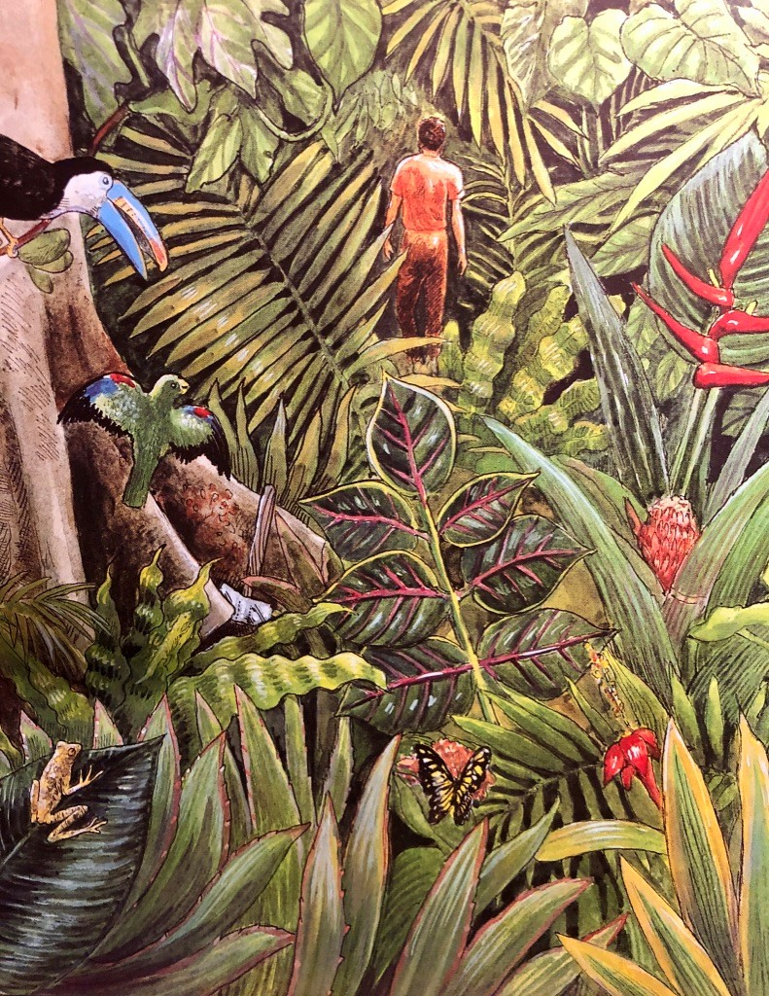

Illustration Verbs
realised
heard
listened
thought
understood
slept
dreamt
decided
chosen
dropped

Present Perfect Form – Revision Card

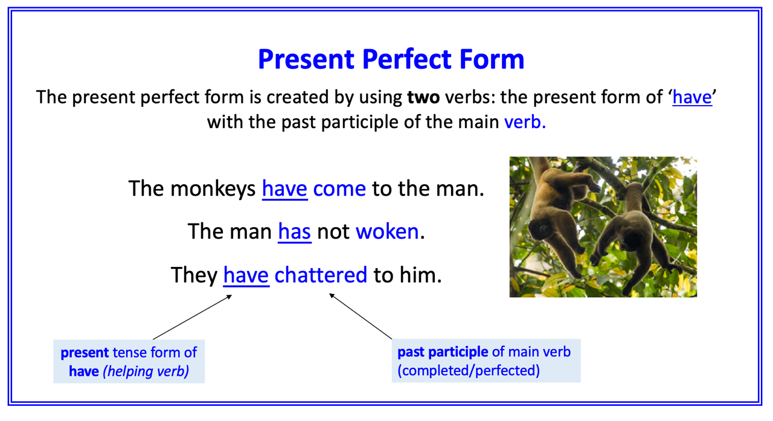
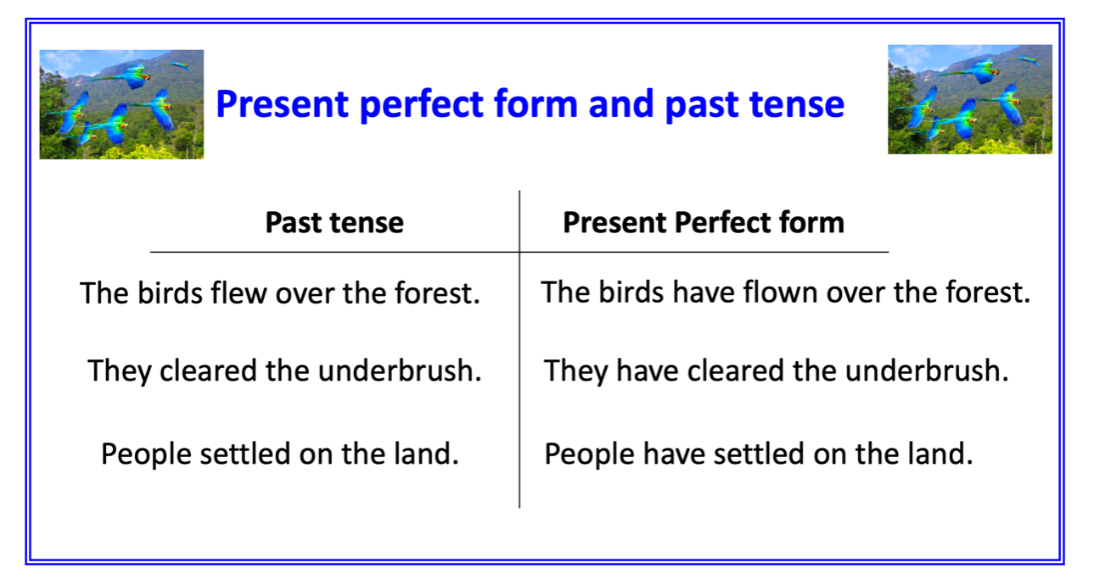
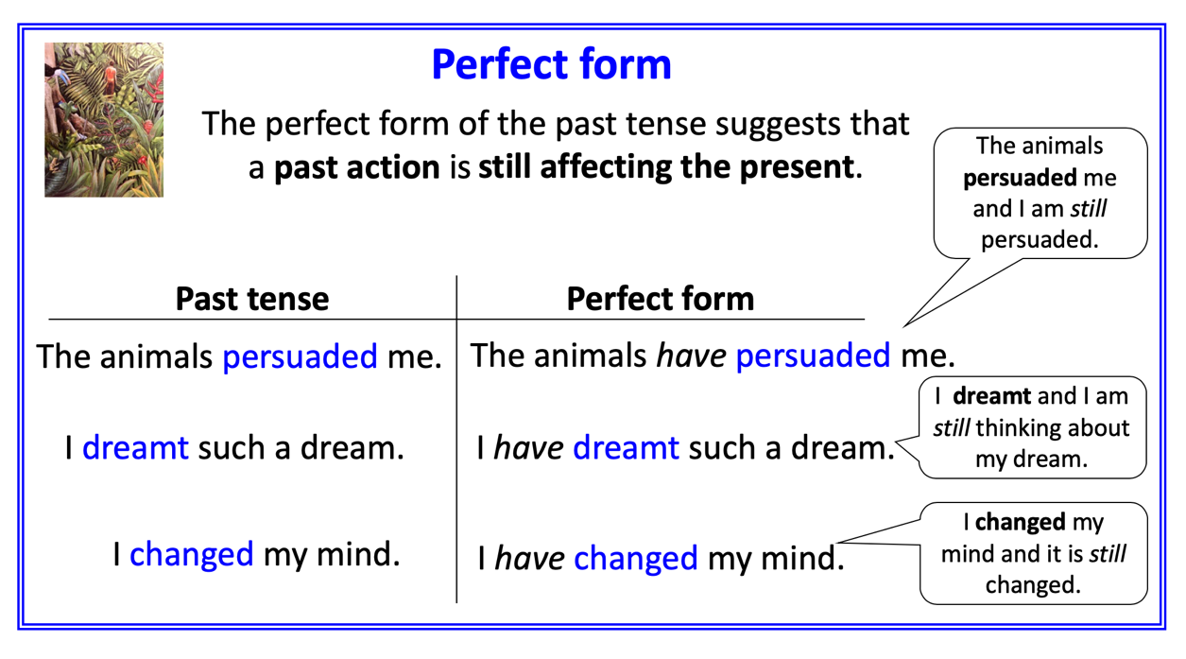

Cloze Activity

The man has ____________ that he should protect the forest.
He has ___________ the animals speak to him
He has ___________ to the child.
He has ___________ about the things he heard.
He has ___________ the message of the animals.
The man has __________ in the rainforest.
He has ___________ an amazing dream!
He has __________ not to chop the axe.
He has __________ not to do as he was told.
He has __________ his axe.

decided | slept | chosen | dreamt | dropped
realised | thought | understood | listened | heard

Postcard

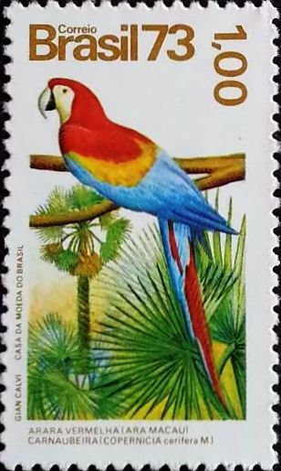

Cloze Activity - Answers

The man has realised that he should protect the forest.
He has heard the animals speak to him
He has listened to the child.
He has thought about the things he heard.
He has understood the message of the animals.
The man has slept in the rainforest.
He has dreamt an amazing dream!
He has decided not to chop the axe.
He has chosen not to do as he was told.
He has dropped his axe.

decided | slept | chosen | dreamt | dropped
realised | thought | understood | listened | heard

