What to do today
IMPORTANT Parent or Carer – Read this page with your child and check that you are happy with what they have to do and any weblinks or use of internet.

1. Look carefully at an illustration
- Look at the picture of Duck and Bird.
- What is happening in the story before this picture? What will happen just after? (Use your Story Summary from Day 1 to remind you).
- Listen to the music that goes with this part of the story:
https://www.youtube.com/watch?v=Vp2Y8ytYDns
- What do you picture when you hear this music? How could you describe the picture in your head?

2. Imagine some speech
- Imagine all the things that Duck and Bird might have said in their argument? What else might they have boasted about? How might they have insulted each other?
- Write your ideas on Duck and Bird Arguments.

3. Now for some writing
- Write a paragraph that tells this part of the story.
- Include some direct speech in your writing. Use the Revision Card to remind you about how to do this.

Well done. Share your writing with a grown-up. Show them how you have punctuated your direct speech.

Try the Fun-Time Extra

Watch the second part of the musical version of the story:
https://www.youtube.com/watch?v=Va8Uz6MoKLg

Duck and Bird

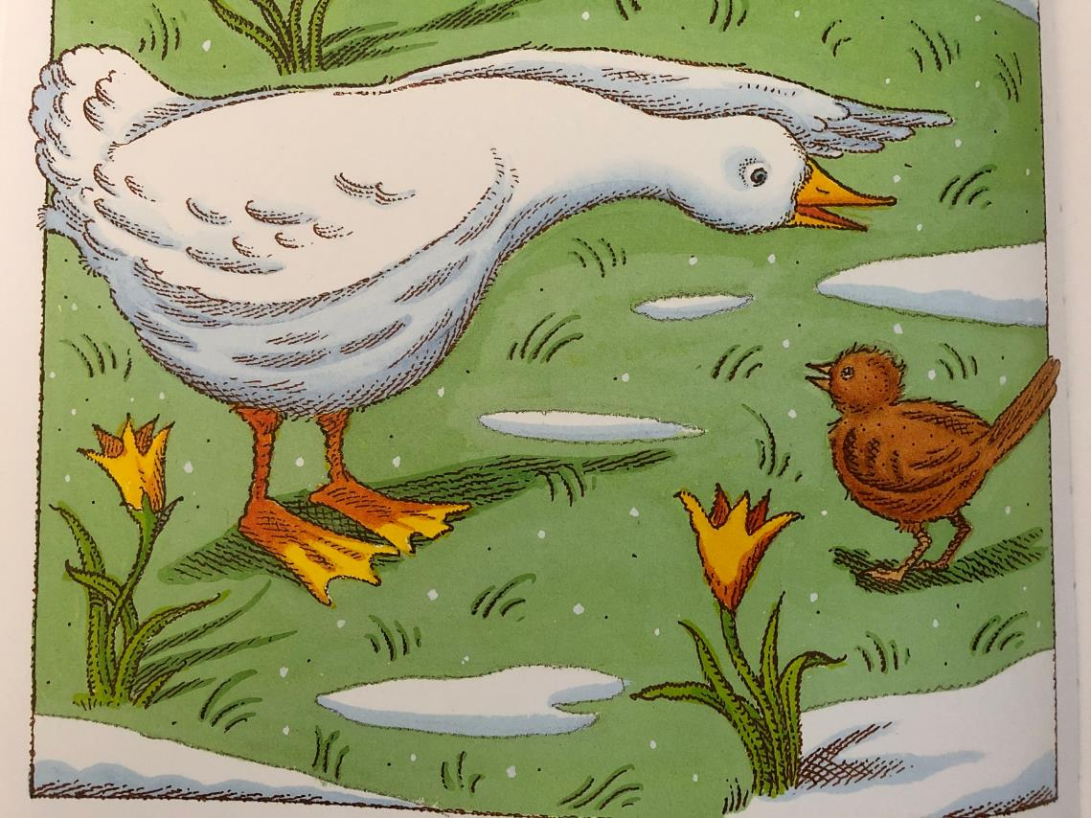
From Peter and the Wolf by Ian Beck
Duck and Bird Arguments

What else might Duck and Bird said to one another? Try to think of 3-5 ideas for each.

Duck | Bird
What sort of bird are you if you can’t swim? | What sort of bird are you if you can’t fly?  Why are your feet so orange?

Revision Card – Punctuating Speech

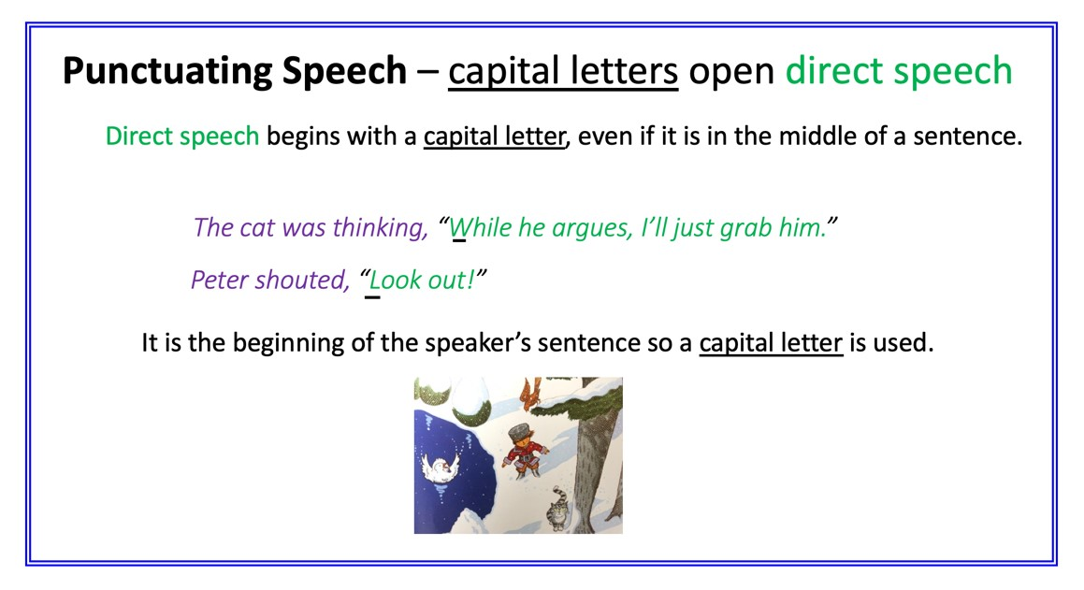 | 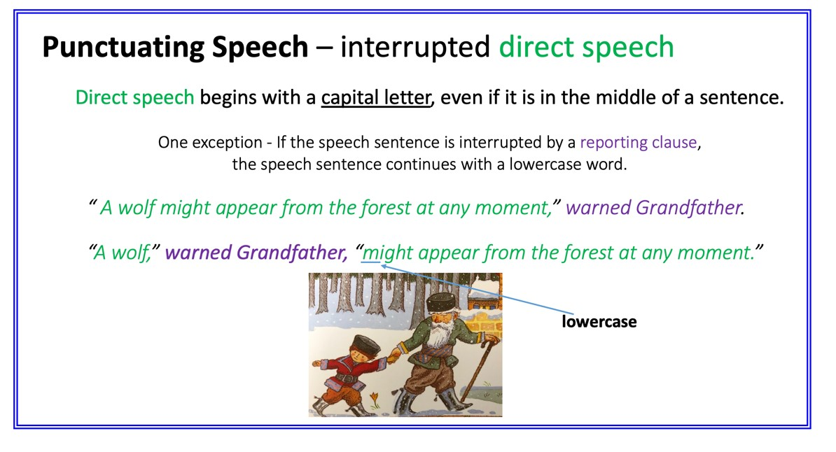
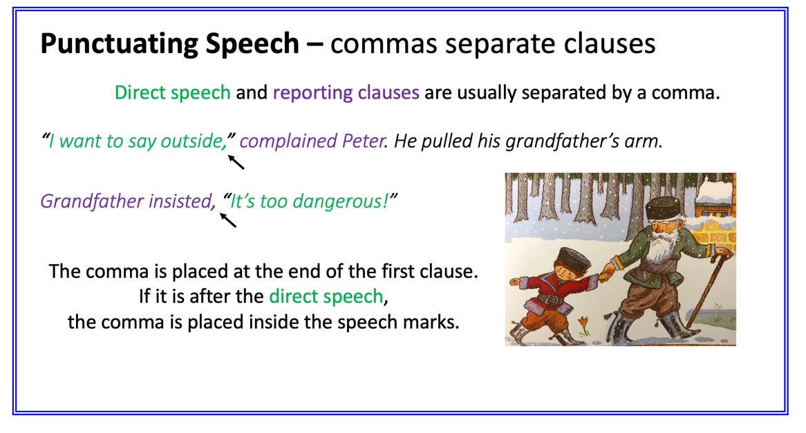 | 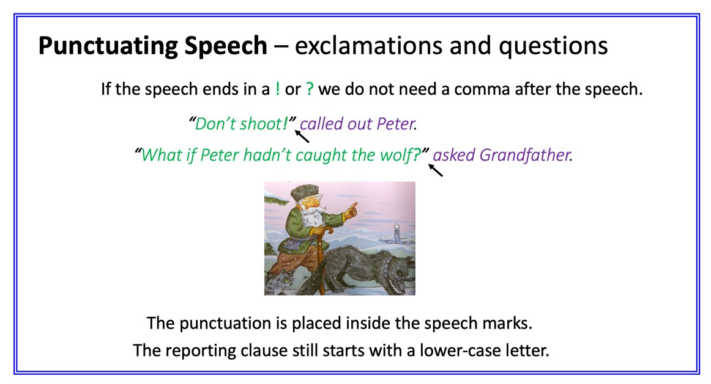

Duck and Bird Argument

