Thursday 4th June: What to do today
IMPORTANT: Dear Parent or Carer – Read this page with your child and check that you are happy with what they have to do and any weblinks or use of internet.
Ms Varga and Mrs McNamara

1. Activity: Read a poem.
- Read Willow Pattern by Tony Mitton. What do you like about the poem? Can you notice any patterns or puzzles?
- Now watch https://www.youtube.com/watch?v=4VwAYc7dsUE How does the poem match the plate?

2. Activity 2: Summarise the story
- Use Plate Picture and add captions to tell the story.
- Now make a plan for telling the story on Story Plan.

3. Activity 3: Now for some writing
- Read Descriptive Language and add your own ideas for descriptive sentences to tell the story.
- Try writing the story. Use your Story Plan and Descriptive Language to help you as you do.

When you have completed activity 3, read your story to a grown-up.
Can you test them to check that they remember what happened?

Try the Fun-Time Extra
- Watch these versions of the Willow Pattern Story. How are they similar to yours? How are they different? What do you like most about each? Which is your favourite? Why?
www.youtube.com/watch?v=Lj5uTZG6G90
www.youtube.com/watch?v=Ge1LD8JDfYg

Willow Pattern by Tony Mitton

Look. On my plate  is a blue garden  it happened in China  A long time ago.  There on a bridge  the soldiers are running  to capture the princess,  the Emperor’s daughter.  She left with the young man  she wanted to marry.  They fled to an island  That lay on a lake.  The Emperor was angry.  He ordered his soldiers  to capture the princess  and kill the young man. | 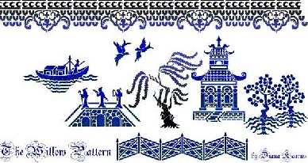
But the man and the princess
were turned into bluebirds.
They flew from the island
and never returned.

The Emperor, in sadness,
Turned into a willow.
And always he droops
as he weeps in his sorrow.

He weeps on my plate
In a blue garden.
It happened in China
a long time ago.

Tony Mitton (The Works p462)

Plate Picture
Add captions to tell the story.

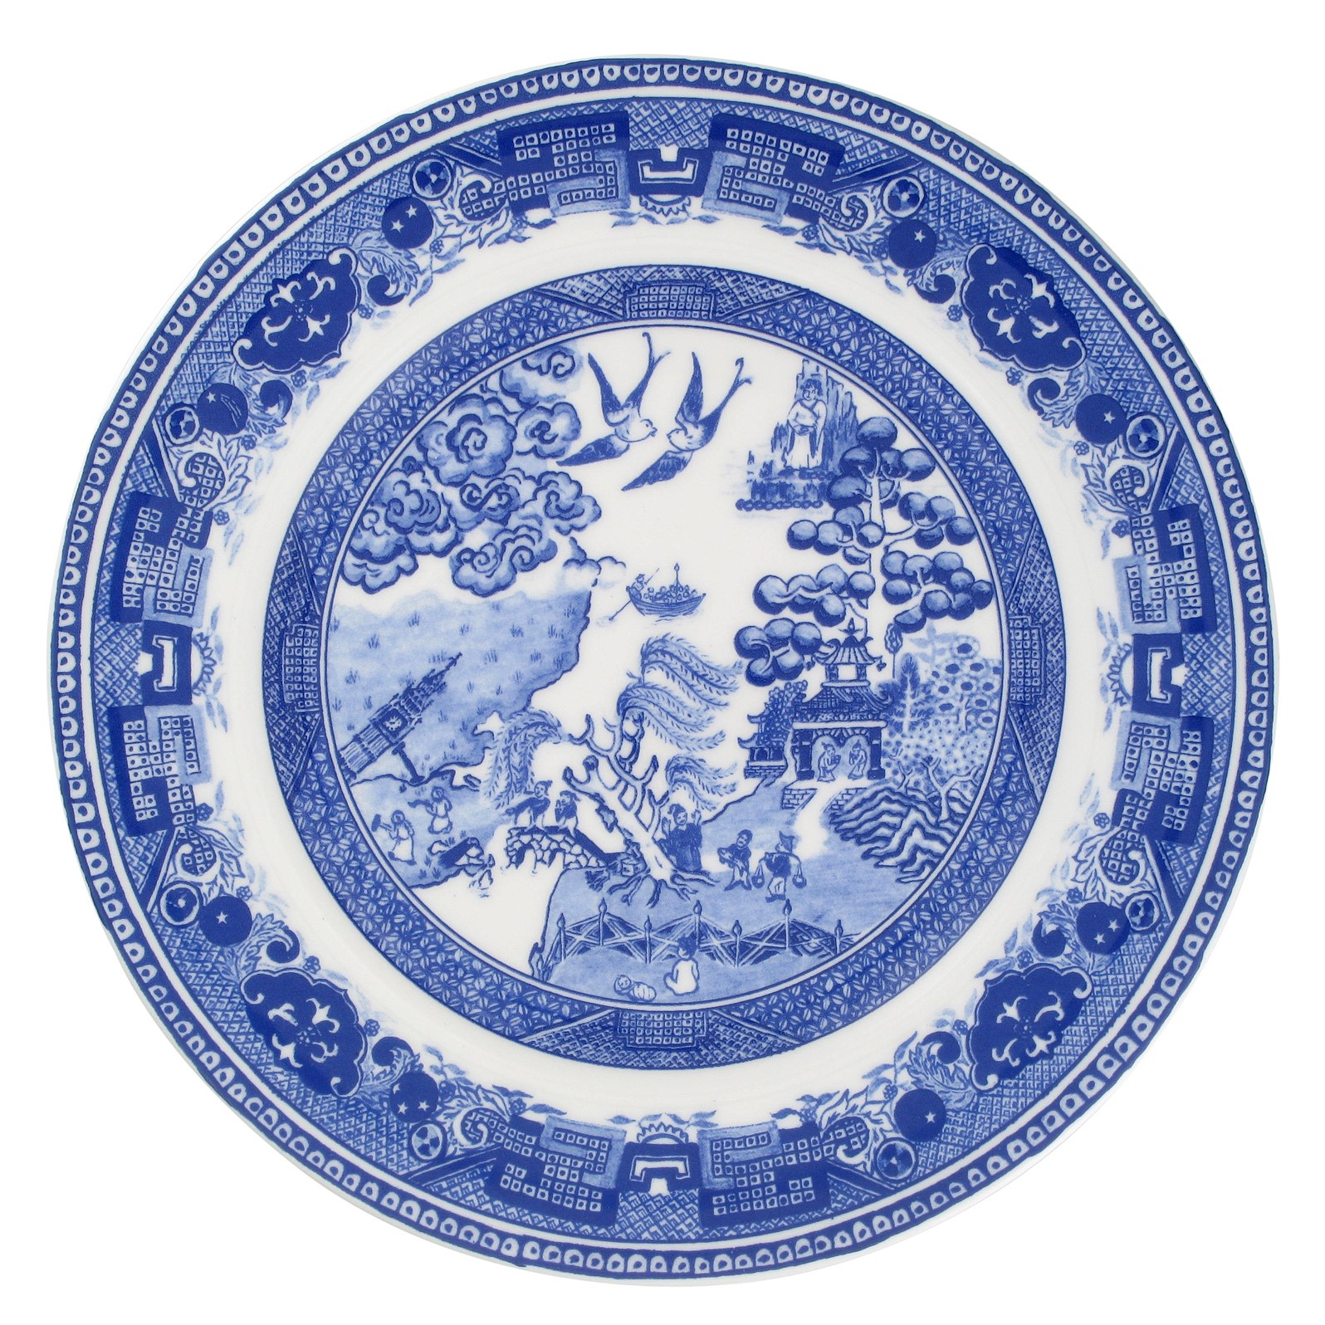

Story Plan

How will you introduce your story?
What will be the first event?
What will happen next?
What will be your final event?
How will you round off your story?

Descriptive Language
Add your ideas for descriptive sentences.

The sky, swirling in a mass of blue and white, appeared to open.

The princess, with glistening hair the colour of ebony, ran over the bridge.

She flew up into the sky, which was orange and warm.

The prince waved his sword, which had been given to him by his father, in the air.
The Willow-Pattern story
Write your version of the story here….remember, use interesting descriptive words to interest your reader!

