Thursday 25th June
What to do today
IMPORTANT : Dear Parent or Carer – Read this page with your child and check that you are happy with what they have to do and any weblinks or use of internet. Ms Varga and Mrs McNamara

1. Read a poem
- Read the poem: Summer and Winter. Read it twice: once in your head and once out loud.
- Read and think about the Poetry Questions. Write some of your answers on the sheet.

2. Remind yourself about adverbials
- Use the PowerPoint giving some teaching on Adverbials. If you can’t access this, then use the Revision card to remind yourself about adverbials.
- Write endings for the Fronted Adverbials. Challenge yourself to write two different endings for each.

3. Choose your favourite poem.
- The fronted adverbials come from these four poems:
  - Windy Nights
  - Pike
  - The Sandpiper
  - Duck’s Ditty
- Read each of the poems out loud. Decide which is your favourite.

Share your favourite poem with a grown-up. Explain to them why you like it best and find out from them which is their favourite of the four poems.

Try the Fun-Time Extra
- Can you try to learn some of your favourite poem off by heart?

Summer and Winter

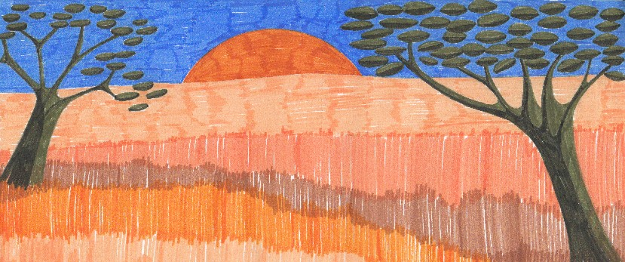
When a warm dawn brings
the sun to your eyes,
blink three times –
it’s time to rise.

When cold winds whistle
around your head,
pull it under the blankets
and stay in bed.

by Michael Dugan
Poetry Questions

What do you like about this poem? Is there anything you dislike? Why? | What does this poem make you think about? Does it remind you of anything?
What patterns can you find in this poem? | What puzzles or questions does this poem raise?

Revision Card - Adverbials

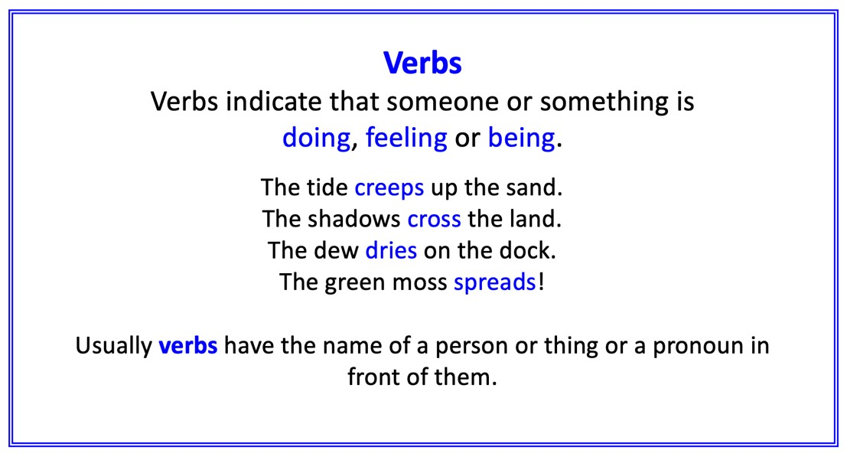 | 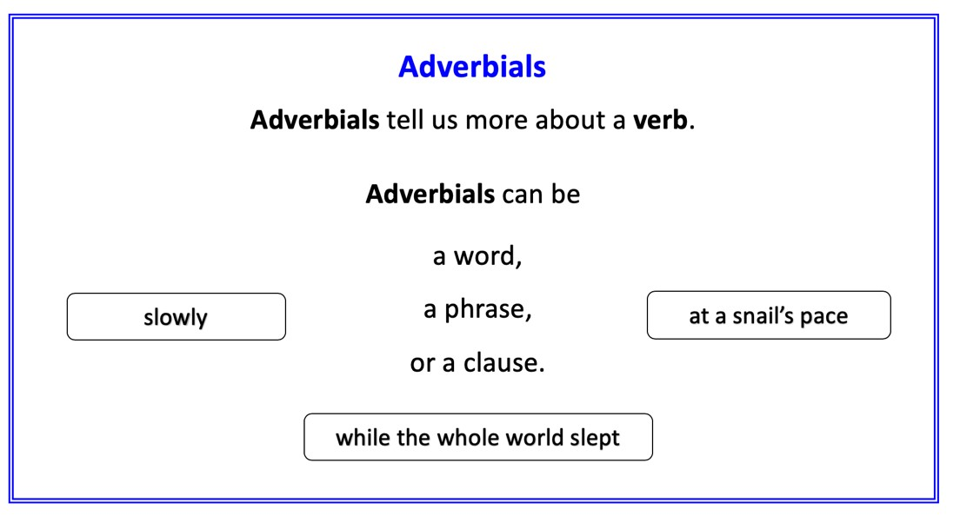
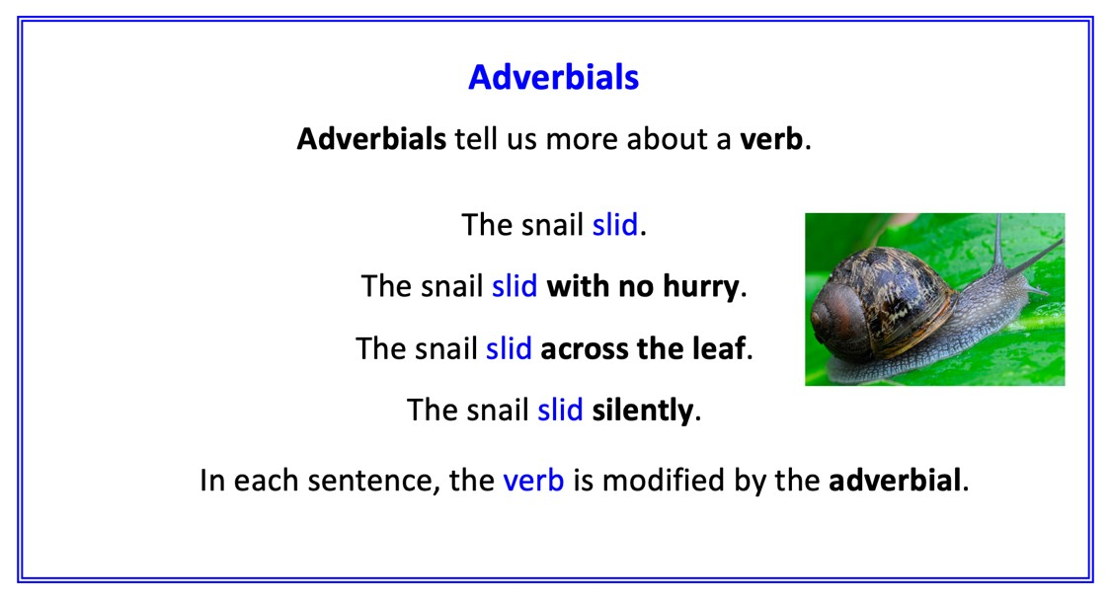 | 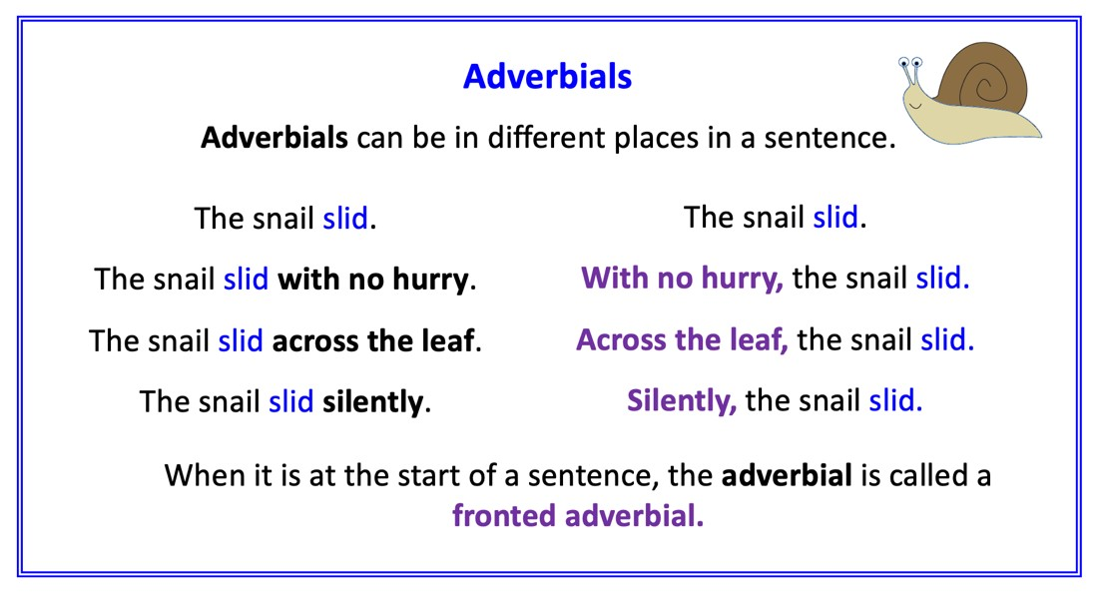

Grammar Focus: Fronted Adverbials

Can you think of the main sentences that could follow these Fronted Adverbials?

- In the brown water,

- Late in the night when the fires are out,

- Whenever the wind is high,

- At the edge of the tide,

- Whenever the moon and stars are set,

- Out from under the reeds,

- All night long in the dark and wet,

- On toothpick legs,

- All along the backwater,

- High in the blue above,

- Whenever the trees are crying aloud,

Windy Nights

Whenever the moon and stars are set,
Whenever the wind is high,
All night long in the dark and wet,
A man goes riding by.
Late in the night when the fires are out,
Why does he gallop and gallop about?

Whenever the trees are crying aloud,
And ships are tossed at sea,
By, on the highway, low and loud,
By at the gallop goes he.
By at the gallop he goes, and then
By he comes back at the gallop again.

by Robert Louis Stevenson

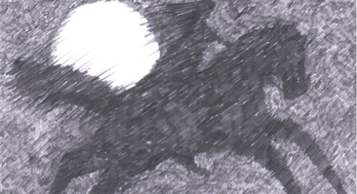

Pike

In the brown water,
Thick and silver-sheened in the sunshine,
Liquid and cool in the shade of the reeds,
A pike dozed.
Lost among the shadows of stems
He lay unnoticed.
Suddenly he flicked his tail,
And a green-and-copper brightness
Ran under the water.

Out from under the reeds
Came the olive-green light,
And orange flashed up
Through the sun-thickened water.
So the fish passed across the pool,
Green and copper,
A darkness and a gleam,
And the blurred reflections of the willows on the opposite bank
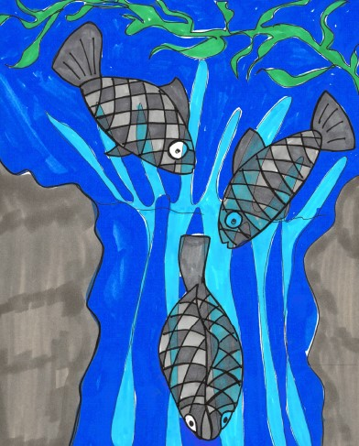
Received it.

by Amy Lowell

The Sandpiper

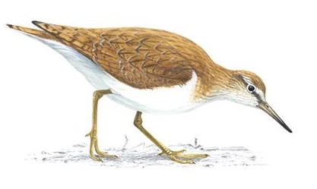

At the edge of tide
He stops to wonder,
Races through
The lace of thunder.

On toothpick legs
swift and brittle,
he runs and pipes
and his voice is little.

But small or not,
he has a notion
To outshout
The Atlantic Ocean.

by Frances M Frost

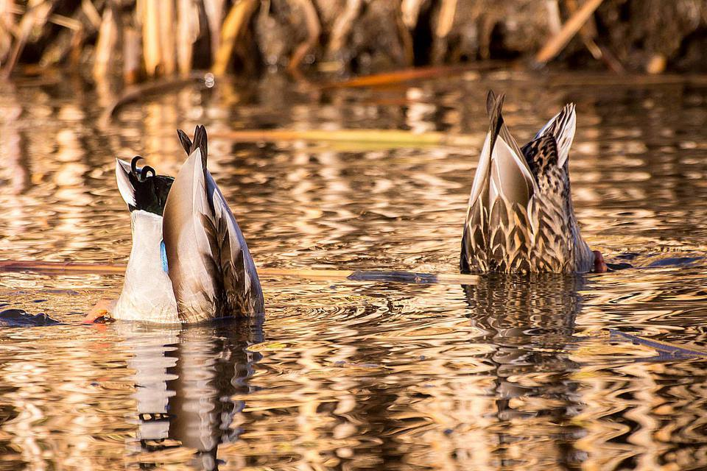
Duck’s Ditty

All along the backwater,
Through the rushes tall,
Ducks are a-dabbling,
Up tails all!

Ducks’ tails, drakes’ tails,
Yellow feet a-quiver,
Yellow bills all out of sight
Busy in the river!

Slushy green undergrowth
Where the roach swim—
Here we keep our larder,
Cool and full and dim.

Everyone for what he likes!
We like to be
Heads down, tails up,
Dabbling free!

High in the blue above
Swifts whirl and call—
We are down a-dabbling
Up tails all!

by Kenneth Grahame

