Purple Is……..
A beautiful bunch of grapes
Juicy round plums
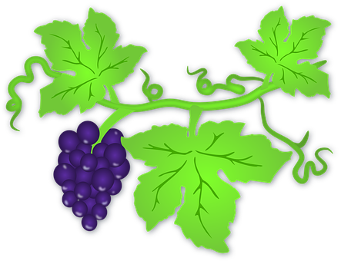
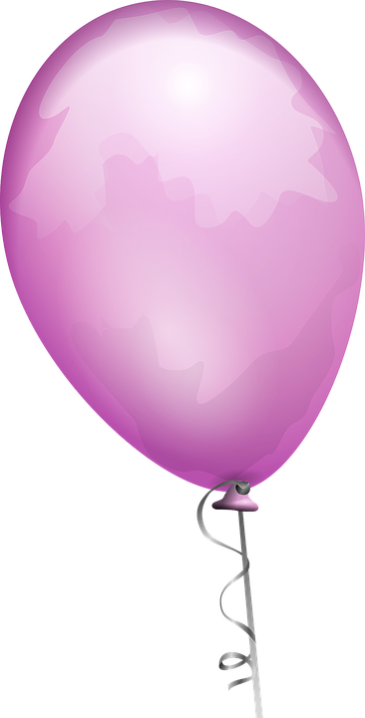
Shimmering waves of heather
Floating shiny balloons
My cosy woolly jumper
That’s what purple is to me
By An Anonymous Poet
