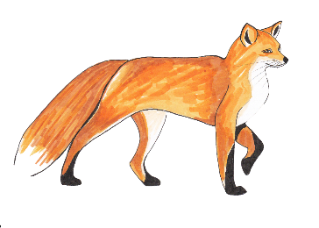
Chapter 16
‘Quick!’ said Mr Fox. ‘Hide!’ He and Badger and the Smallest Fox jumped up on to a shelf and crouched behind a big row of cider jars. Peering around the jars, they saw a huge woman coming down into the cellar. At the foot of the steps, the woman paused, looking to right and left. Then she turned and headed straight for the place where Mr Fox and Badger and the Smallest Fox were hiding. She stopped right in front of them. The only thing between her and them was a row of cider jars. She was so close, Mr Fox could hear the sound of her breathing. Peeping through the crack between two bottles, he noticed that she carried a big rolling-pin in one hand.
‘How many will he want this time, Mrs Bean?’ the woman shouted. And from the top of the steps the other voice called back, ‘Bring up two or three jars.’
‘He drank four yesterday, Mrs Bean.’
‘Yes, but he won’t want that many today because he’s not going to be up there more than a few hours longer. He says the fox is bound to make a run for it this morning. It can’t possible stay down that hole another day without food.’
The woman in the cellar reached out and lifted a jar of cider from the shelf. The jar she took was next but one to the jar behind which Mr Fox was crouching.
‘I’ll be glad when the rotten brute is killed and strung up on the front porch,’ she called out. ‘And by the way, Mrs Bean, your husband promised I could have the tail as a souvenir.’
‘The tail’s been shot to pieces,’ said the voice from upstairs. ‘Didn’t you know that?’
‘You mean it’s ruined?’
‘Of course it’s ruined. They shot the tail but missed the fox.’
‘Oh heck!’ said the big woman. ‘I did so want that tail!’
‘You can have the head instead, Mabel. You can get it stuffed and hang it on your bedroom wall. Hurry up now with that cider!’
‘Yes. Ma’am, I’m coming,’ said the big woman, and she took down a second jar from the shelf.
If she takes one more, she’ll see us, thought Mr Fox. He could feel the Smallest Fox’s body pressed tightly against his own, quivering with excitement.
‘Will two be enough, Mrs Bean, or shall I take three?’
‘My goodness, Mabel, I don’t care so long as you get a move on!’
‘Then two it is,’ said the huge woman, speaking to herself now. ‘He drinks too much anyway.’
Carrying a jar in each hand and with the rolling-pin tucked under one arm, she walked away across the cellar. At the foot of the steps she paused and looked around, sniffing the air. ‘There’s rats down here again, Mrs Bean. I can smell ‘em.’
‘Then poison them, woman, poison them! You know where the poison’s kept.’
‘Yes, Ma’am,’ Mabel said. She climbed slowly out of sight up the steps. The door slammed.
‘Quick!’ said Mr Fox. ‘Grab a jar each and run for it!’
Rat stood on his high shelf and shrieked. ‘What did I tell you! You nearly got nabbed, didn’t you? You nearly gave the game away! You keep out of here from now on! I don’t want you around! This is my place!’
‘You,’ said Mr Fox, ‘are going to be poisoned.’
‘Poppycock!’ said Rat. ‘I sit up here and watch her putting the stuff down. She’ll never get me.’
Mr Fox and Badger and the Smallest Fox ran across the cellar clutching a gallon jar each. ‘Goodbye, Rat!’ they called out as they disappeared through the hole in the wall. ‘Thanks for the lovely cider!’
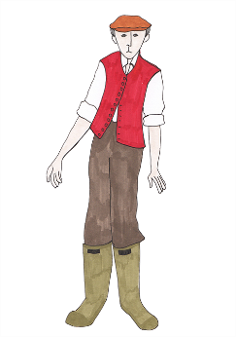
‘Thieves!’ shrieked Rat. ‘Robbers! Bandits! Burglars!’

