Year 4 - 12 bits of fun for reading and writing!
Every Friday, we would like you to choose an activity from the choices below.
These activities could be completed with a book you have read in school/know, a book you are reading now or a book online. Some of them you might have to do a bit more research. You can do them in any order. On the way you can collect points for prizes!
We can’t wait to see what you choose! Have fun!

Use a book you have read or a book you know or choose a book to read!
Wanted  Choose a character from a book and make a wanted poster Include a description, why they are wanted and who to contact!  Bonus!  You could do this for more than one character. How would they be different?  5 points | Story map  Take a book or a story that you have read or know well.  Make a story map of what happened in the story. Add in details about the characters and events.  Bonus!  You could illustrate a key scene or part.  5 points |  | Comic strip  Turn a story/book into a comic strip”  You could do this either on a book you have read or are reading OR make up your own.  Bonus!  Complete another comic strip on a book from a different genre  10 points |  | Quizzical!  Take a book/ topic you have read and write 10 questions on it. You could make it into a guessing game by folding a piece of paper – question on top and answer underneath. Can your family/ friend answer the questions?  Bonus!  10 points  You could make it into a fortune-teller game! |  | Connect up!  Make a family tree of characters in a book that you know well. Draw them and include key facts.  You could also do this on:  A film, A TV show, Your own family!  Bonus!  Take a different genre of book or another book by the same author  5 points |  | Could it rhyme?  Take a book / story you have read or know.  Can you write a poem about a character or the book?  It could be a rhyming poem, an acrostic poem, a limerick or any type of poem!  Bonus!  Could you read about a topic or an event/ person from the past and do the same?  15 points
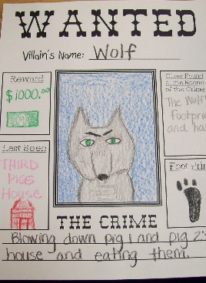 | 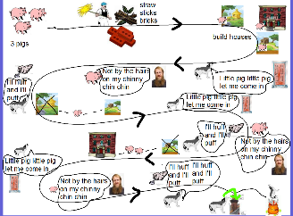 |  | 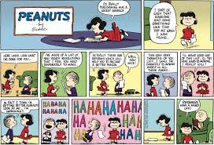 |  | 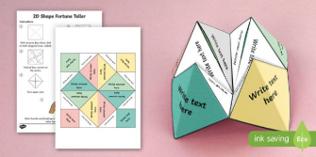 |  | 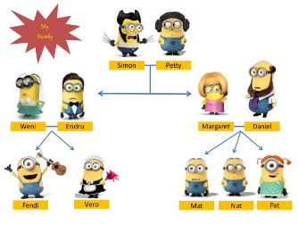 |  | 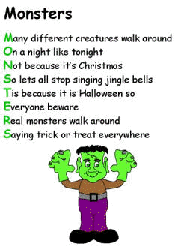
A little bit of research…
All about me!  Make a book about yourself and your family. Interview them in person or by phone. Make a page for everyone. Think about what you could ask.  Bonus!  If you wanted to you could do this about a book character too!  5 points |  | Feel an emotion!  Think of a book you have read or a book you are reading. Choose 3 emotions that you felt and draw/ write about them. Why did you feel that way and how did the author do this?  Bonus!  Could you make this into an emotions graph of a story?  10 points |  | Read all about it!  Think of an important event in history or in a book.  Research it then write a newspaper article about it. Include quotes and who, what where when why?  Bonus!  You could write some adverts / letters of advice/ comic strip for a character too that could be in your newspaper!  15 points |  | A blast from the past  Find out about a person in history or an event.  What questions would you ask them?  What would they say?  Bonus!  You could get someone to be that person and then record the interview or write it up as a script!  5 points |  | A big wide world  Choose a country/ city in the world. Find out information about it and then make a leaflet/ non-fiction book. Think about buildings, people, places, life e.g. food etc.  Bonus!  Could you find out about a country in EVERY continent! You could use your information to write a story set in that country!  15 points |  | Get Creative!  Find a picture that you like either by a famous artist or a book illustration or a photo  Can you write about it?  It could be a story/ newspaper/ poem/ fact file  Bonus!  Read about the illustrator/ artist  10 points
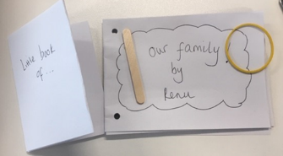 |  | 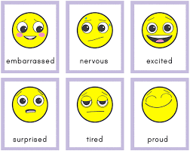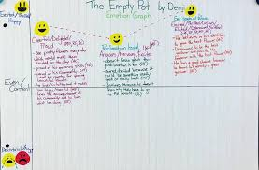 |  | 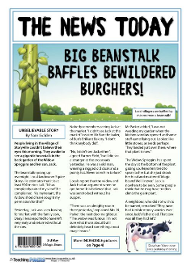 |  | 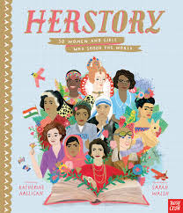 |  |  |  | 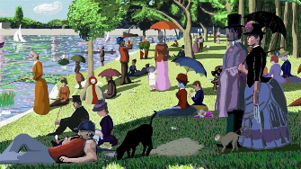

Points mean prizes… Collect points as you go and turn them into prizes or even more fun!
Collect your points from every challenge. Get 5 points for every bonus. Colour in the star when you have collected the points. |  | My rewards – agree with someone at home what will your reward be for collecting points e.g. Have a dance party, play a game, watch TV, make biscuits, phone a friend – you can decide together!  Write what the reward will be in each box! | The praise part  What have you been proud of?  Write in this column what you are pleased with and why!
10
15
25
50
75
100
Over 100

