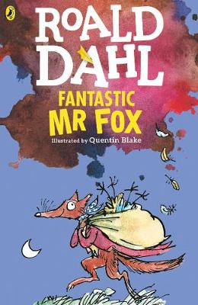

Chapter One – The Three Farmers

Down in the valley there were three farms. The owners of these
farms had done well. They were rich men. They were also nasty men.
All three of them were about as nasty and mean as any men you
could meet. Their names were Farmer Boggis, Farmer Bunce and
Farmer Bean.

Boggis was a chicken farmer. He kept thousands of chickens. He was
enormously fat. This was because he ate three boiled chickens
smothered with dumplings every day for breakfast, lunch and supper.

Bunce was a duck-and-goose farmer. He kept thousands of ducks and
geese. He was a kind of pot-bellied dwarf. He was so short his chin
would have been underwater in the shallow end of any swimming-
pool in the world. His food was doughnuts and goose-livers. He
mashed the livers into a disgusting paste and then stuffed the paste
into the doughnuts. This diet gave him a tummy-ache and a beastly
temper.

Bean was a turkey-and-apple farmer. He kept thousands of turkeys in
an orchard full of apple trees. He never ate any food at all. Instead,
he drank gallons of strong cider which he made from the apples in his
orchard. He was as thin as a pencil and the cleverest of them all.

‘Boggis and Bunce and Bean

One fat, one short, one lean.
These horrible crooks
So different in looks

Were none the less equally mean.’

That is what the children round about used to sing when they saw
them.

Chapter 2 Mr Fox

On a hill above the valley there was a wood.

In the wood there was a huge tree.

Under the tree there was a hole.

In the hole lived Mr Fox and Mrs Fox and their four Small Foxes.

Every evening as soon as it got dark, Mr Fox would say to Mrs Fox,
‘Well, my darlings, what shall it be this time? A plump chicken from
Boggis? A duck or a goose from Bunce? Or a nice turkey from Bean’
And when Mrs Fox had told him what she wanted, Mr Fox would creep down into the valley in the darkness of the night and help
himself.

Boggis and Bunce and Bean knew very well what was going on, and it
made them wild with rage. They were not men who liked to give
anything away. Less till did they like anything to be stolen from them.
So every night each of them would take this shotgun and hide in a
dark place somewhere on his own farm, hoping to catch the robber.

But Mr Fox was too clever for them. He always approached a farm
with the wind blowing in his face, and this meant that if any man
were lurking in the shadows ahead, the wind would carry the smell of
that man to Mr Fox’s nose from far away. Thus, if Mr Boggis was
hiding behind his Chicken House Number One, Mr Fox would smell
him out from fifty yards off and quickly change direction, heading for
Chicken House Number Four at the other end of the farm.

‘Dang and blast that lousy beast!’ cried Boggis.

‘I’d like to rip his guts out!’ said Bunce.

‘He must be killed!’ cried Bean.

‘But how?’ said Boggis. ‘How on earth can we catch the
blighter?’

Bean picked his nose delicately with a long finger. ‘I have a plan,’
he said.

‘You’ve never had a decent plan yet,’ said Bunce.

‘Shut up and listen,’ said Bean. ‘Tomorrow night we will all hide just
outside the hold where the fox lives. We will wait there until he
comes out. Then…Bang! Bang-bang-bang.’

‘Very clever,’ said Bunce. ‘But first we shall have to find the
hole.’

‘My dear Bunce, I’ve already found it,’ said the crafty Bean. ‘It’s
up in the wood on the hill. It’s under a huge tree…’

