Worm, Slug, Maggot and Leech
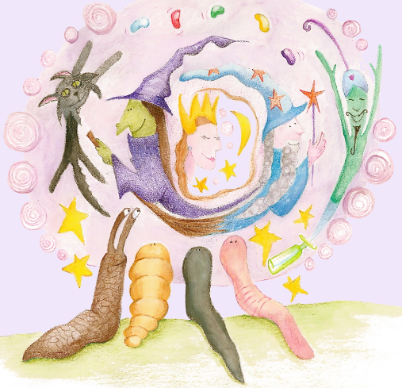
by Polly Walker
The minibeasts were so jealous of the other beautiful minibeasts that they wished to change. They decided to call for a magical person to help them to change their looks. They thought that if they were more beautiful, then their lives would improve. They wished and wished and wished.
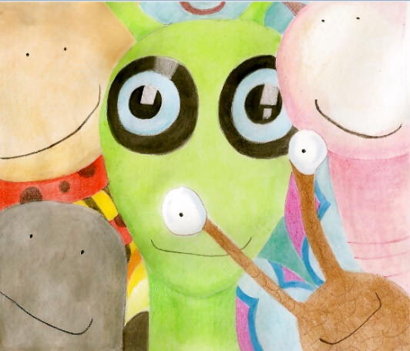
Oh Wow! Suddenly, something emerged from the trees. It was creature with special abilities! She was an extremely optimistic, magical being, with the power of her mind to be able to change things. She was determined to create happiness for the friends.
She asked what they really wanted her to do, to see if she could help. The friends told her all about the pretty dragonflies, the delicate wings of the butterflies, the shimmering beetles, the dainty bugs and how they would love to look like them.

Learning Goal: I can retrieve and infer information from the text.  wriggle, disliked, plain, ugly  explore, investigate, peaceful | 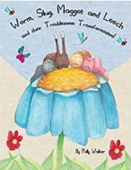
Home School Learning Wednesday - Worm, Slug, Maggot and Leech by Polly Walker
- What did the animals do to call the magical creature?
- What do you think will happen next in the story?
- Draw these creatures: pretty dragonflies, delicate butterflies, shimmering beetles and red, dainty bugs.

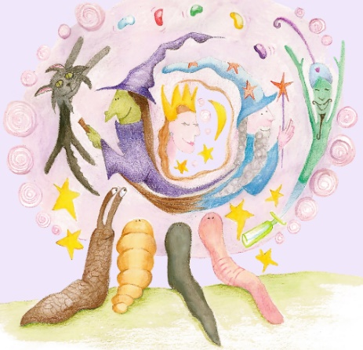

My Beautiful Creatures

