Lesson 2 text
Worm, Slug, Maggot and Leech
by Polly Walker
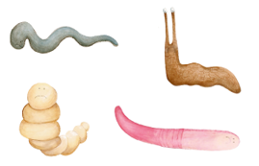
Worm, Slug, Maggot and Leech lived in a quiet and peaceful wood in Minibeast land. They loved to explore the beautiful countryside around them as they investigated all the nooks and crannies where they lived. They met up every day to go on an adventure, but they were not happy. Why? Well, they just did not like how they looked! They always compared themselves to other animals they met and dreamed of changing into creatures more beautiful.
Each one disliked something about how they looked: one was too plain, one was too ugly, one was too round, and one was too pink! So, they met together and tried to work out how they could change their looks.

Learning Goal: I can retrieve and infer information from the text.  wriggle, disliked, plain, ugly  explore, investigate, peaceful | 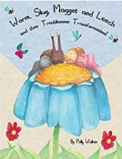
Home School Learning Tuesday - Worm, Slug, Maggot and Leech by Polly Walker
- Where did the animals live?
- What didn’t the animals like about themselves? How do you know?
- Draw an ugly animal and label it.

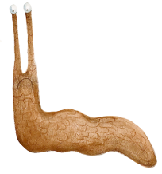
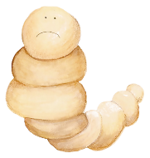
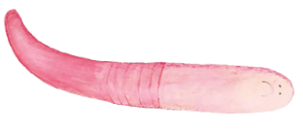
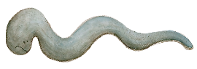

My Ugly Animal

