Year 5 Learning
Date: 7th May 2020
Maths | WALT- subtract fractions  To subtract fractions, you will continue to use the same skills as you did for ordering and adding. Watch the tutorial below. This tells you to simplify your fraction at the end. This is also how the answers to today’s questions are given.  https://www.youtube.com/watch?v=c5dNa2TVHiQ  Questions:  The final two require you to find the lowest common denominator.  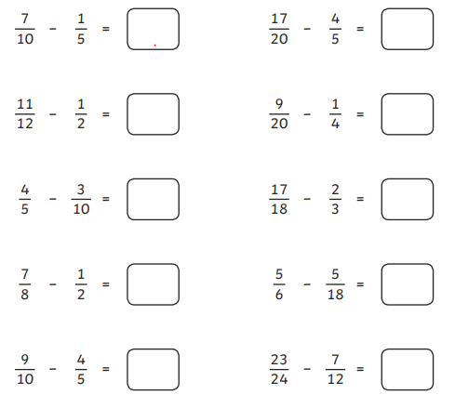  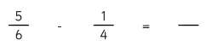  Extension:  This should be completed in the maths book given. Answers can be found at the bottom of the page.  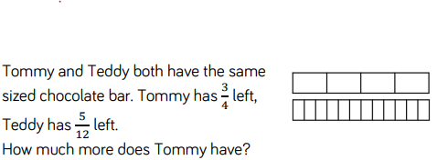
English | WALT- write a biography  Research the life of our wartime Prime Minister, Winston Churchill. Use the information to write a simple biography. On the blog, you can see a Year 5 example biography of Mary Seacole to show you the structure. You may remember looking at it from when we did our Joan Proctor writing. Winton Churchill’s life contained many events. You do not need to include them all. Create 3 clear sections such as: Early life, Life as Prime Minister and Death and Legacy. You can feel free to make your own subheadings so that you can write about the parts of his life that interest you the most.  Remember, biographies are a great text type to include relative causes in.  https://www.theschoolrun.com/homework-help/winston-churchill  This is a link to a website that has more than enough information but also contains links to other websites too.
Reading | Readtheory.org x 10  Read your own book for 20 minutes
Spelling | Spellingframe.co.uk- take the spelling test for rule 57
Science | WALT- identify what parts of a plant we eat  Watch this BBC clip to learn about rationing and food availability in the War.  https://www.bbc.co.uk/teach/class-clips-video/history-ks2-rationing-in-the-uk/zbgby9q  As you can see, people were encouraged to grow their own food. Do some research and place 4 additional items (one has been done as an example) into the grid below to identify what part of the plants we eat.  Seeds Fruit Stem Flower Root Leaves  Rice Strawberry Celery Cauliflower Carrot Lettuce  Next time your parents go shopping, take a look at the fruits and vegetables they buy. Sort them like in the picture below.  