Year 5 Learning
Date: 6th May 2020
Maths | WALT- add mixed numbers.  Watch the online tutorial:  https://www.youtube.com/watch?v=gLWphGTjGHI  In some cases, you might have to change both fractions in order to create like fractions. Let’s use the example of the first box.  The denominators are different and they are not a multiple of each other. Therefore, we need to make them like fractions by changing both of them into equivalents. I know that 12 is in the 3 and the 4 times table, so I can convert them both into twelfths.  Now I can add the whole numbers: 2+3 = 5 and I can add the fractions:  My final answer is:  Questions:  If you can, play this as a four in row game with someone. If not, chose 8 calculations to solve. Some are trickier than others.  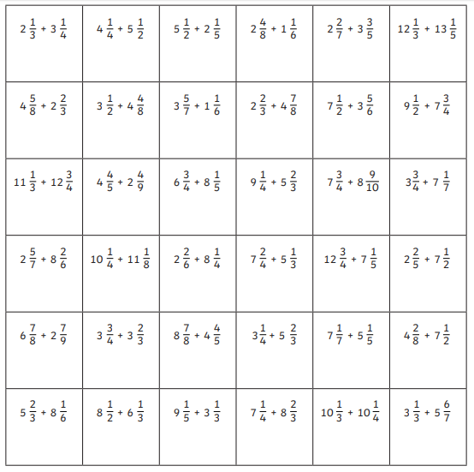  Extension:  This should be completed in the maths book given. Answers can be found at the bottom of the page.  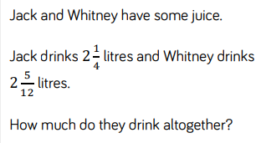
English | WALT- edit punctuation  Below is a recount of VE day by a Lady called Helen Andrews. There are 9 pieces of punctuation missing from the recount. Copy it in to your books and include the missing punctuation. Remember to add in a capital letter if you put in a full stop. The answers are at the bottom of the page to check yourself afterwards.  I was working at Bletchley Park when we found out the war had ended. A bloke came into the room where we were working and said “It’s all over. They’ve surrendered. The atmosphere was festive marvellous, and a wonderful thing to remember. We had a tea party, a little crowd of us, and music and dancing afterwards. We were so pleased it was all over, the anxiety and the worry.  I was stationed near London, so I was able to get into Trafalgar Square. Two or three of us went together and we had a lovely time I was still at Bletchley, because we hadn’t closed yet, so we hitchhiked a lift. We all did it then because apart from the difficulty of travelling, petrol was scarce too, so the drivers didn’t mind picking us up.  Trafalgar Square on VE Day my dear! Millions of people were all singing, dancing, having a wonderful time and thinking how nice it was that the war was over. Princess Elizabeth and Margaret were in the crowd they’d been allowed to mingle with us for the day because it was such a special occasion. There was lots of dancing and noise and people climbed up lampposts and the Nelson’s column. Some people had something to drink (which all added to the tremendously festive atmosphere and some jumped in the fountains! Churchill came out I didn’t see him because we were in this huge crowd, but we knew there were important people amongst us. We sang Auld Lang Syne with arms linked. It was bonding and very lively!  We spent most of the day gallivanting around Trafalgar Square and London, and had tea in one of the cafes. We got home at about midnight usually there was a curfew, but nobody minded for once.
Reading | Readtheory.org x 10  Read your own book for 20 minutes
Spelling | Spellingframe.co.uk- spelling rule 57
Art | One of the big symbols of VE day is the Union Jack flag. Use it to get creative and make some artwork. I have included some ideas below. Use whatever you have at home. If you have a talent for knitting, sewing or crochet, you could use that. Or it could be a pencil drawing. You can put up your artwork in a window of your house for Friday.  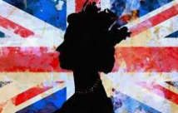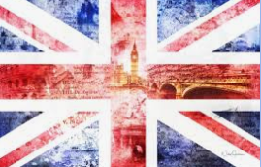  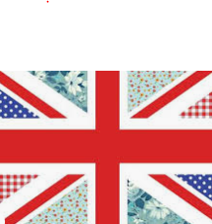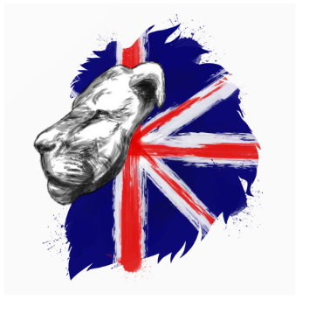  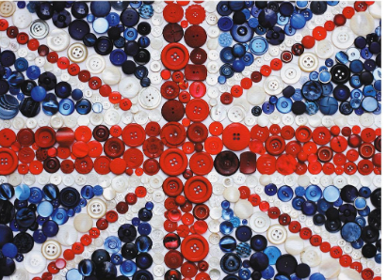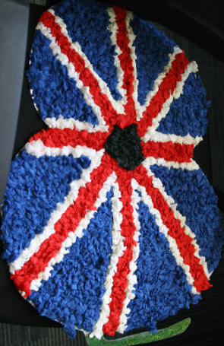  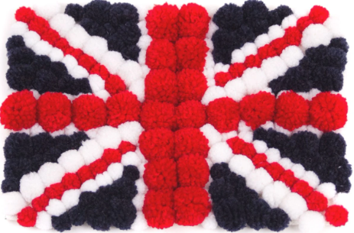
PE | Get ready to celebrate and learn some 40s dance moves! On VE day, people would have been dancing and singing in the streets. Learn some moves from two of the popular dances of the time: The Lambeth Walk and the Lindy Hop. Please send through any clips of you dancing.  The Lambeth Walk:  https://www.youtube.com/watch?v=bdSvLV-EgSA  https://www.youtube.com/watch?v=WNMzyOCGFOQ  The Lindy Hop:  https://www.youtube.com/watch?v=r5DWLZGQOoE

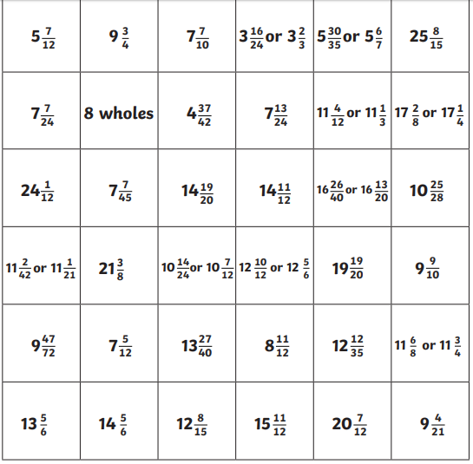
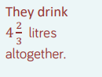
I was working at Bletchley Park when we found out the war had ended. A bloke came into the room where we were working and said, “It’s all over. They’ve surrendered.” The atmosphere was festive, marvellous, and a wonderful thing to remember. We had a tea party, a little crowd of us, and music and dancing afterwards. We were so pleased it was all over, the anxiety and the worry.
I was stationed near London, so I was able to get into Trafalgar Square. Two or three of us went together and we had a lovely time. I was still at Bletchley, because we hadn’t closed yet, so we hitchhiked a lift. We all did it then because apart from the difficulty of travelling, petrol was scarce too, so the drivers didn’t mind picking us up.
Trafalgar Square on VE Day – my dear! Millions of people were all singing, dancing, having a wonderful time and thinking how nice it was that the war was over. Princess Elizabeth and Margaret were in the crowd. They’d been allowed to mingle with us for the day because it was such a special occasion. There was lots of dancing and noise and people climbed up lampposts and the Nelson’s column. Some people had something to drink (which all added to the tremendously festive atmosphere) and some jumped in the fountains! Churchill came out. I didn’t see him because we were in this huge crowd, but we knew there were important people amongst us. We sang Auld Lang Syne with arms linked. It was bonding and very lively!
We spent most of the day gallivanting around Trafalgar Square and London, and had tea in one of the cafes. We got home at about midnight. Usually there was a curfew, but nobody minded for once.

