Year 5 Learning
Date: 4th May 2020
Maths | WALT- add fractions  Parents note: In order to do this lesson, children must be able to find equivalent fractions. If this is challenge, spend more time on this instead.  Watch the online tutorial:  https://www.youtube.com/watch?v=tDQipFjAoT8  Questions:  Answers at the end of the page  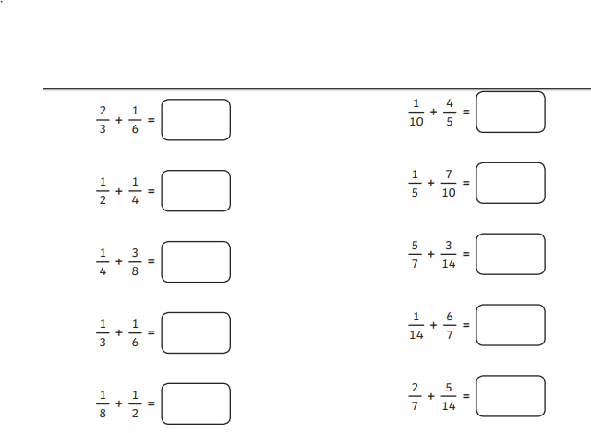  Extension:  This should be completed in the maths book given. Answer at bottom of the page.  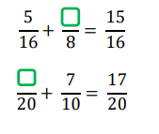
English | WALT- improve reading skills.  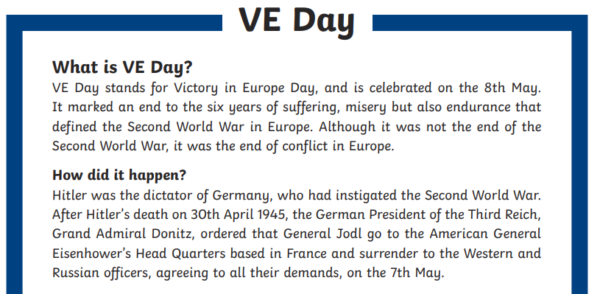  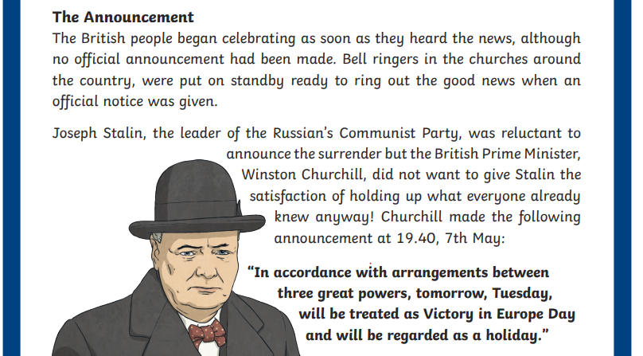  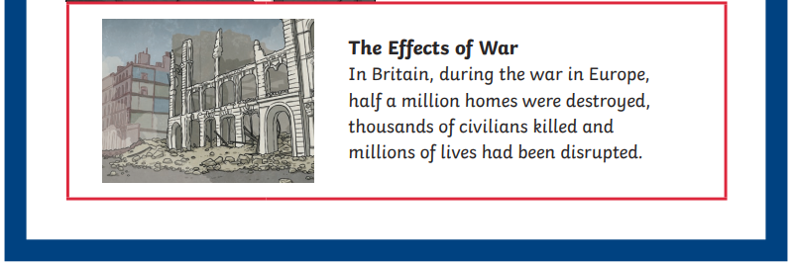  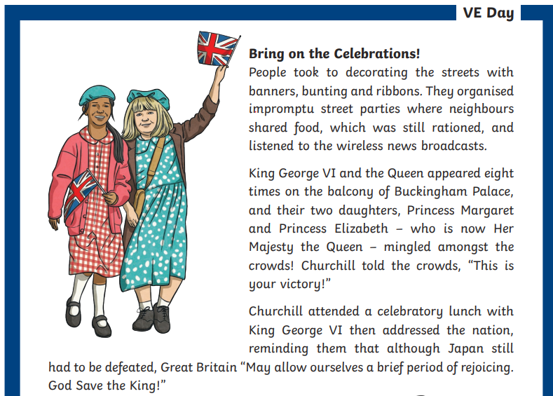  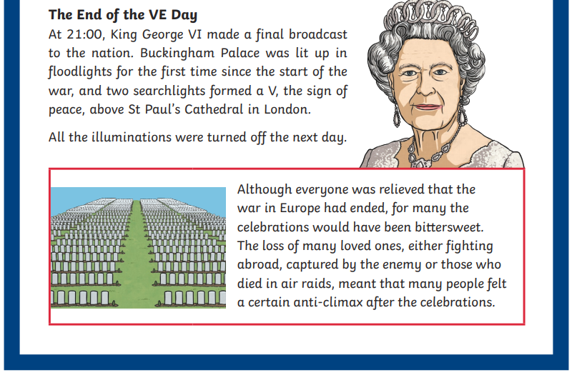  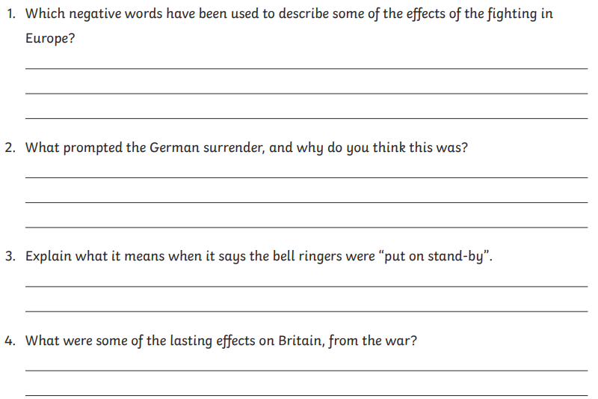  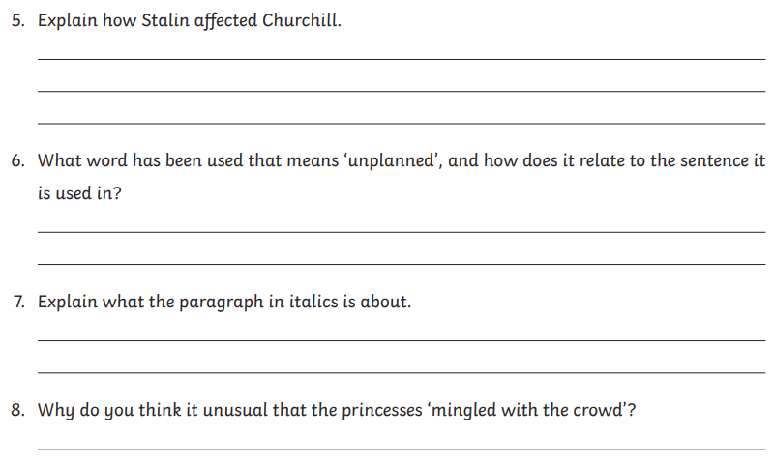  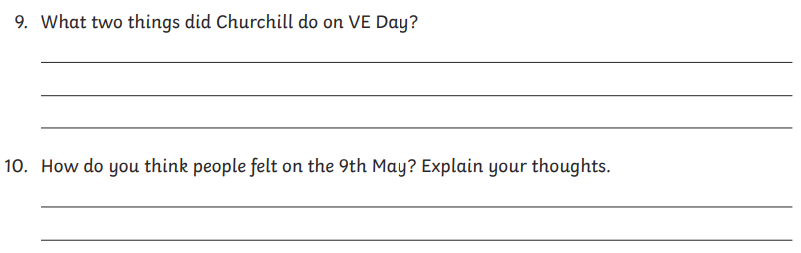
Reading | Readtheroy.org x 10  Read your own book for 20 minutes
Spelling | Spellingframe.co.uk- Spelling rule 57
History | WALT- Examine a photograph as a primary source.  Watch these clips about VE day:  https://www.bbc.co.uk/teach/class-clips-video/history-ks2-ve-day/z7xtmfr  https://www.youtube.com/watch?v=NEavcsrMoMw  Now look at this picture of a street party from VE day and answer the questions.  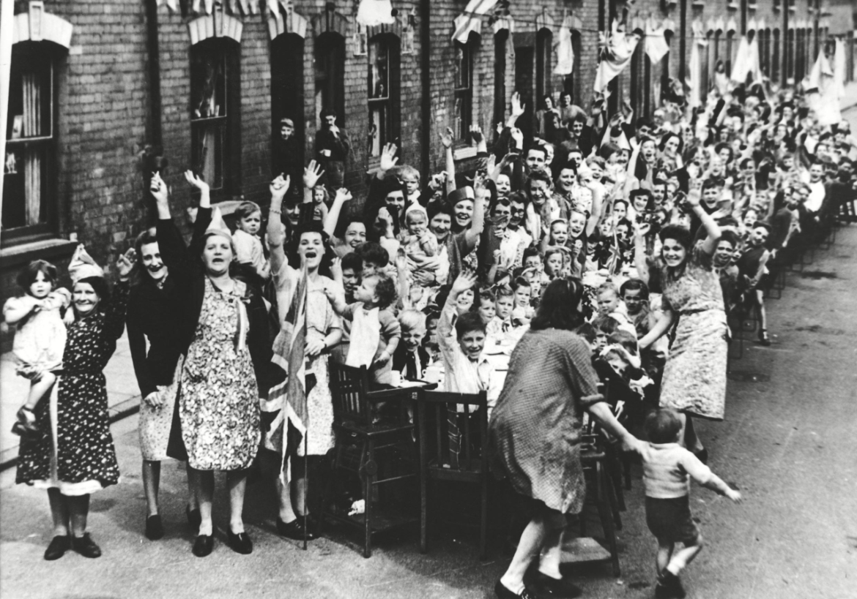  What can you see?  What is happening?  How are people feeling?  Would we see this happening today? Why/why not?  What doesn't the picture tell you?  Do you notice anything strange about the picture? Is anyone missing?  What questions do you have?  If you could talk to someone in the picture, what would you ask and why?  Extension:  When I was looking for VE day pictures, there were so many. Do an internet search and pick one you think represents VE day best and explain why.
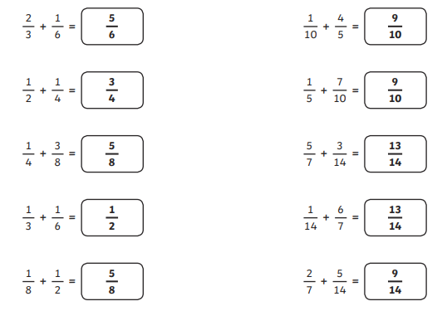
5 and 3
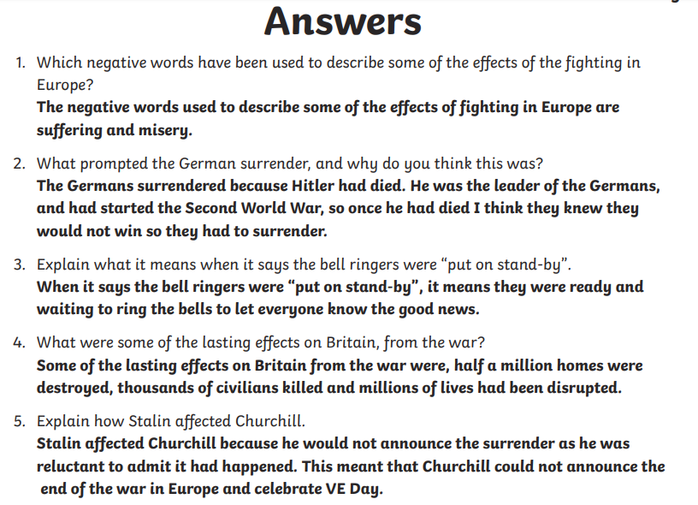
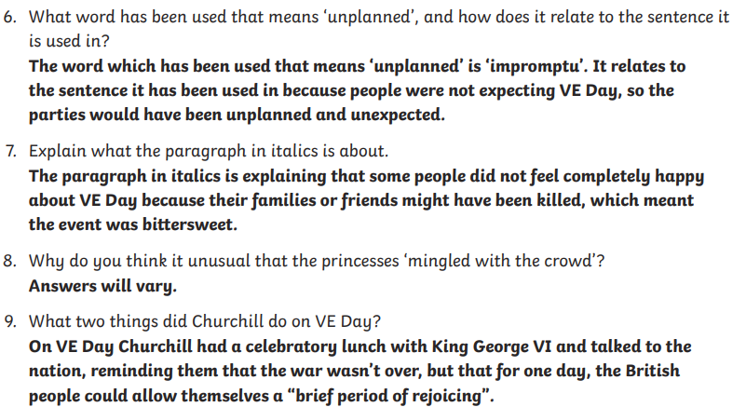

10. This is your own personal response. You may include things about being relieved and happy. You may also consider the sadness at those who will not come home. There may be feelings of being apprehensive about how long until your loved one returns and how the country will rebuild. If you are a woman, your role may change when the men return. How will this feel? You might also be hopeful and think about a future free from war and rationing.

