Year 5 Learning
Date: 22nd May 2020
Maths | Fluency Friday  On Fridays, we will complete a series of questions based on learning we have already done. If your child is having difficulty with the multiplication in question 1, here is a link to an online tutorial: https://www.youtube.com/watch?v=RVYwunbpMHA&t=118s  This was the last unit we covered and so has not had as much practise.  Questions:  - 867 x 27  - 3862 divided by 4. Express the remainder as a fraction and a decimal.  - 8520ml = ____L  - What is $\frac{4}{5}$ of 60?  - What is $\frac{26}{9}$ as a mixed number?  - 3.27m = ____cm  - 2$\frac{3}{4}$ + 4$\frac{2}{8}$=  - $\frac{2}{3}-$ $\frac{3}{6}$ =  - Write the mixed number and improper fraction for this image:  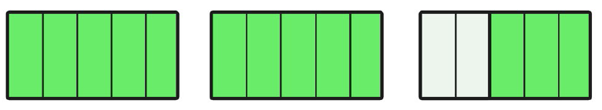  - $\frac{2}{5}$ = $\frac{12}{}$  - 38.08 kg = _______g  - 1.2 kg + 2634g =_______kg  - 3502 – 307=  14. 4 $\frac{5}{6}$ x 5  15. 3 $\frac{4}{7}$ - $\frac{2}{14}$  Extension:  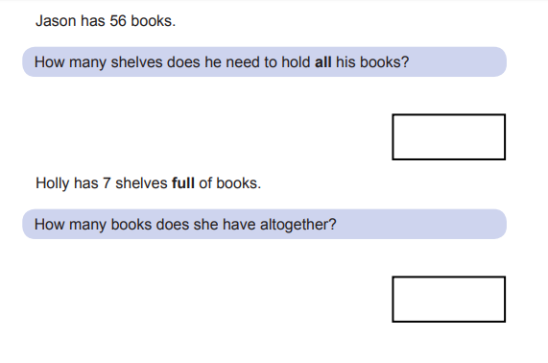
English | WALT- write a character description  https://www.thenational.academy/year-5/english/character-description-write-a-character-description-year-5-wk2-5
Reading | Readtheory.org x 10  Read your own book for 20 minutes
Spelling | Spellingframe.co.uk- take the spelling test for rule 59
RE | WALT- understand the symbols of Pentecost  Begin this lesson by completing the 3 minute retreat  https://www.loyolapress.com/retreats/pentecost-sunday/  The symbols of Pentecost are:  - Red  - Dove  - Fire  - Wind  Create your own poster to show the symbols. Some examples are below. Can you include all of the symbols?  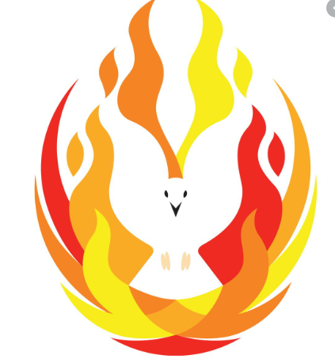  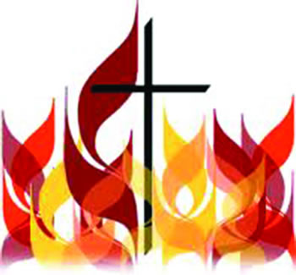  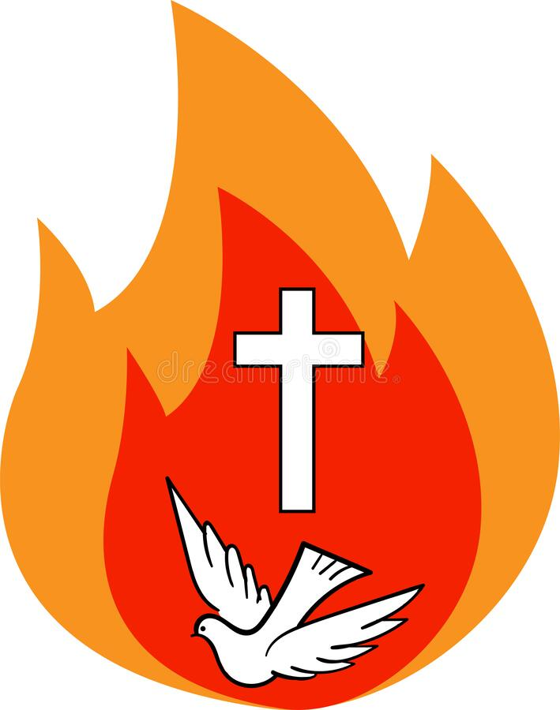
Spirituality Week | Take a look at the blog for today’s activity
Maths answer | - 23409  - 965.5 as a fraction, the remainder is $\frac{2}{4}$ or $\frac{1}{2}$  - 8.52L  - 48  - 2 $\frac{8}{9}$  - 327  - 7  - $\frac{1}{6}$  - 2$\frac{3}{5}$ or $\frac{13}{5}$  - $\frac{12}{30}$  - 38,080  - 3.834kg  - 3195  - 24 $\frac{1}{6}$  - $3 \frac{6}{14}$  Extension:  