Year 5 Learning
Date: 21st May 2020
Maths | WALT- convert units of capacity  Follow the PowerPoint on the blog.  Questions:  Complete the questions on mathletics.  Extension:  This should be completed in the maths book given. Answers can be found at the bottom of the page.  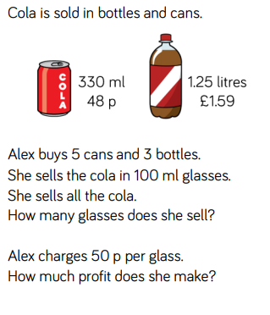
English | WALT- use parenthesis  https://www.thenational.academy/year-5/english/setting-description-spag-focus-parenthesis-year-5-wk1-4
Reading | Readtheory.org x 10  Read your own book for 20 minutes
Spelling | Spellingframe.co.uk- take the spelling test for rule 59
Science | WALT- understand animals have different gestation periods  We have looked at lifecycles of both animals and plants. We are now going to focus on mammals. Most mammals are viviparous. This means that they give birth to live young, rather than lay eggs. The time it takes to develop in the womb is called the gestation period.  The mammal starts off as a zygote (a single cell) and develops into an embryo (made of many cells). After that, it becomes a foetus which has skin, bones, blood and organs. Each animal has a different gestation period. Look at the table below.  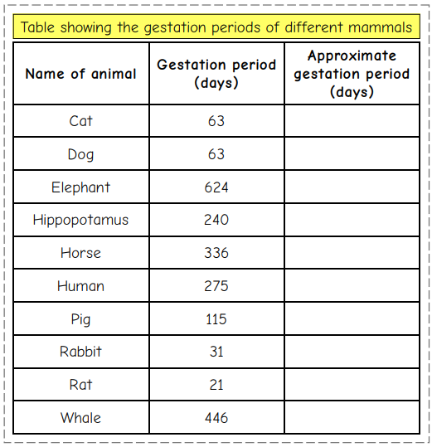  Round each one to the nearest 10 and create a bar chart of your data.  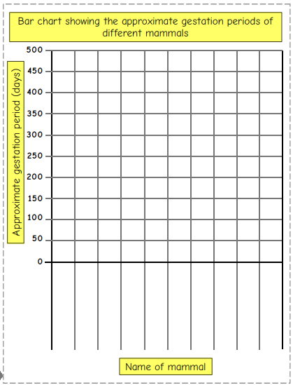  Write a few sentences explaining what the graph shows you.
Spirituality Week | Follow the instructions from today’s Spirituality week blog.

5 cans x 330ml = 1650ml
1.25L x 3 bottles = 3.75L or 3750ml
1650 + 3750 = 5400 ml of cola in total.
5400 divided by 100 = 54. Therefore, she sells 54 glasses.
She cares 50p per glass. 50 x 54 = 2700p or £27.00
Her original spend was 48px 5, which is 240p or £2.40
And 1.59 x 3, which is £4.77.
In total she spent £7.17
Subtract that from her total earned. £27.00 – 7.17= £19.83 profit.

