Year 5 Learning
Date: 20th May 2020
Maths | WALT- convert units of mass  Watch the tutorial:  https://www.youtube.com/watch?v=7j4GNdqTnzw  Questions:  Complete the mathletics activities set.  Extension:  This should be completed in the maths book given. Answers can be found at the bottom of the page.  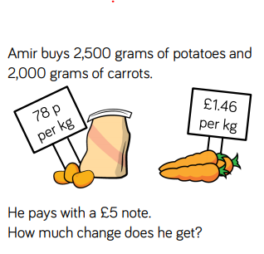
English | WALT- identify the features of a text.  https://www.thenational.academy/year-5/english/character-description-identifying-the-features-of-a-text-year-5-wk2-3
Reading | Readtheory.org x 10  Read your own book for 20 minutes
Spelling | Spellingframe.co.uk- spelling rule 59
Art | WALT- proportion figures  In our art lessons at school, we learnt about proportioning the face so that we were able to add in features. Let’s build upon this now and learn how to proportion bodies.  https://www.youtube.com/watch?v=85A_F7_N3t0
Spirituality Week | Complete the activity for 3, 4, 5 and 6.

Start by converting the grams into kg. That means he has 2.5kg of potatoes and 2kg of carrots.
Next, you need to add 78p +78p and 39p as he has two full kg and one half of a kg of potatoes. This gives you 195p or £1.95.
Amir has 2kg of carrots so that is £2.92 (£1.46 + £1.46)
£1.95 + £2.92 = £4.87

£5.00 - £4.87 = 13 pence.

