Year 5 Learning
Date: 1st May 2020
Maths | Fluency Friday  On Fridays, we will complete a series of questions based on learning we have already done. If your child is having difficulty with the multiplication in question 1, here is a link to an online tutorial: https://www.youtube.com/watch?v=RVYwunbpMHA&t=118s  This was the last unit we covered and so has not had as much practise.  Questions:  - 731 x 43  - 1956 divided by 3  - 0.2 x 0.9  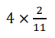  - Round 15.27 to the nearest whole number.  - 4319 divided by 5. Express the remainder as a decimal  - What is 47 as a mixed number?  5  - 3017 divided by 4. Express the remainder as a fraction.  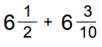  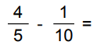  - Write the mixed number and improper fraction for this image:  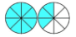  - 3 = 9  8  - What is 5 $\frac{3}{9}$ as an improper fraction?  14.  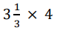  15.  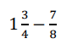  Extension:  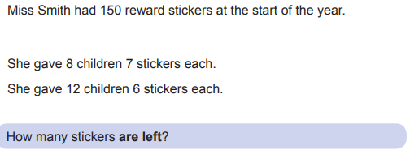
English | WALT- use SPaG knowledge  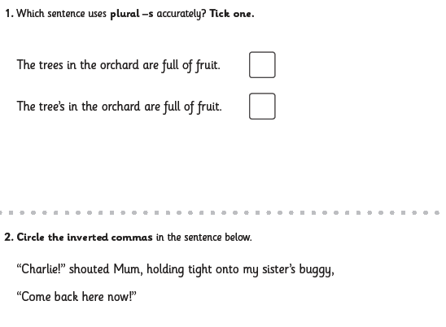  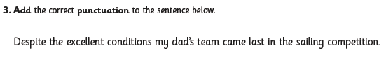  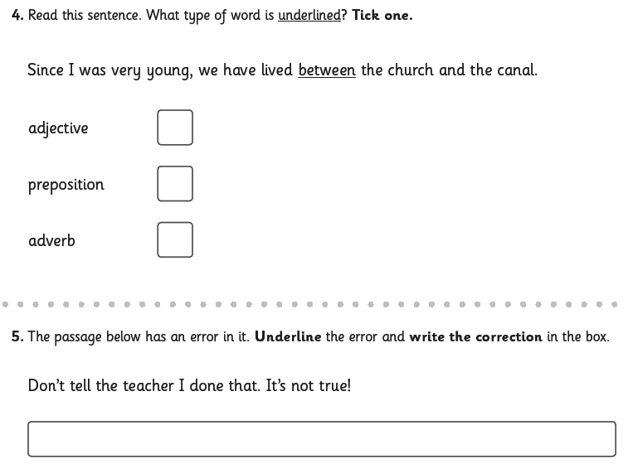  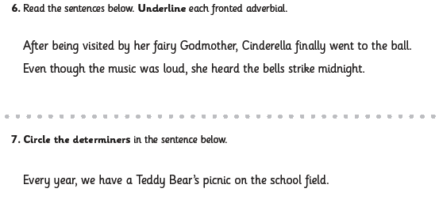  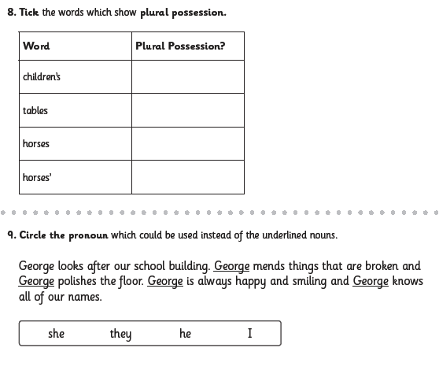  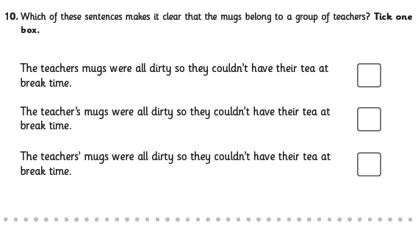
Reading | Readtheory.org x 10  Read your own book for 20 minutes
Spelling | Spellingframe.co.uk- take the spelling test for rule 58
RE | WALT- represent Jesus’ Ascension through art.  Begin this lesson by completing the 3 minute retreat  https://www.loyolapress.com/retreats/feast-of-the-ascension-start-retreat/  Earlier in the week, we looked at Matthew’s version of the Ascension. During the 3 minute retreat, you listened to Luke’s. We know that Gospels often record events differently, but they contain the same core truths. In this case, that Jesus ascended into heaven, he will always be with us and we were tasked with going out, spreading the Gospel and baptising others (The Great Commission).  Read how Luke records this in Acts:  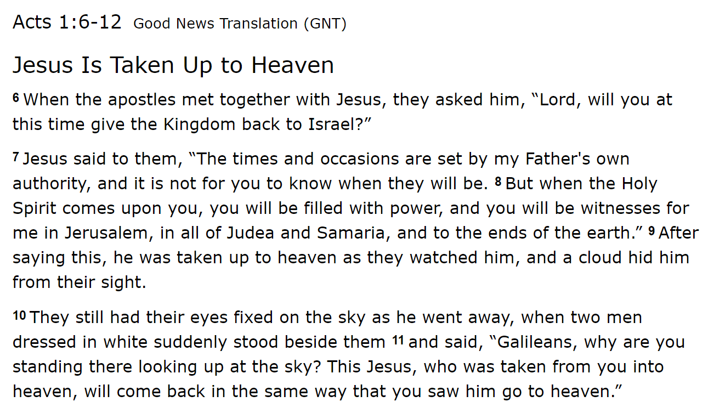  Visualise this moment. Close your eyes and think about:  - What can you see?  - What do you hear?  - How do you feel?  For generations, artists have tried to capture this. Take a turn yourself and create an Ascension art piece.  I have included some ideas.  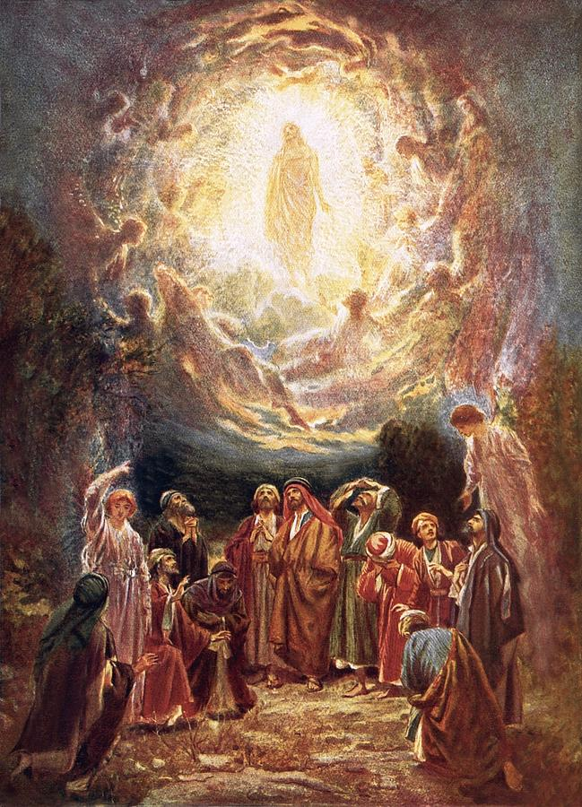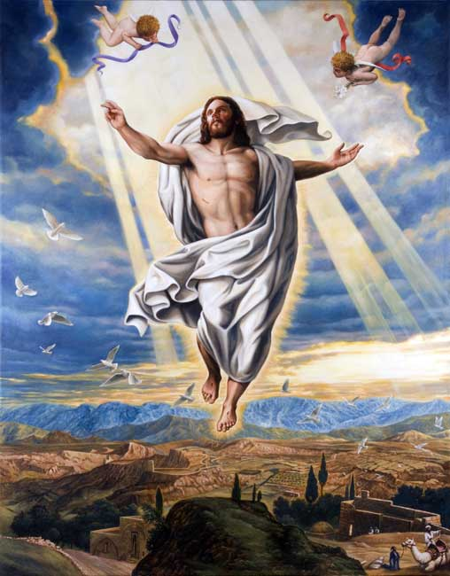  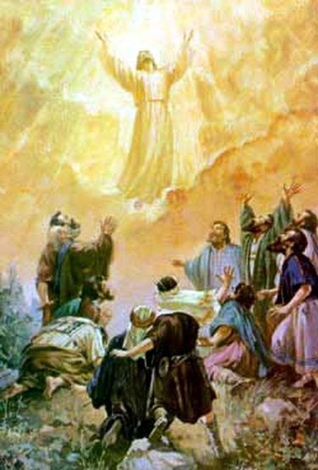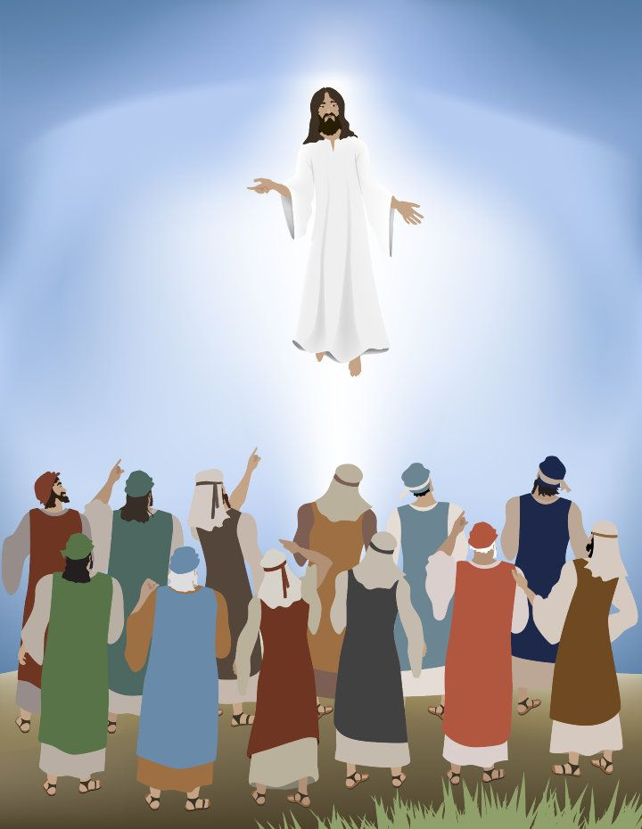  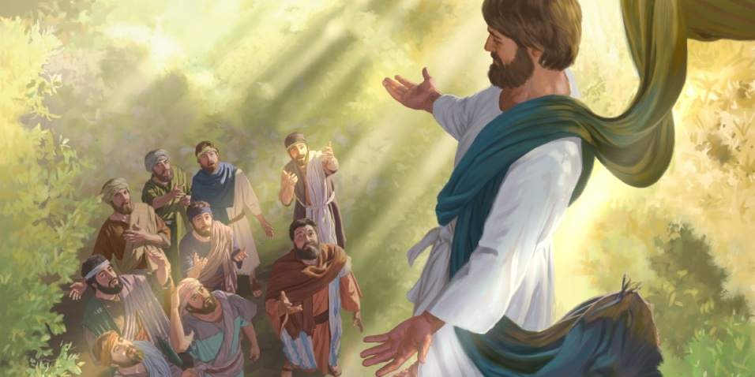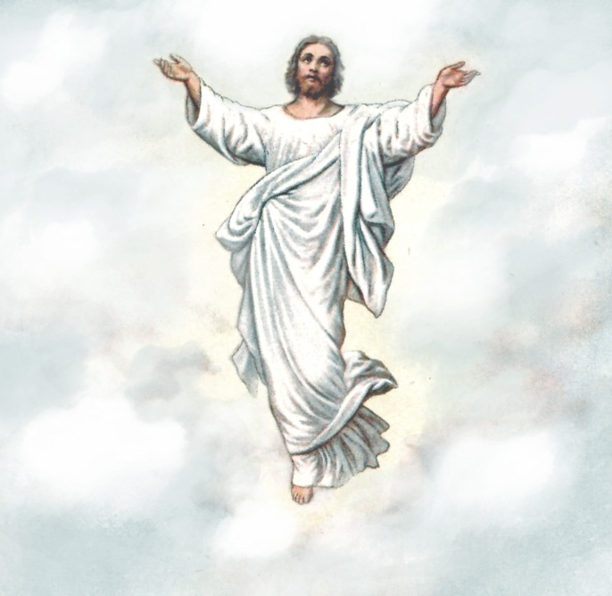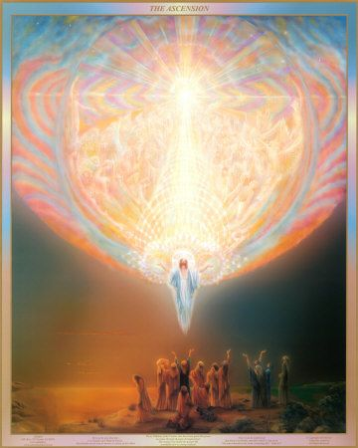
- 31433
- 652
- 0.18
- $\frac{8}{11}$
- 15
- 863.8
- 9$\frac{2}{5}$
- 754$\frac{1}{4}$

- 12$\frac{8}{10}$ or 12$\frac{4}{5}$

- $\frac{7}{10}$

- 1$\frac{3}{8}$ and $\frac{12}{8}$

- $\frac{3}{8}$ = $\frac{9}{24}$

- $\frac{48}{9}$ = 5 $\frac{3}{9}$

- 13 $\frac{1}{3}$

- $\frac{7}{8}$

