Year 5 Learning
Date: 14th May 2020
Maths | WALT- multiply fractions by mixed numbers  Follow the PowerPoint on the blog.  Questions:  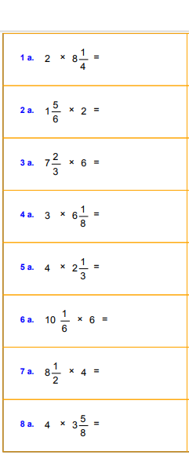  Extension:  This should be completed in the maths book given. Answers can be found at the bottom of the page.  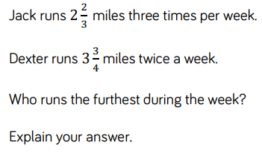
English | WALT- understand apostrophes  In class, this is still something we see a lot of mistakes in. Follow along the BBC bitesize lesson.  https://www.bbc.co.uk/bitesize/articles/zdsthbk  Complete activities 1 and 2
Reading | Readtheory.org x 10  Read your own book for 20 minutes
Spelling | Spellingframe.co.uk- take the spelling test for rule 58
Science | WALT- understand flowering plant reproduction  